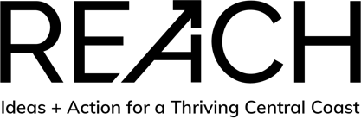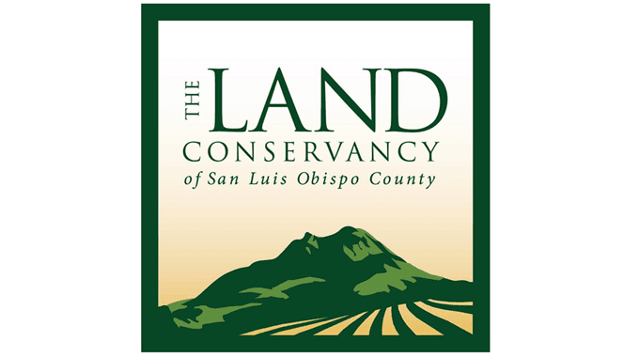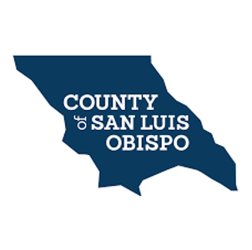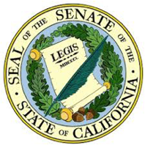

**MEMORANDUM OF UNDERSTANDING**

**BETWEEN**

**24TH DISTRICT, UNITED STATES CONGRESS**

**AND**

**17TH DISTRICT, CALIFORNIA STATE SENATE**

**AND**

**35TH DISTRICT, CALIFORNIA STATE ASSEMBLY**

**AND**

**COUNTY OF SAN LUIS OBISPO**

**AND**

**CAL POLY STATE UNIVERSITY, SAN LUIS OBISPO**

**AND**

**REACH**

**AND**

**THE LAND CONSERVANCY OF SAN LUIS OBISPO COUNTY**

**AND**

**TRI-COUNTIES BUILDING & CONSTRUCTION TRADES COUNCIL AF OF L CIO**

**AND**

**ytt NORTHERN CHUMASH NONPROFIT**

**WHEREAS,** this Memorandum of Understanding (MOU) by and between Congressman, 24th District, United States; Senator, 17th District, California; Assemblyman, 35th District, California, the County of San Luis Obispo; Board of Trustees of the California State University by its campus at California Polytechnic State University, California; REACH; The Land Conservancy of San Luis Obispo County hereafter “LCSLO”; Tri-Counties Building & Construction Trades Council AF of L CIO; ytt Northern Chumash Nonprofit; hereinafter referred to collectively as “the Participants,” is for voluntary cooperation in pursuing a unified vision for the decommissioning of the Diablo Canyon Power Plant (DCPP) and future uses at the industry site, “Parcel P.”

**WHEREAS,** PG&E has announced its intent to cease power generation operations of DCPP no later than August 26, 2025, the interests of the community in closure, decommissioning and future use of Parcel P require urgent and ongoing attention. Therefore, the Participants are unified in support of the following vision. Concerning closure of DCPP, the community has a clear interest in mitigating the loss of many high paying jobs and a significant reduction in sales, property and unitary tax revenue, and the consequent negative impact on the regional economy. Concerning DCPP decommissioning, the community interest lies first in safety, which includes ensuring spent nuclear fuel is placed into dry cask storage as soon as possible and that the decommissioning process is begun immediately and is protective of human health, the environment and local quality of life; the community interest is also in timely decommissioning and in ensuring local businesses and local workforce members are utilized in the decommissioning process to the maximum extent possible through a community workforce agreement that specifies local hire provisions and adherence to local Joint Apprenticeship Training Standards, and other local programs supporting high paying careers and career pathways into the skilled building and construction trades. Finally, concerning future use, the community interest is in pursuing future uses at Parcel P, which include but are not limited to: renewable energy, research & development (renewable energy, blue economy, aquaculture, and so forth), water resilience, continued protection of Northern Chumash cultural resources, etc.

**NOW, THEREFORE**:

**SECTION I**

**Strategic Objective**

The Participants share the common objective of aligning and guiding the diverse range of public and private sector officials around a shared vision for the DCPP decommissioning process and future use of Parcel P, thereby championing social, cultural, environmental and economic interests of Central Coast residents.

**SECTION II**

**Areas of Cooperation**

The Participants intend to achieve the stated strategic objective through initiatives, consistent with Joint Ethics Regulation and all other applicable federal and state ethics regulations, focused on, but not limited to, the following areas of cooperation:

a) Collaboration to pursue actions that will refine and advance the unified vision for DCPP decommissioning and future use of the Parcel P site.

b) Define the key enabling requirements, priorities, and actions stemming from unified vision and pursue joint advocacy channels at legislative and regulatory bodies at the local, state and federal levels.

c) Connect and liaise with other local, state, and federal entities of government, private industry partners, community organizations, and other interested parties to support the strategic objective of the Participants.

**SECTION III**

**Specific Activities**

Specific activities to implement the areas of cooperation and to achieve the Participants’ objective include:

a) The Participants will lead development of the strategic objective into actions that achieve the objective.

b) Participants commit to monthly meetings, on mutually agreed upon dates and times. Meetings will be held to align objectives and priorities consistent with this MOU between the Participants and stated vision and strategic objective.

c) Congressman, 24th District, United States shall engage appropriate Federal agencies in ensuring the safety of decommissioning of Diablo Canyon Power Plant and pursuing a shared effort for economic development within the region.

d) Senator, 17th District, California shall advocate for the region by engaging with statewide agencies and decision-makers such as the California Public Utilities Commission (CPUC), the California State Legislature, and the California Governor's Office. The Senator also supports a strong role for the decommissioning work to be done by Central Coast labor through local hire agreements and provisions. The Senator supports the future use of the site be repurposed for a resilient blue economy with focuses in renewable energy and higher education partnerships. The Senator supports prioritizing safety during the decommissioning with spent fuel in dry cask storage.

e) Assemblyman, 35th District, California shall facilitate communications between the parties of the MOU and state agencies and regulatory bodies in order to help achieve overarching objectives and goals; advocate with the Public Utilities Commission, PG&E, and other relevant stakeholders to ensure that decommissioning funds are spent in a manner that is most beneficial to the local economy; work to ensure that local governmental bodies are given maximum input on decisions relating to decommissioning and its impact on our communities; promote and protect the local workforce before and during the decommissioning process; support and facilitate future use opportunities at the Parcel P site which enhance economic prosperity on the Central Coast, including: Offshore wind, water resilience, higher education, research and development, as well as other opportunities that serve the interests of 35th Assembly District constituents.

f) County of San Luis Obispo shall pursue legislative efforts that are aligned with its adopted legislative platform and support the Participants in the development of strategic objectives developed through the implementation of this MOU.

g) Cal Poly San Luis Obispo shall support MOU Participant partnership meetings, advocacy, and to-be-determined initiatives consistent with the Vision and Strategic Objective detailed in this document, specific to “Parcel P” decommissioning and future use, and consistent with Cal Poly’s Learn by Doing approach, interests, values and priorities.

h) REACH shall perform overall meeting coordination and facilitation, and implement and carry out actions pursuant to agreed objectives.

i) The Land Conservancy of San Luis Obispo County shall support and advise the Participants in their pursuit of future uses of Parcel P that address community interests, while primarily focusing on the permanent protection of private lands surrounding Parcel P owned by PG&E and Eureka Energy alongside multiple community partners. LCSLO may also support real property transactions associated with Parcel P, such as temporary holding of fee title, fundraising, and other temporary real estate activities.

j) Tri-Counties Building & Construction Trades Council AF of L CIO shall work with interested parties and the owner and operator of DCCP to develop the community workforce agreement to ensure that the local workforce and businesses are utilized to the maximum extent possible during the lengthy decommissioning process. Undertake outreach to regional building and construction trades council representatives and allied businesses to ensure an adequate highly skilled and growing workforce is maintained in the area including apprentices that are specifically trained for the scopes of work contained in the community workforce agreement.

k) ytt Northern Chumash Nonprofit representing yak tityu tityu yak tiłhɨnɨ Northern Chumash Tribe of San Luis Obispo County and Region with direct descendants from villages on the Pecho Coast, will support and promote the repurposing of Diablo Canyon Power Plant facilities for the benefit of the region and the Tribe’s economic and educational interests that include the preservation of Native American cultural and natural resources.

l) The Participants will support outreach relating to the unified vision through appropriate events and forums, as mutually agreed upon by the Participants and in a manner consistent with Joint Ethics Regulation and all other applicable federal and state ethics regulations.

**SECTION IV**

**Points of Contact**

Each Participant identifies the following primary point of contact for matters pertaining to communication and information exchange, as well as any notice required to be submitted under this MOU.

Points of Contact:

**24th Congressional District**: Caitlin Cox, District Representative, [caitlin.cox@mail.house.gov](mailto:caitlin.cox@mail.house.gov)

**17th Senate District**: Clint Weirick, District Representative, [clint.weirick@sen.ca.gov](mailto:clint.weirick@sen.ca.gov)

**35th Assembly District**: Nick Mirman, Chief of Staff, [Nicholas.Mirman@asm.ca.gov](mailto:Nicholas.Mirman@asm.ca.gov)

**County of San Luis Obispo**: Guy Savage, ACAO, [gsavage@co.slo.ca.us](mailto:gsavage@co.slo.ca.us)

**Cal Poly San Luis Obispo**: Bob Linscheid, Economic Advisor, [bob@wemanage.org](mailto:bob@wemanage.org)

**REACH**: Julie Sinton Pruniski, Director of Strategic Initiatives, [julie@reachcentralcoast.org](mailto:julie@reachcentralcoast.org)

**LCSLO**: Kaila Dettman, Executive Director, [kailad@lcslo.org](mailto:kailad@lcslo.org)

**Tri-Counties Building & Construction Trades Council AF of L CIO**: David Baldwin, Plumbers and Steamfitters, [davidb@ua403.org](mailto:davidb@ua403.org)

**ytt Northern Chumash Nonprofit**: Scott R. Lathrop, President, [srlinslo@hotmail.com](mailto:srlinslo@hotmail.com)

**SECTION V**

**Availability of Personnel and Resources**

This Memorandum of Understanding, once in effect upon signature, does not create any legally binding rights or obligations as to any Participant.

This Memorandum of Understanding does not involve the exchange of funds, nor does it represent any obligation of funds by any Participant. All costs that may arise from activities covered by, mentioned in, or pursuant to this Memorandum of Understanding will be assumed by the Participant who incurs them, unless otherwise stipulated and decided pursuant to a future written arrangement. All activities undertaken pursuant to this Memorandum of Understanding are subject to the availability of funds, personnel and other resources of each Participant.

The personnel designated by a Participant for the execution of this Memorandum of Understanding will work under the orders and responsibility of the Participant and any other organization or institution to which they belong, at all times maintaining any preexisting employment relationship with the Participant and such organization or institution. Their work will not create an employer-employee relationship with another Participant or any other organization or institution, so in no case will that other Participant, or other organization or institution, be considered as a substitute or joint employer of the designated personnel.

**SECTION VI**

**Compliance with Applicable Laws**

All activities undertaken pursuant to this Memorandum of Understanding, and all personnel designated by the Participants for the execution of those activities undertaken pursuant to this Memorandum of Understanding are subject to all applicable laws, including all laws applicable in the jurisdiction where the activities are performed. Such personnel, if visiting the other Participant to participate in an activity pursuant to this Memorandum of Understanding, will not engage in any activity detrimental to this Memorandum of Understanding.

**SECTION VII**

**Interpretation and Application**

Any difference that may arise in relation to the interpretation or application of this Memorandum of Understanding will be resolved through consultations between the Participants, who will endeavor in good faith to resolve such differences.

**SECTION VIII**

**No Legal Rights or Remedies**

Nothing in this MOU creates any legally cognizable or enforceable rights or remedies as to any Participant. In no event will any disagreement arising under this MOU—including, but not limited to, any alleged breach of, or nonperformance under, this MOU—give rise to any cause of action, or any legal or equitable remedy, in any forum whatsoever. Nothing in this MOU waives any sovereign immunity, or any other applicable immunity, that any Participant may otherwise enjoy.

This understanding is for the exchange of information to improve the understanding of agency mission needs and future requirements. The exchange of information is solely to improve understanding and does not serve as a basis for contract formation.

**SECTION IX**

**Final Provisions**

This Memorandum of Understanding is effective from the date of its signature, for a four-year period, unless renewed or extended by the Participants in the same manner that the Participants may otherwise modify this MOU.

This Memorandum of Understanding is not transferable except with the written consent of the Participants.

This Memorandum of Understanding may be modified at any time by mutual consent of all the Participants. Any modification shall be made in writing and specify the date on which such modification is to become effective.

Any Participant may, at any time, withdraw from this Memorandum of Understanding by providing a written notice to the other Participants.

The termination of this Memorandum of Understanding shall not affect the conclusion of the cooperation activities that may have been initiated during the time this Memorandum of Understanding is in effect, unless the Participants mutually decide otherwise.

It is expressly understood and agreed that this Memorandum of Understanding embodies the entire understanding between the Participants regarding the MOU’s subject matter.

_____________________________________ ______________________________

Salud Carbajal Date

Congressman

24th Congressional District

_______________________________________ ______________________________

John Laird Date

CA State Senator

17th Senate District Congressional District

_______________________________________ ______________________________

Jordan Cunningham Date

CA State Assemblyman

35th Assembly District

____________________________________ ______________________________

Lynn Compton Date

Board Chair, County of San Luis Obispo

____________________________________ ______________________________

Jeffrey Armstrong Date

President, Cal Poly San Luis Obispo

________________________________________ ______________________________

Melissa James Date

CEO, REACH

________________________________________ ______________________________

Kaila Dettman Date

Executive Director

The Land Conservancy San Luis Obispo

_______________________________________ ______________________________ Joshua Medrano Date

Executive Secretary, Treasurer

Tri-Counties Building and Construction Trades Council

___________________________________ ______________________________

Scott Lathrop Date

President, ytt Northern Chumash