1000 Mill Street  San Luis Obispo, CA 93408  (805) 781-5465 Phone  (805) 781-5697 Fax  www.SLOPensionTrust.org | 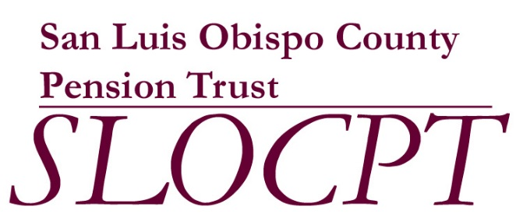

DATE: August 26, 2019

TO: Board of Trustees

FROM: Carl Nelson
Executive Secretary

RE: Board of Trustees Meeting Schedule for 2019 (REVISED)

Pursuant to Section 5.01:Regular Meetings of the By-Laws of the San Luis Obispo County Pension Trust, the following dates have been established for the Regular Meetings of the Board of Trustees for the year 2019. Unless otherwise indicated, meetings will take place on the 4th Monday of each month and be held in the Board of Supervisors Chambers in the County Administration Building.

January 28, 2019 9:30 AM BoS Chambers
February 25, 2019 9:30 AM BoS Chambers
March 25, 2019 9:30 AM BoS Chambers

April 22, 2019 9:30 AM BoS Chambers
May 20, 2019 (3rd Mon.) 9:30 AM BoS Chambers
June 24, 2019 9:30 AM BoS Chambers

July 22, 2019 9:30 AM BoS Chambers
August 26, 2019 9:30 AM BoS Chambers
September 23, 2019 9:30 AM Room 161/162

October 28, 2019 9:30 AM BoS Chambers *
November 25, 2019 9:30 AM BoS Chambers
December 16, 2019 (3rd Mon.) 9:30 AM BoS Chambers *

* Meetings removed from the schedule effective August 26, 2019

