DIRECTIONS

All applications should include tax -exempt status documentation (e.g., IRS determination letter) and a copy of current status of nonprofit organization from Secretary of State and Attorney General Office. These documents can be accessed at the specific agency’s web site at Secretary of State and Attorney General’s Office.

Grant applications from organizations that do not include this documentation or whose non-profit status is “inactive“ or “delinquent” will not be accepted. This requirement does not apply to grant applications from public agency such as a school district, County agency or department.

Please see below examples of the documentation and directions.

SECRETARY OF STATE EXAMPLE

Search Screen:

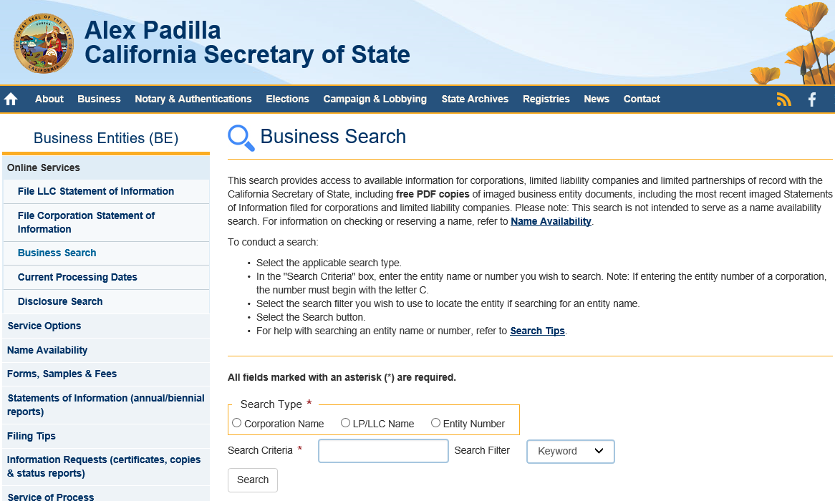

- Provide a copy of either page

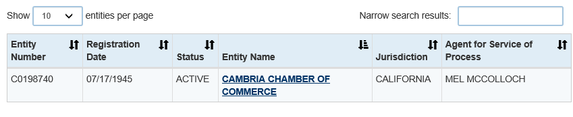

- or

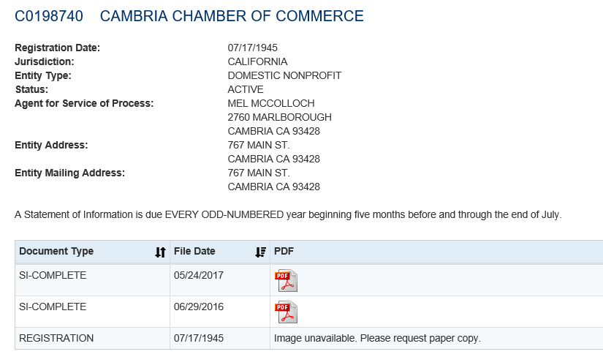

DEPARTMENT OF JUSTICE/OFFICE OF ATTORNEY GENERAL EXAMPLE

Search Screen:

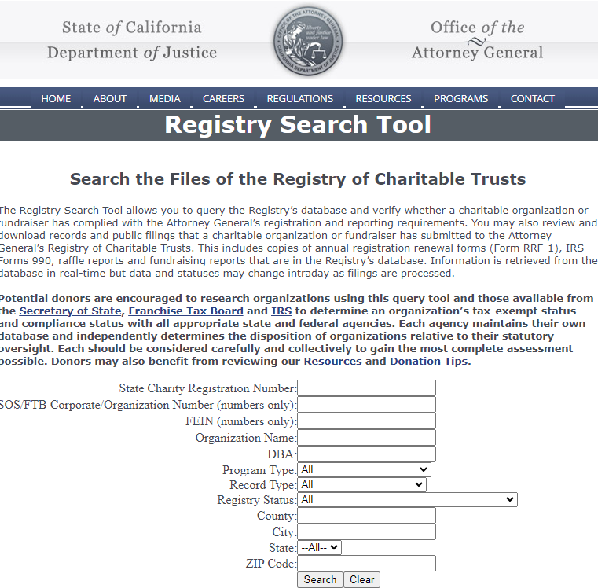

- Provide a copy of either page

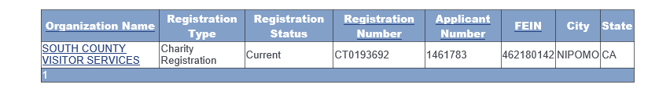

- or

