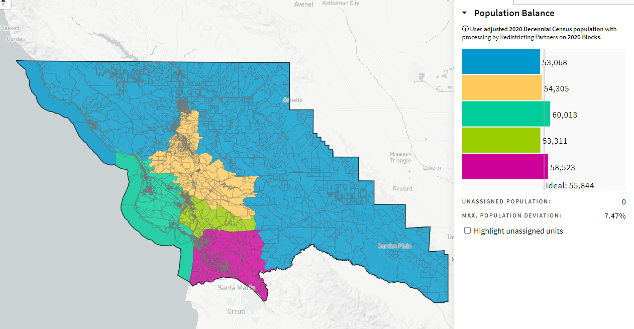
Akalvans_ID-71480_10-27-21

