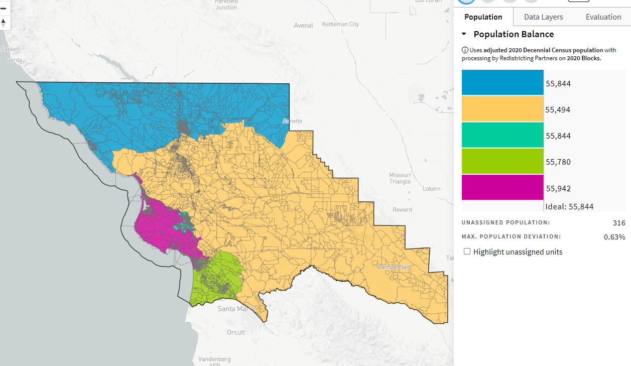
All Related Municipalities on Own District Rural Balance_ID-73162_10-31-21

