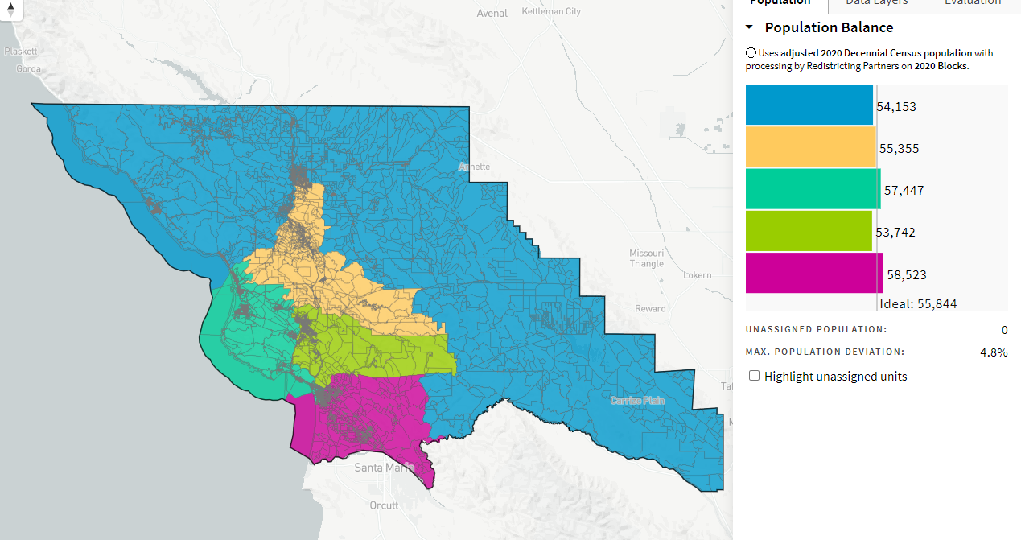
ARkalvans_ID-71672_10-28-21

