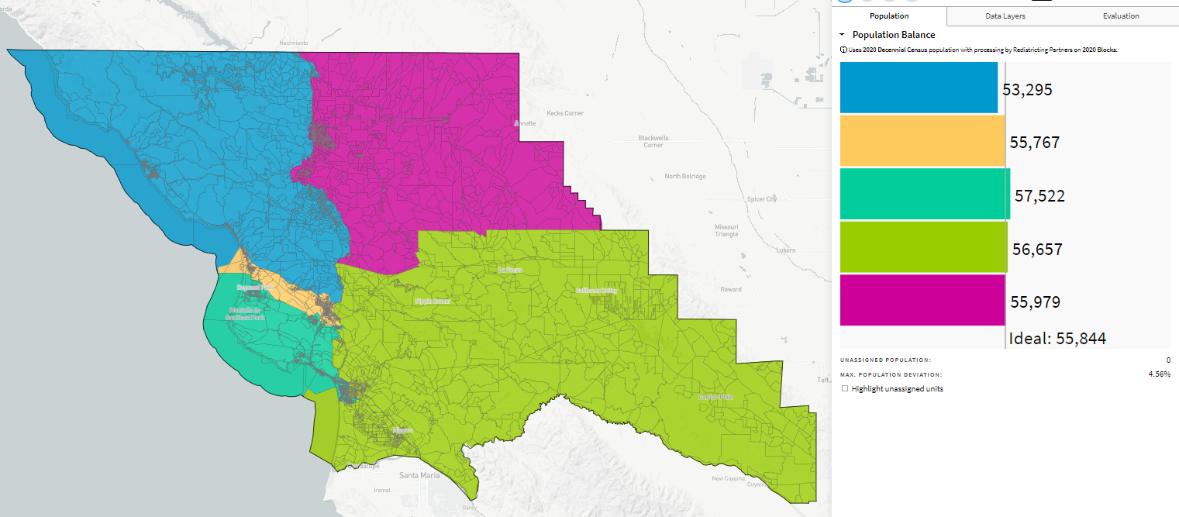
Attempt at Richard’s Map Details, 70186
10/26/21

