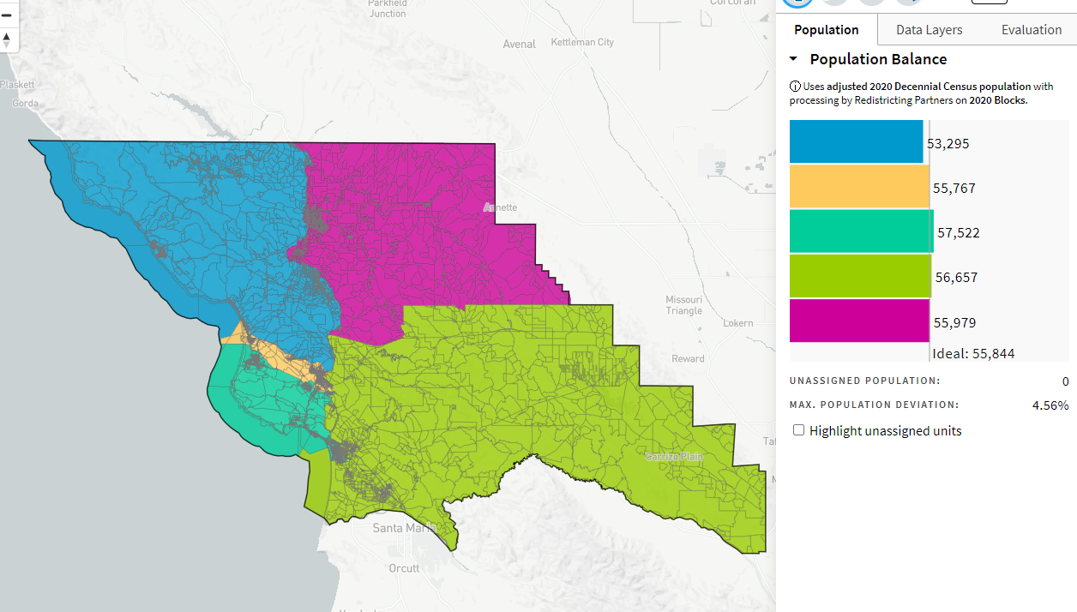
Attempt at Richard’s Map Details_ID-70186_10-26-21

