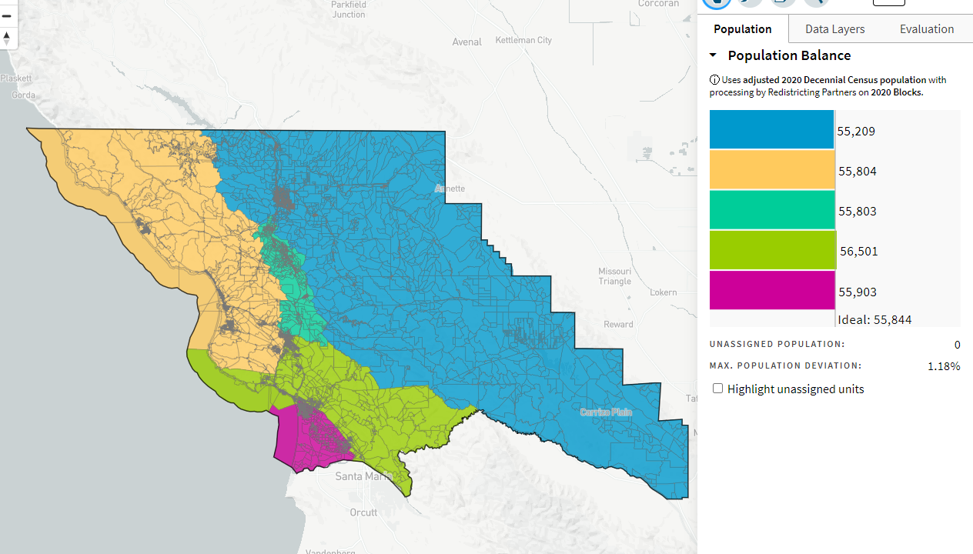
BlatantRepublicanPowerGrab_ID-73650_11-1-21

