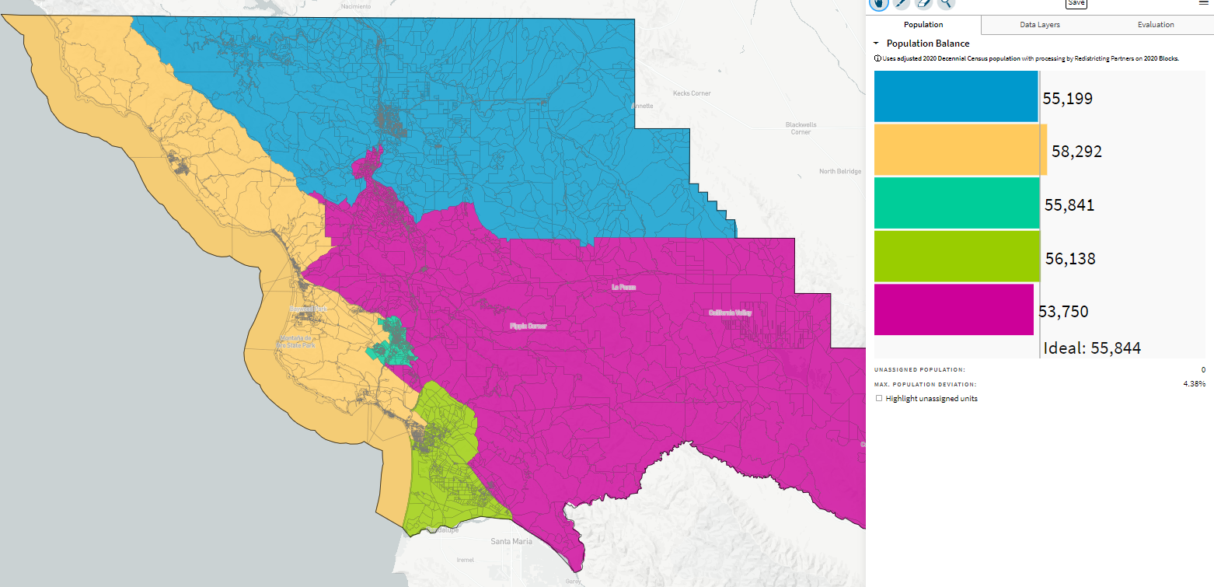
Coastal & SLO Districts (Now Balanced)_ID-70648- 10-26-21

