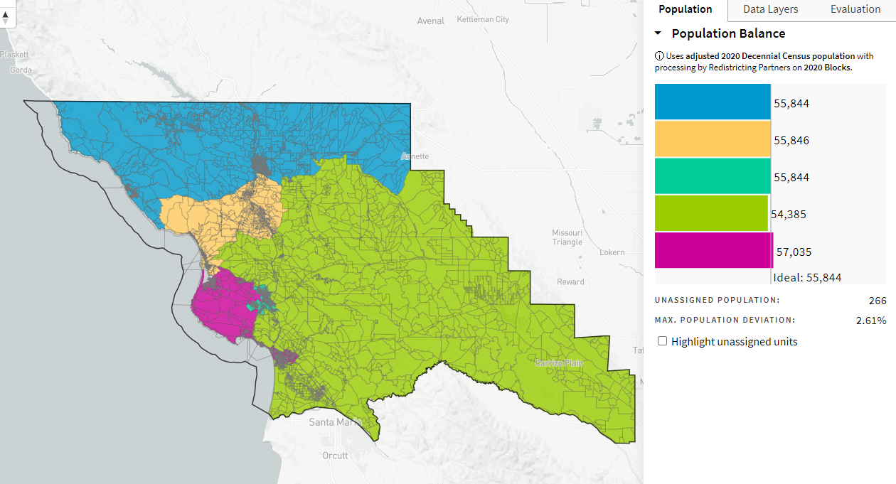
Each Related Municipality in One District_ID-73151_10-31-21

