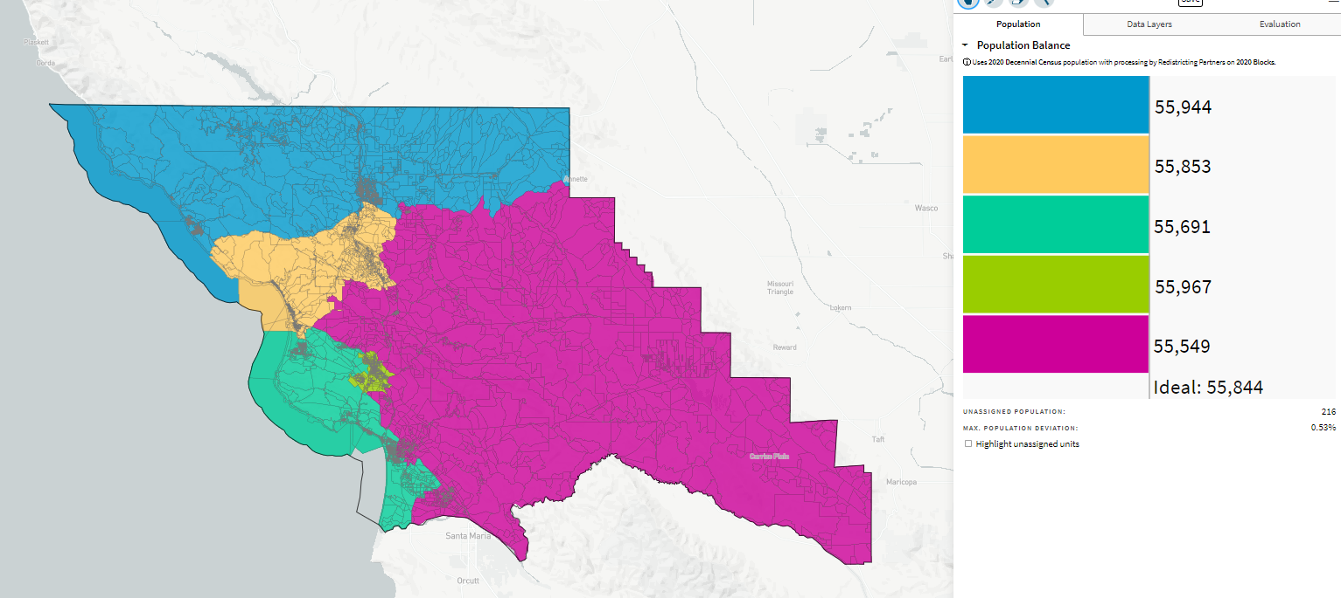
Equal Communities of Interest Districts, 69437
10/24/21 5:55 pm

