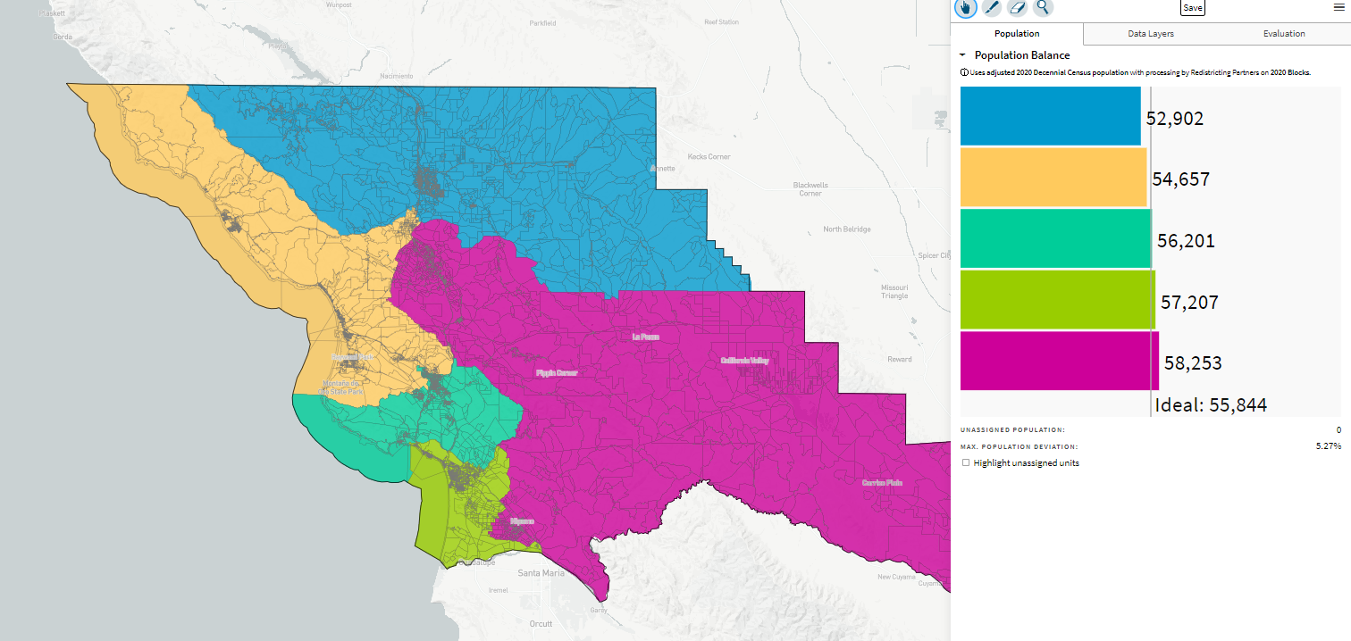
Five Cities District (Now Balanced)_ID-70657 10-26-21

