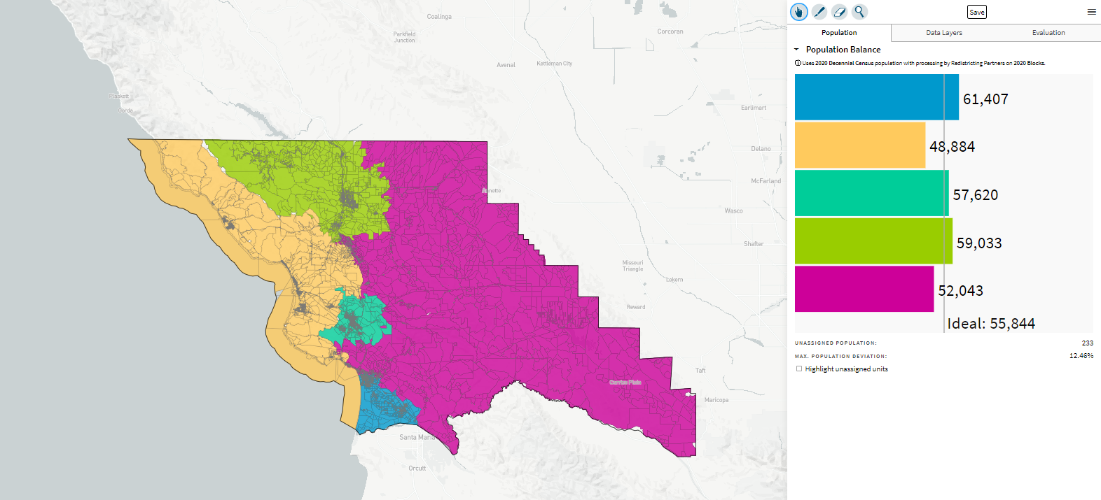
Kristin Tara Horowitz, 10/26/21, “Horowitz Map”
Email:
Yellow/coastal - I live in Los Osos and as a resident, I feel that the concerns and interests absolutely align along the coast - our intrusion/water issues, our tourism concerns, economies, and largely unincorporated and unimproved areas feel quite uniform. It also makes sense to me that one person represents the waters as a matter of interest, but I could see the south county region I drew taking that area in order to diversify representation. The mountains (along 41 and 46) have always been coastal to me in that people tend to flow down to the coast to get things done and head east for what is not available otherwise. Plus, those corridors provide a bit more tourist traffic than some might allow for, making it more of the tourism/coastal concerns.
Blue/Five Cities - Absolutely its own little region, a little bit more sprawl to its character while also a little more urban in a way altogether different from the city of SLO. There's some farm and ag, but its issues reflect more urban that truly rural if that makes sense - services can respond quickly, the culture remains similar in that area, though each town has distinct flavor.
Turquoise - city of SLO, pretty self explanatory. Its got it's own little "city" feel compared to all the rest of the area, and the most population. The natural borders are within the mountain ranges
Green - North County, but surrounding Paso - Paso is growing into a tourism center in its own right but is largely defined by its expansive land surrounding it as well. It makes sense that it covers this region but doesn't extend to the coast because the coastal communities simply don't align with the Paso/rural culture as much as they do with one another. I did not link Atascadero here because of Paso's stronger urban/commercial/tourism development and housing plans pushing it more urban over time.
Pink - East/Rural county - SLO county really is dominated less by its cities than by its rural spaces, even if many don't truly see it that way, which for me means that the less populated areas are represented by those who understand those needs - agriculture, less access to public defenders, and a much different culture than the more urban centers.

