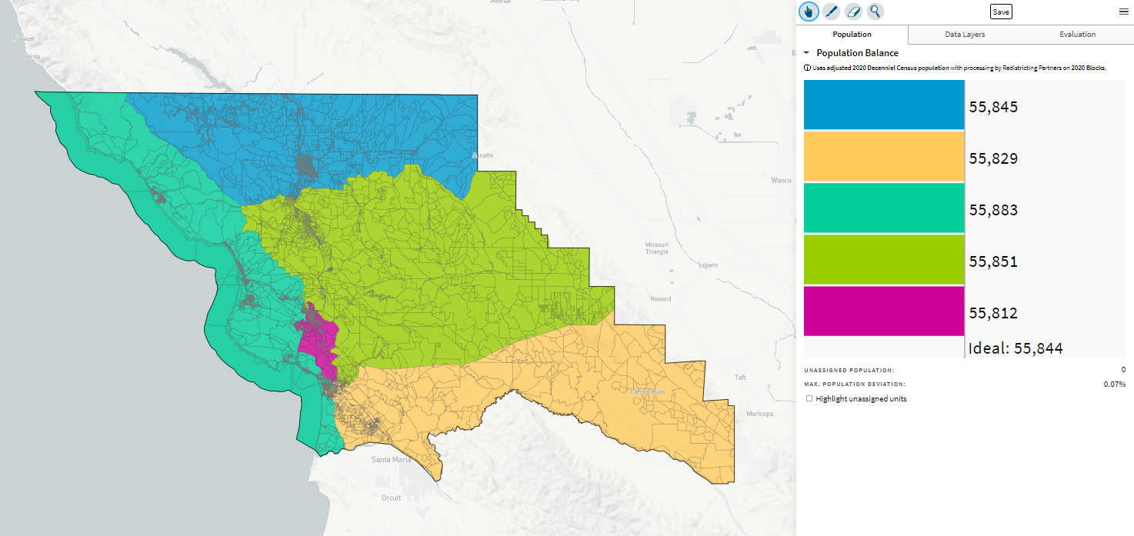
MikeB-V1_ID 72443 10-29-21

