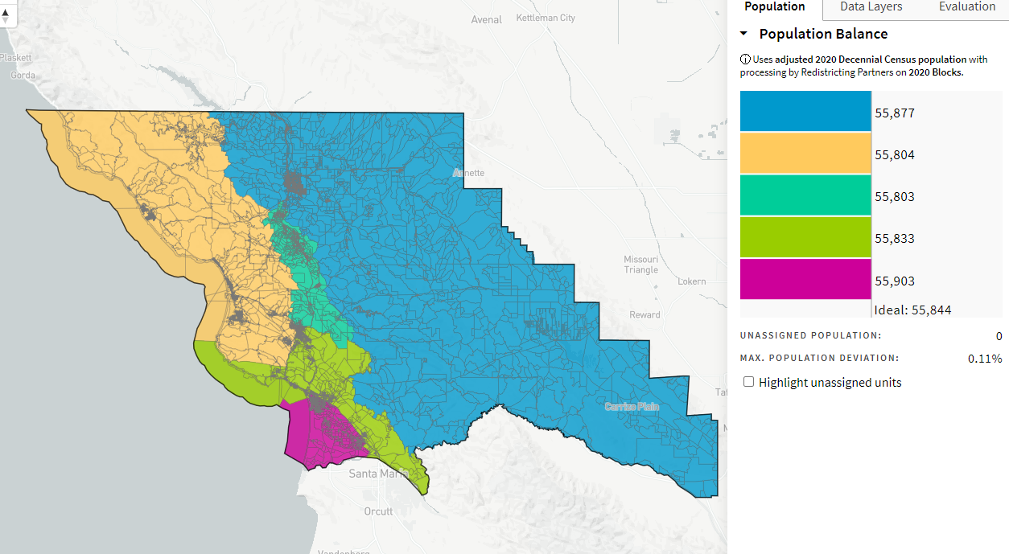
Redistricting Map by Marco_ID-72716_10-29-21

