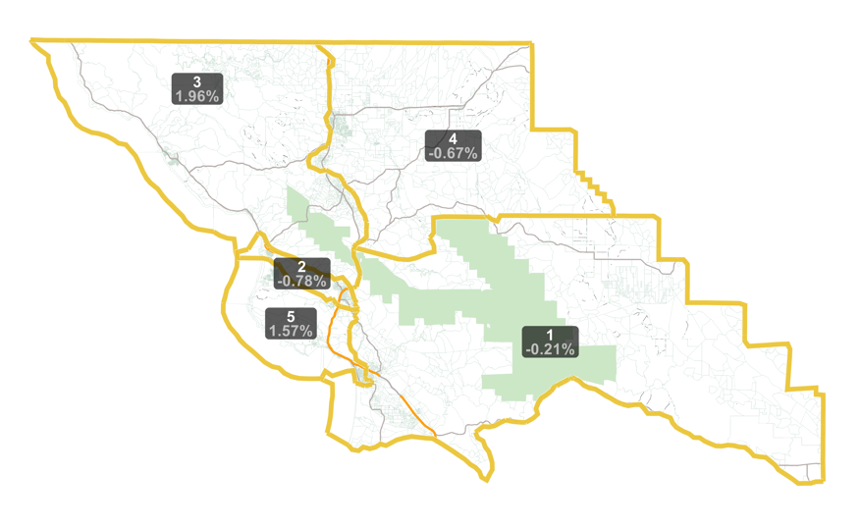
10/12/21
Richard Patten (via email)

