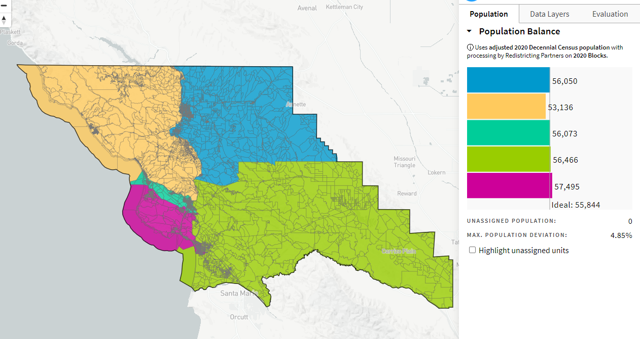
Richard Patten Rev_1_ID-70186_1-03-21

