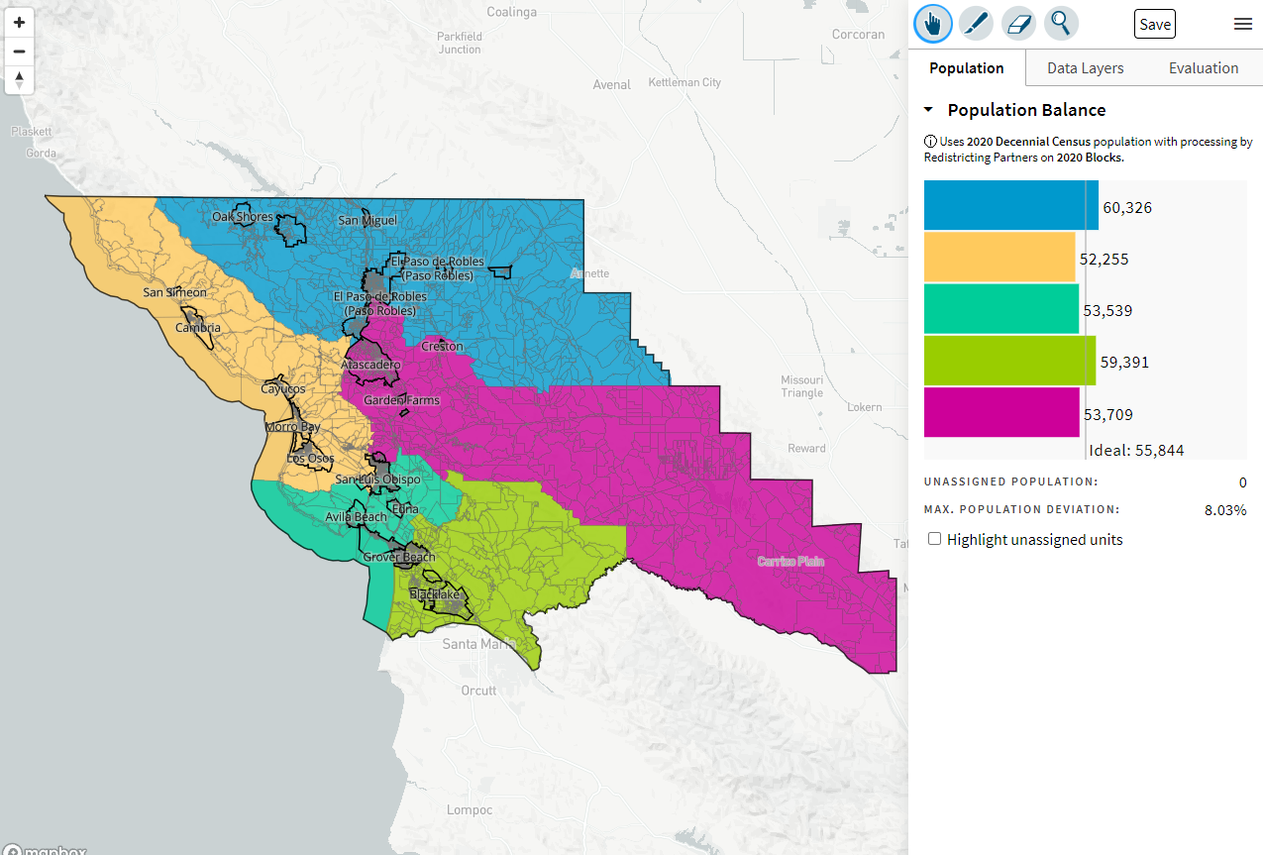
10/13/2021 – South County District, but SLO Divided (ID: 63335)

