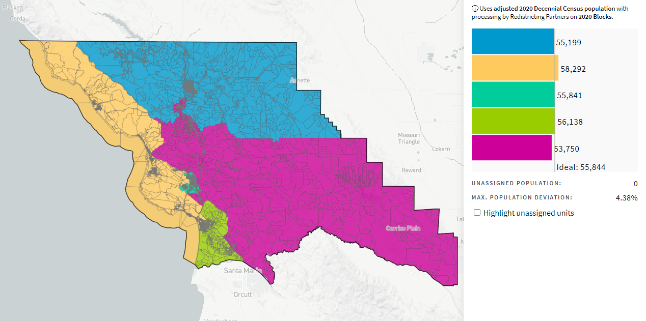

South County District (Now Balanced), 70662
10/26/2021

