I. INTRODUCTION

Purpose

The Community Based Organization/Preventive Health Grant (CBO/PHG) programs provide funding for local programs/projects that support and complement (not duplicate) the efforts of the County's health and human services departments in promoting the health and well-being of the community, encouraging behaviors and activities that focus on enabling County residents to reach and maintain optimal health, stability, and independence.

Source and Amount of Funding

The Community Based Organization Grant program receives its funding from the County General Fund. A total of $1,123,500 was distributed to community based non-profit organizations in FY 2020-21.

The Preventive Health Grant program receives its funding from a lawsuit settled by the tobacco industry in 1998. In FY 2020-21, $347,940 was awarded for preventive health grants.

The total amount of funds available for the FY 2021-22 CBO/PHG Grant Program has not been determined as of the release date of the Request for Application (RFA).

Timeline and Process: The RFA is being released on March 2, 2021. Completed electronic applications will be accepted until May 3, 2021 at 5 p.m. NOTE:
- Grant applications should be one complete PDF document.
- No paper copies of the grant application will be accepted.
- Incomplete electronic submittals will not be accepted.

The CBO/PHG Grant Committee will evaluate the applications shortly after receipt. The Board of Supervisors will adopt the budgets for both the Community Based Organizations and Preventative Health Grants in June 2021, and individual organization allocations will be adopted at the start of the fiscal year.

II. ELIGIBILITY

Both public and private nonprofit organizations are eligible to apply. Organizations must either have a non-profit designation at the time of grant application submission or be a public agency such as a school district, County agency or department. Programs/projects must be carried out in San Luis Obispo County and serve only San Luis Obispo County residents.

Applicants must offer their services to all residents of San Luis Obispo County, regardless of political or religious opinions or affiliations, age, sex, race, color, national origin, marital status, disability, sexual orientation.

III. REVIEW AND SELECTION CRITERIA

Local programs/projects must support and complement (not duplicate) the efforts of the County's health and human services departments in promoting the health and well-being of the community, encouraging behaviors and activities that focus on enabling County residents to reach and maintain optimal health stability and independence.

Programs/Projects will be reviewed and prioritized, among other things, on:
1. Local need.
2. Identified funding sources showing the ability to leverage the other funds.
3. Program/project goals, results, outputs/outcomes; if applicable, projected results from prior year.
5. Program cost compared with number of people served.
6. Geographic distribution of services.
7. Percentage of requested funding being used for direct services.
8. Program/project sustainability with funds granted.
9. Collaboration with other community-based agencies and County departments.
10. Organizational cultural competency.

Program/project funding shall not be used to supplant other revenue sources.

Please Note: sober living and recovery homes are not eligible to receive funding via this grant program. Funds for these types of programs are available through the Drug and Alcohol division of County Behavioral Health.

IV. REQUEST FOR APPLICATION REQUIRED COMPONENTS

Organizations that normally submit separate applications for various projects/programs carried out by their organization are encouraged to submit one application. The maximum number of pages for the program/project information (#1-#5 below) is FIVE pages. The submittal should also include a cover sheet, scope of work or work plan, budget, and budget narrative. Pages should be numbered consecutively.

The application should be submitted in the following order:

COVER SHEET

Application must have a COVER SHEET which clearly identifies:
1. Project Title
2. Organization/Agency Name
3. Executive Director and/or Program Contact Person
4. Current Mailing Address
5. Phone number
6. E-mail address
7. Amount of grant funding requested
8. If applicable, funds received in the prior year (or most recent fiscal year when funds were received)
9. A brief (50 words or less) description of proposed project

PROGRAM/PROJECT INFORMATION

The application must contain the following information:

1. Briefly describe your organization and its mission.
2. Summarize your program/project by providing a brief description.
3. How is the program or service beneficial to County residents?
- How does it complement and collaborate with existing efforts?
- Describe how the proposed program or service is different than health and human services programs provided by the County or other community-based organizations?
- How was the local need for this program/project determined?
- Is there a fee associated with service?
4. Describe your organizational capacity to successfully carry out the proposed activities (i.e., past performance and history of the organization will be considered to assess the agency's prospects for achieving its goals and objectives).
5. If the program is not fully funded, how will the program continue?

SCOPE OF WORK OR WORK PLAN

The following information should be provided in the format as shown below.

1. FY 2021-22 Scope of Work or Work Plan

Your scope of work or work plan should answer these questions:
- What is the program/project goals?
- How will those goals be achieved including time frame?
- What is your evaluation methodology for measuring results?

2. FY 2020-21 Program Results

All requests from agencies that received Preventive Health or Community Based Organization grant funds in FY 2020-21 must specify actual program results attained to date as well as projected results for the balance of the fiscal year. Results must be described in meaningful, measurable terms.

EXHIBIT A
SCOPE OF WORK/WORK PLAN FORMAT

Requested Grant Funds in Fiscal Year 2021-22

Program/Project Summary: _______________________________________________

Goal/Objective  (refer to 1.A above) | Major Tasks  (in order to achieve goal)  (refer to 1.B above) | Timeline | Evaluation methodology  (refer to 1.C above)
Program/Project OUTPUTS
Program/Project OUTCOMES

Grant Funds Received in Fiscal Year 2020-21 (if applicable)

Program/Project Summary: _______________________________________________

Goal/Objective  (refer to 1.A above) | Major Tasks  (in order to achieve goal)  (refer to 1.B above) | Timeline | Evaluation Mythology  (refer to 1.C above)
Program/Project OUTPUTS
Program/Project OUTCOMES

SCOPE OF WORK/WORK PLAN

Results:

A meaningful, measurable result will demonstrate the difference the proposed project makes, or is intended to make, in the lives of the people receiving the service.

OUTPUT results show the amount of work performed or services received - e.g., number of patients treated, number of meals served, number of childcare slots created, etc.

Output Measures: 500 people will participate in health screening clinics and receive referrals for follow-up when indicated.

75 people will be enrolled in Healthy Families MediCal program to improve utilization of health services.

XX number of meals will be served to seniors during the year.

OUTCOMES show the quality of performance and answer the question: who is better off by doing this project? Here are some examples:

Outcome Measures: At least XX% of smokers who participate in services will successfully quit using tobacco.

XX% of clients that receive substance abuse treatment services and are drug and alcohol free one year later.

XX% of program participants in the prevention program will demonstrate their commitment to an alcohol and drug-free lifestyle.

PROGRAM/PROJECT BUDGET

The following information should be provided in the format as shown below.

- A one (1) page budget narrative is required that:
- Describes each line item.
- Explains changes in funding requests.
- If these funds will be used for a community match required by other funding sources, please list the other funding source, and the amount of the match required.

- Provide a budget that includes the following information:
- Description of all funding sources for the proposed program/project, including funding received from County sources or those not secured.
- Identifies the part of the proposed program/project the requested funds will be used for

- If your organization is submitting one application for multi-programs/projects, please submit a separate budget for each program/project request.

- A current year organizational budget. If the applicant is a County department, please submit your current fiscal year line-item actuals.

PROGRAM BUDGET REQUEST FORM

 | Project  Expense | Grant Budget  Requested | Other Funding Available*  Amount & source
- PERSONNEL EXPENSES
(associated with the proposed project)

Subtotal – Personnel Expenses
- OPERATING EXPENSES
(associated with the proposed project)

Subtotal – Operating Expenses
- INDIRECT @_______ OF PERSONNEL

Total Grant Project Expenses
*List in this column all agency funds available to support the project. Indicate with a “@” next to the amount that are in-kind and a “NS” for those not yet secured.

GENERAL APPLICATION INFORMATION

- All applications should be clear, concise and complete. No additional information will be accepted past the May 3, 2021 deadline unless specifically requested by the County.

- All applications should be one complete PDF electronic submittal, including the information requested in #3 below. There should not be any separate attachments as part of the grant submittal. Postmarks and hand delivered applications will not be accepted.

- All applications should also include the following:
  - Organizational operating budget
  - Key program personnel (include a short description of their background)
  - Board of Directors of your organization and relevant advisory boards (please include member affiliations.)
  - Adopted organization policy or statement on inclusion, diversity, or affirmative action.
  - Tax-exempt status documentation, e.g., IRS determination letter.
  - A copy (each) of the current status of non-profit organization from Secretary of State and Attorney General Office. These documents can be accessed at the specific agency’s web site (Secretary of State: https://businesssearch.sos.ca.gov/and Attorney General’s Office:
http://rct.doj.ca.gov/Verification/Web/Search.aspx?facility=Y)

See Exhibit 2 for examples of these status reports. Please do not send your organization’s Statement of Information.

Grant applications from organizations that do not include this documentation or whose non-profit status is “inactive“ or “delinquent” will not be accepted. This requirement does not apply to grant applications from public agency such as a school district, County agency or department.

- Please DO NOT include electronic attachments such as letters of references, brochures or flyers. If necessary, this information will be requested later.

- All costs associated with the preparation and submission of this application will be borne by the applicant.

- All applications become the property of the County of San Luis Obispo and will become public information after the submission deadline.

- Applications should be SUBMITTED ELECTRONICALLY ONLY to the following address: nschmidt@co.slo.ca.us

Any questions regarding the RFA or process should be directed to Nikki Schmidt of the County Administrative Office at 805/788-2642.

Exhibit 2

SECRETARY OF STATE EXAMPLE
Please include your organization’s information in your electronic submittal.

Search Screen:
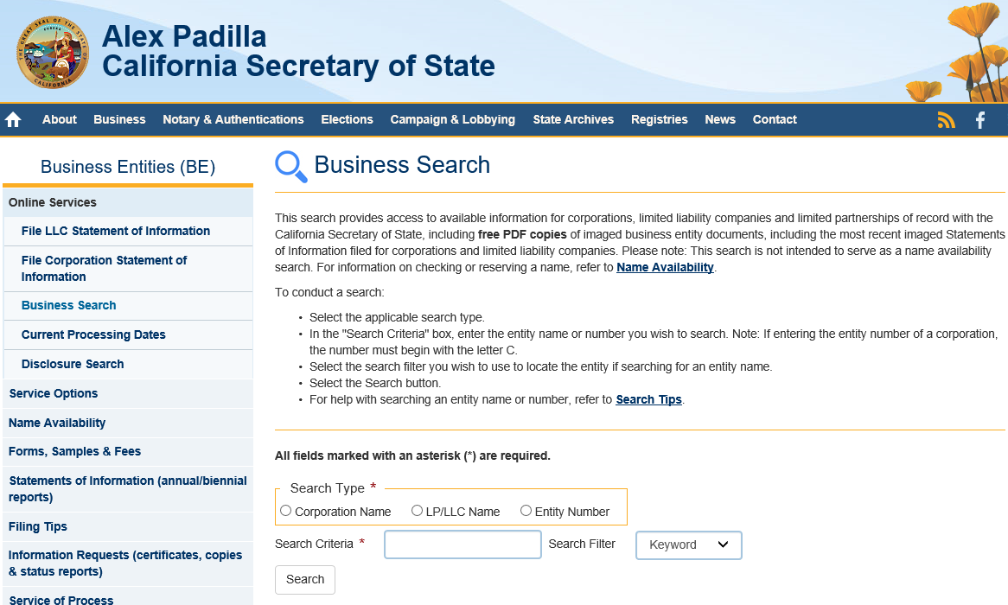

Provide a copy of either page.

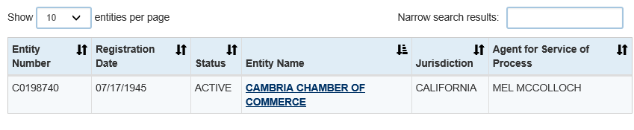

or

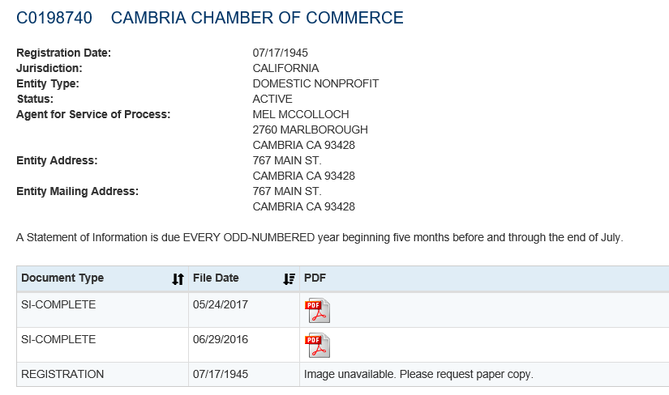

DEPARTMENT OF JUSTICE/OFFICE OF ATTORNEY GENERAL EXAMPLE

Search Screen:
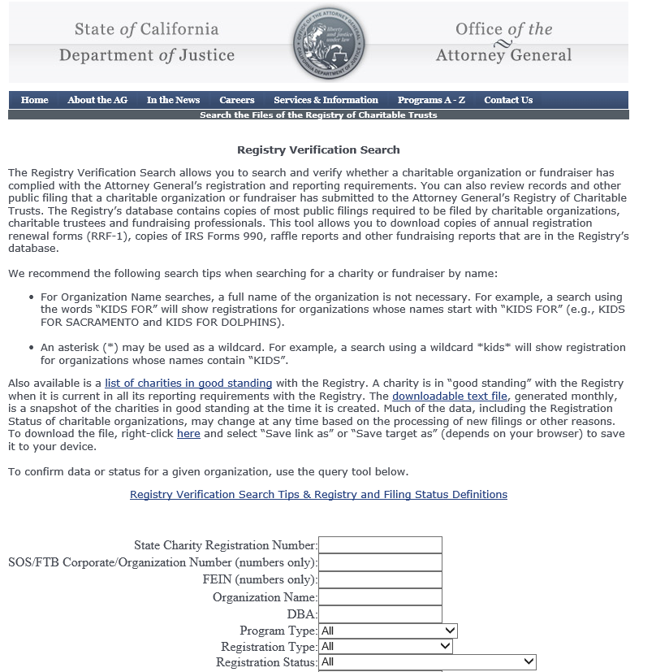

Provide a copy of either page.

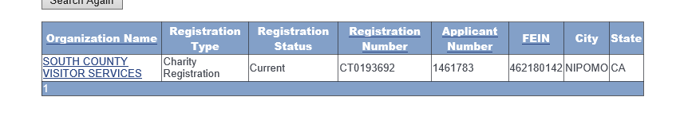
or

