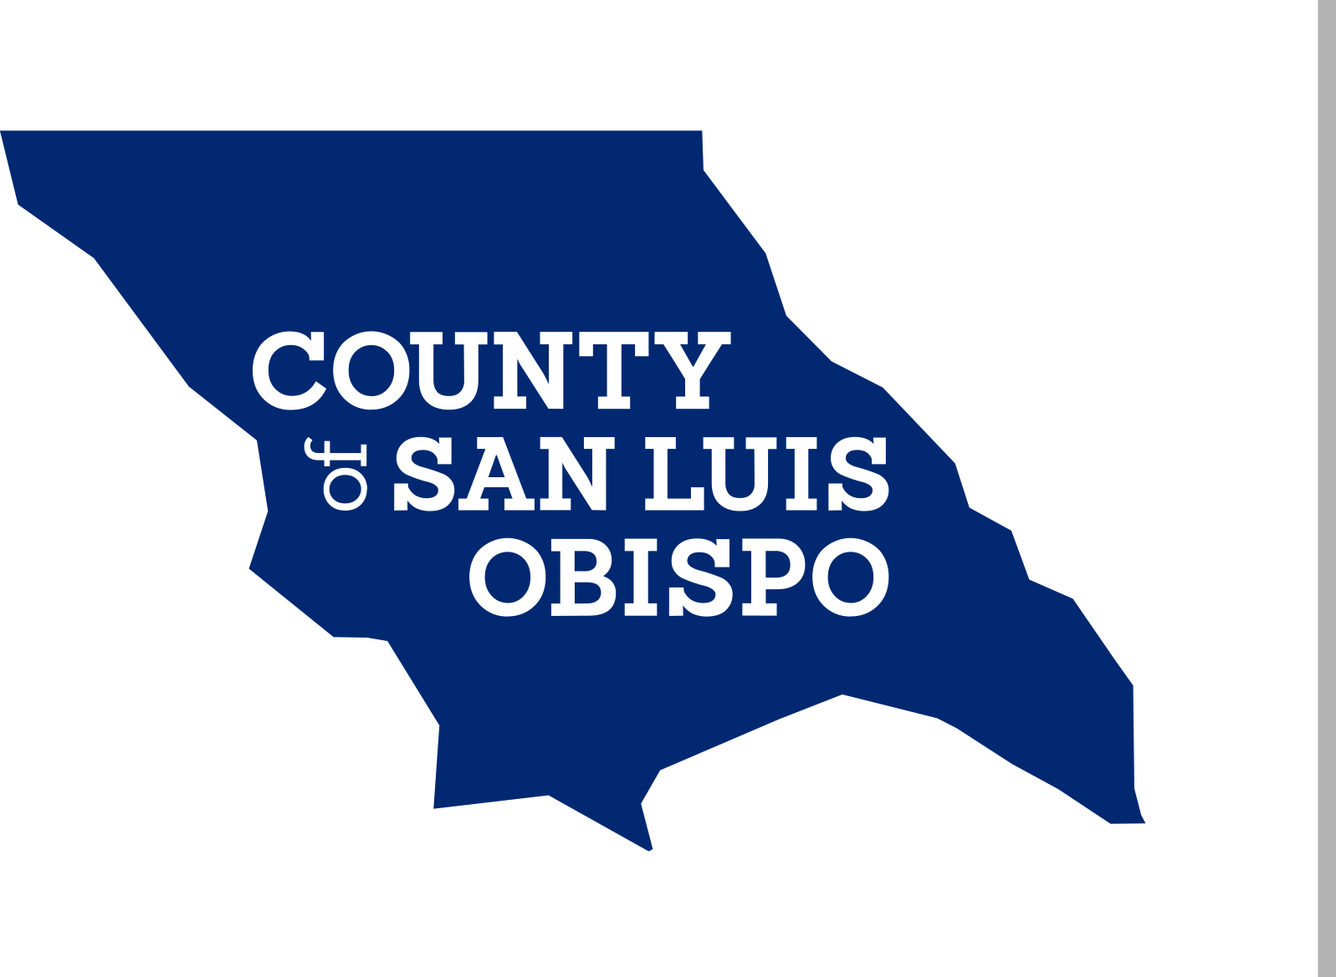

COUNTY OF SAN LUIS OBISPO
OFFICE OF THE PUBLIC GUARDIAN
Representative Payee Program
P.O. Box 1489
San Luis Obispo, CA 93406
(805) 781-5845 / fax: (805) 781-5566

MONEY REQUEST
(Please fill out form completely, sign and note: RECEIPTS REQUIRED)
(Specify dollar amount for each item)

DATE: _________________ REQUESTED BY: _______________________________

CLIENT NAME: ________________________________________________________

AMOUNT OF REQUEST: ________________________________________________

CHECK PAYABLE TO: __________________________________________________

REASON FOR THIS REQUEST: __________________________________________

_____________________________________________________________________

SEND CHECK TO: _________________________________________________________

ADDRESS: ___________________________________________________________

_____________________________________________________________________

COMMENT: ___________________________________________________________

_____________________________________________________________________

I understand I am required to supply receipts showing how the money was spent. I also understand if I fail to provide these receipts, my future requests may not be approved.

_________________________________ ________________________________
Client Signature Date

_________________________________ ________________________________
Case Manager Signature Date Phone Number

