[INSERT YEAR] STATEWIDE MEDICAL AND HEALTH EXERCISE
CONTROLLER/EVALUATOR
HANDBOOK

INFECTIOUS DISEASE SCENARIO
FUNCTIONAL EXERCISE


PREFACE
The [Insert year] California Statewide Medical and Health Exercise (SWMHE) is sponsored by the California Department of Public Health (CDPH) and the Emergency Medical Services Authority (EMSA).

This C/E Handbook follows guidelines set forth by the U.S. Federal Emergency Management Agency (FEMA) Homeland Security Exercise and Evaluation Program (HSEEP). This C/E Handbook enables C/Es to understand their roles and responsibilities in Functional Exercise (FE) execution and evaluation. Expert control and evaluation are the cornerstones of a successful FE. See Appendix J for a listing of agency/event acronyms. All exercise participants should use appropriate guidelines to ensure proper control of information within their areas of expertise and protect this material in accordance with current jurisdictional directives.

[CUSTOMIZING THE C/E HANDBOOK]
[Throughout this document, there are opportunities for customization by jurisdiction/organization/facility planners. This document serves as a template guidance document. This document, and particularly the objectives, schedule and locations should be modified to reflect the unique characteristics of your region and participants. Bracketed text (e.g., [your jurisdiction]) is provided to aid with location-specific customization. These should be removed or modified as appropriate prior to finalizing this document. Exercise planners can insert their customized language and then remove the highlight and brackets. After tailoring the document to your jurisdiction/organization/facility, be sure to update the Table of Contents by right clicking on them and selecting “update field”.]

TABLE OF CONTENTS
PREFACE 2
[CUSTOMIZING THE C/E HANDBOOK] 2
TABLE OF CONTENTS 3
EXERCISE OVERVIEW 5
GENERAL INFORMATION 7
EXERCISE OBJECTIVES & CAPABILITIES 7
PARTICIPANT ROLES & RESPONSIBILITIES 8
EXERCISE ASSUMPTIONS & ARTIFICIALITIES 9
Functional EXERCISE TOOLS 9
EXERCISE LOGISTICS 10
Safety 10
Site Access 10
PARKING & TRANSPORTATION 11
REGISTRATION/CHECK-IN 11
LUNCH 11
CLEANUP & RESTORATION 12
POST-EXERCISE & EVALUATION ACTIVITIES 13
DEBRIEFINGS 13
EVALUATION 13
IMPROVEMENT PLANNING 14
PARTICIPANT INFORMATION & GUIDANCE 15
EXERCISE RULES 15
PLAYER INSTRUCTIONS 15
SIMULATION GUIDELINES 16
CONTROLLER INFORMATION & GUIDANCE 17
EXERCISE CONTROL OVERVIEW 17
EXERCISE CONTROL DOCUMENTATION 17
EXERCISE CONTROL STRUCTURE 17
CONTROLLER INSTRUCTIONS 18
CONTROLLER RESPONSIBILITIES 20
EVALUATOR INFORMATION AND GUIDANCE 21
EXERCISE EVALUATION OVERVIEW 21
Evaluation Documentation 21
EVALUATOR INSTRUCTIONS 22

APPENDIX A: EXERCISE SCHEDULE 25
APPENDIX B: EXERCISE PARTICIPANTS 26
APPENDIX C: COMMUNICATIONS PLAN 27
PLAYER COMMUNICATIONS 27
CONTROLLER COMMUNICATIONS 27
COMMUNICATIONS CHECK 27
PLAYER BRIEFING 27
PUBLIC AFFAIRS 27
COMMUNICATIONS DIRECTORY 28
APPENDIX D: EXERCISE SITE MAPS 29
APPENDIX E: EXERCISE SCENARIO 30
MAJOR EVENTS 30
APPENDIX F: CONTROLLER & EVALUATOR ASSIGNMENTS 31
APPENDIX G: COMMUNICATION & INFORMATION MANAGEMENT 32
APPENDIX H: FORMS 39
APPENDIX I: SAFETY CHECKLIST 40
Site Control/scene safety 40
Participant Safety 40
APPENDIX J: ACRONYMS 41

EXERCISE OVERVIEW
Exercise Name | [Insert year] California Statewide Medical and Health Exercise (SWMHE) – Functional Exercise (FE)
Exercise Date | [Insert Jurisdiction/Organization/Facility’s Exercise Date]
Scope | This is an FE planned for [Jurisdiction/Organization/Facility] to take place at [insert FE date and time] at [insert FE location]. The [Insert year] SWMHE Program is a progressive exercise program comprised of a series of training exercises tied to a set of common program priorities. This year’s exercise is a multiphase program culminating in the FE on [insert date of play]. An After Action Meeting (AAM) will be conducted within 60 days of the FE.
Mission Area(s) | [Insert mission area(s)]
Capabilities | [Based on the capabilities selected for your exercise, whether you are using Public Health Emergency Preparedness (PHEP), Health Care Preparedness and Response Capabilities, or National Core Capabilities (or a combination), please list them here. These should be selected based on your objectives and requirements for the exercise.]
Objectives | [For sample objectives, please refer to the Objectives template documents for Ambulance, Behavioral Health, Community Clinics, Coroner/Medical Examiner, Emergency Medical Services (EMS) Agencies, Fire, Hospital, Law Enforcement, Long Term Care Facilities, Offices of Emergency Management, and Public Health.]  - [Insert the objectives selected by the Jurisdiction/Organization/Facility.]
Scenario | [Insert scenario]
Sponsor | The [Insert year] SWMHE is sponsored the California Department of Public Health (CDPH) and Emergency Medical Services Authority (EMSA) in collaboration with response partners representing local health departments, public safety, and healthcare facilities across California.
Participating Organizations | [Insert participating organizations here and in the appendices]

GENERAL INFORMATION

EXERCISE OBJECTIVES & CAPABILITIES
Exercise objectives in Table 1 describe expected outcomes for the functional exercise (FE). The objectives are linked to [Public Health Emergency Program (PHEP) / Health Care Preparedness and Response / National Core] capabilities, which are elements necessary to achieve specific mission area(s). Objectives and aligned capabilities are guided and selected by the Exercise Planning Team.

[Please insert the objectives that are most relevant and applicable to your agency/organization in Table 1. According to the Federal Emergency Management Agency’s (FEMA) Emergency Management Institute and general Homeland Security Exercise and Evaluation Program (HSEEP) guidelines, ten or fewer objectives are recommended for an exercise.]

The objectives listed below are those tailored for this FE. A set of example objectives customized for different participating agencies and organizations (Ambulance, Behavioral Health, Community Clinics, Coroner/Medical Examiner, Emergency Medical Services [EMS] Agencies, Fire, Hospital, Law Enforcement, Long Term Care Facilities, Offices of Emergency Management, and Public Health) is available on the Statewide Medical and Health Exercise website.

Table 1: Exercise Objectives and Associated Capabilities
EXERCISE OBJECTIVE | CAPABILITY
[Insert Jurisdiction/Organization/Facility’s selected objectives] | [Insert Jurisdiction/Organization/Facility’s selected capabilities]
[Insert Jurisdiction/Organization/Facility’s selected objectives] | [Insert Jurisdiction/Organization/Facility’s selected capabilities]
[Insert Jurisdiction/Organization/Facility’s selected objectives] | [Insert Jurisdiction/Organization/Facility’s selected capabilities]
[Insert Jurisdiction/Organization/Facility’s selected objectives] | [Insert Jurisdiction/Organization/Facility’s selected capabilities]
[Insert Jurisdiction/Organization/Facility’s selected objectives] | [Insert Jurisdiction/Organization/Facility’s selected capabilities]
[Insert Jurisdiction/Organization/Facility’s selected objectives] | [Insert Jurisdiction/Organization/Facility’s selected capabilities]
[Insert Jurisdiction/Organization/Facility’s selected objectives] | [Insert Jurisdiction/Organization/Facility’s selected capabilities]
[Insert Jurisdiction/Organization/Facility’s selected objectives] | [Insert Jurisdiction/Organization/Facility’s selected capabilities]
[Insert Jurisdiction/Organization/Facility’s selected objectives] | [Insert Jurisdiction/Organization/Facility’s selected capabilities]

PARTICIPANT ROLES & RESPONSIBILITIES
The term participant encompasses many groups of people, not just those playing in the FE. Groups of participants and their respective roles and responsibilities, are as follows:
- Players. Players are personnel who have an active role in discussing or performing their response roles and actions during the exercise. Players discuss or initiate their actions in response to the simulated emergency.
- Exercise Director. The Exercise Director oversees all exercise functions during exercise conduct, oversees and remains in contact with controllers and evaluators, debriefs controllers and evaluators following the exercise and oversees setup and cleanup of the exercise as well as positioning of controllers and evaluators.
- Safety Controller. The Safety Controller monitors exercise activities and advises the Exercise Director on all matters relating to incident health and safety of all exercise participants. The Safety Controller has emergency authority to stop and/or prevent unsafe acts during incident operations.
- Controllers. Controllers plan and manage FE play, set up and operate the FE site, and act in the roles of organizations or individuals that are not playing in the FE. Controllers direct the pace of the FE, provide key data to players, and may prompt or initiate certain player actions to ensure FE continuity. In addition, they issue FE material to players as required, monitor the FE timeline, and supervise the safety of all FE participants.
- Simulators. Simulators are control staff personnel who role-play nonparticipating organizations or individuals. They most often operate out of the Simulation Cell (SimCell), but they may occasionally have face-to-face contact with players. Simulators function semi-independently under the supervision of SimCell controllers, enacting roles (e.g., media reporters or next of kin) in accordance with instructions provided in the Master Scenario Events List (MSEL). All simulators are ultimately accountable to the Exercise Director and Senior Controller.
- Evaluators. Evaluators evaluate and provide feedback on a designated functional area of the FE. Evaluators observe and document performance against established capability targets and critical tasks, in accordance with the Exercise Evaluation Guides (EEG).
- Actors. Actors simulate specific roles during FE play, typically as victims or other bystanders. [Delete bullet if not applicable]
- Observers. Observers visit or view selected segments of the FE. Observers do not play in the FE, nor do they perform any control or evaluation functions. Observers view the FE from a designated observation area and must remain within the observation area during the FE. Very Important Persons (VIPs) are also observers, but are frequently grouped separately.
- Media Personnel. Some media personnel may be present as observers, pending approval by the sponsor organization and the Exercise Planning Team. [Delete bullet if not applicable]
- Support Staff. FE support staff includes individuals who perform administrative and logistical support tasks during the FE (e.g., registration, catering).

EXERCISE ASSUMPTIONS & ARTIFICIALITIES
In any exercise, assumptions and artificialities may be necessary to complete play in the time allotted and/or account for logistical limitations. FE participants should accept that assumptions and artificialities are inherent in any exercise, and should not allow these considerations to negatively impact their participation.
Assumptions constitute the implied factual foundation for the FE and, as such, are assumed to be present before the FE starts. The following assumptions and/or artificialities apply to the FE:
- [The FE is conducted in a no-fault learning environment wherein capabilities, plans, systems, and processes will be evaluated.]
- [The FE scenario is plausible, and events occur as they are presented.]
- [FE simulation contains sufficient detail to allow players to react to information and situations as they are presented as if the simulated incident were real.]
- [Participating agencies may need to balance FE play with real-world emergencies.
Real-world emergencies take priority.]
- [Decisions are not precedent setting and may not reflect your organization’s final position.]
- [Time lapses may be inserted to achieve the FE objectives.]
- [Impacts are seen across the spectrum of the response community.]
- [Participants should use existing plans, policies, and procedures. If during the course of the FE there is disagreement with existing plans, policies, and procedures, this should be noted, and relevant stakeholders should assess the need to change documents after the FE.]
- [There are no “hidden agendas” or trick questions.]
- [All players receive information at the same time.]
- [If a player would normally contact an individual or department that is not represented at the FE, they should tell the SimCell what information they need and who they would contact. This action should be noted.]
- [Include any additional assumptions / artificialities to be used in the FE.]

Functional EXERCISE TOOLS
[In addition to this document, several tools have been developed by the California Department of Public Health (CDPH) to aid healthcare entities and their partners in the development of their exercise. Other tools available at the Statewide Medical and Health Exercise website include:]

- [Scenario Summary]
- [Exercise Evaluation Guide (EEG)]
- [After Action Report (AAR) Template]
- [Actor Cards Template]
- [Objectives]
- [Master Scenario Events List (MSEL)]
- [Player Handout]
- [Additional Resources]

EXERCISE LOGISTICS
[Each agency should fill in logistics information specific to their Functional Exercise (FE).]

Safety
FE participant safety takes priority over FE events. The following general requirements apply to the FE:
- A Safety Controller is responsible for participant safety; any safety concerns must be immediately reported to the Safety Controller. The Safety Controller and Exercise Director will determine if a real-world emergency warrants a pause in FE play and when FE play can be resumed.
- For an emergency that requires assistance, use the phrase [“THIS IS NOT A DRILL.”] The following procedures should be used in case of a real-world emergency during the FE:
  - Anyone who observes a participant who is seriously ill or injured will immediately notify emergency services and the closest controller, and, within reason and training, render aid.
  - A controller aware of a real-world emergency will initiate the [“THIS IS NOT A DRILL”] broadcast and provide the Safety Controller, Senior Controller, and Exercise Director with the location of the emergency and resources needed, if any. The Senior Controller will notify the [Control Cell or Simulation Cell (SimCell)] as soon as possible.

Fire Safety [delete section if not applicable]
Standard fire and safety regulations relevant to the [jurisdiction, venue, or organization] will be followed during the FE. [Insert any organization or venue-specific guidelines/protocols.]

Emergency Medical Services [delete section if not applicable]
The sponsor organization will coordinate with local Emergency Medical Services (EMS) in the event of a real-world emergency. [Insert any organization or venue-specific guidelines/protocols.]

Electrical and Generating Device Hazards [delete section if not applicable]
All applicable electrical and generating device safety requirements should be documented prior to the start of the FE. [Insert any organization or venue-specific guidelines/protocols.]

Weapons Policy [delete section if not applicable]
All participants will follow the relevant weapons policy for the exercising organization or FE venue.

Site Access

Security
If entry control is required for FE venue(s), the sponsor organization is responsible for arranging appropriate security measures. Access to FE sites and the [Control Cell and/or SimCell] is limited to FE participants to prevent interruption of the exercise. Players should advise their venue’s controller or evaluator of the presence of any unauthorized persons.

Media/Observer Coordination [delete section if not applicable]
Organizations with media personnel and/or observers attending the event should coordinate with the sponsor organization for access to the FE site. Media/Observers are escorted to designated areas and accompanied by an FE controller at all times. Sponsor organization representatives and/or the observer controller may be present to explain FE conduct and answer questions. Exercise participants should be advised of media and/or observer presence.

Exercise Identification [delete section if not applicable]
Exercise staff may be identified by badges, hats, and/or vests that clearly display exercise roles; additionally, uniform clothing may be worn to show agency affiliation. Table 2 describes these identification items.

Table 2: Exercise Identification
GROUP | COLOR
[Exercise Director]
[Controllers]
[Evaluators]
[Actors]
[Support Staff]
[Observers/VIPs]
[Media Personnel]
[Players, Uniformed]
[Players, Civilian Clothes]

PARKING & TRANSPORTATION
Parking will be available at the FE sites. Public transportation options are also available.
[Add parking information]

REGISTRATION/CHECK-IN
All participants should check in prior to the FE and receive instructions on facility characteristics.
[Add registration time and location]

LUNCH
Food and refreshments will be provided for all FE participants. [Add lunch time and location information. Delete if not applicable]

CLEANUP & RESTORATION
After the FE, controllers, evaluators, and players will begin cleanup operations to restore the area to pre-FE conditions. All participating organizations will assist in these efforts.

POST-EXERCISE & EVALUATION ACTIVITIES
For a full functional exercise (FE) schedule, including the time and location of all post-FE meetings, please see [Appendix A].

DEBRIEFINGS
Post-FE debriefings aim to collect sufficient relevant data to support effective evaluation and improvement planning.

Hot Wash
At the conclusion of FE play, controllers facilitate a Hot Wash to allow players to discuss strengths and areas for improvement, and evaluators to seek clarification regarding player actions and decision-making processes. All participants may attend; however, observers are not encouraged to attend the meeting. The Hot Wash should not exceed 30 minutes.

Controller & Evaluator Debriefing
Immediately following the FE, controllers and evaluators attend a facilitated Controller/Evaluator (C/E) debriefing where they provide an overview of their observed functional areas and discuss strengths and areas for improvement.

Participant Feedback Forms
Participant Feedback Forms provide players with the opportunity to comment candidly on FE activities and design. These forms should be collected at the conclusion of the Hot Wash.

EVALUATION

Exercise Evaluation Guides
Exercise Evaluation Guides (EEG) assist evaluators in collecting relevant FE observations. EEGs document FE objectives and aligned capabilities, capability targets and critical tasks. Each EEG provides evaluators with information on what they should expect to see demonstrated in their functional area. The EEGs, coupled with Participant Feedback Forms and Hot Wash notes, are used to evaluate the FE and compile the After Action Report (AAR).

After Action Report

The AAR summarizes key information related to evaluation. It primarily focuses on the analysis of capabilities, including capability performance, strengths, and areas for improvement. The AAR also includes basic exercise information, including the exercise name, type, dates, location, participating organizations, mission area(s), specific threat or hazard, a brief scenario description, and the name of the exercise sponsor and point of contact (POC).

IMPROVEMENT PLANNING
Improvement planning is the process by which observations recorded in the AAR are resolved through development of concrete corrective actions, which are prioritized and tracked as part of a continuous corrective action program.

After Action Meeting
The After Action Meeting (AAM) is held among decision- and policy-makers from the exercising organizations, the Lead Evaluator, and members of the Exercise Planning Team to debrief the FE and review/refine the draft AAR and Improvement Plan (IP). The AAM should be an interactive session, providing attendees the opportunity to discuss/validate the observations and corrective actions in the draft AAR/IP.

Improvement Plan
The IP identifies specific corrective actions, assigns them to responsible parties, and establishes target dates for their completion. It is created by elected and appointed officials from participating organizations, and discussed/validated during the AAM.

PARTICIPANT INFORMATION & GUIDANCE

EXERCISE RULES
The following general rules govern functional exercise (FE) play:
- Real-world emergency actions take priority over FE actions.
- FE players will comply with real-world emergency procedures, unless otherwise directed by control staff.
- All communications (including written, radio, telephone, and e-mail) during the FE will begin and end with the statement [“This is an exercise.”]
- FE players who place telephone calls or initiate radio communication with the Simulation Cell (SimCell) must identify the organization or individual with whom they wish to speak.
- [Insert your jurisdiction/organization/facility’s specific rules here.]

PLAYER INSTRUCTIONS
Players should follow certain guidelines before, during, and after to ensure a safe and effective FE.

Before the Exercise
- Review appropriate organizational plans, procedures, and FE support documents.
- Be at the appropriate site at least 30 minutes before the FE starts. Wear the appropriate uniform and/or identification item(s).
- Sign in when you arrive.
- If you gain knowledge of the scenario before the FE, notify a controller so that appropriate actions can be taken to ensure a valid evaluation.
- [Read your Player Handout, which includes information on FE safety.]
- [Insert your jurisdiction/organization/facility’s specific tasks here.]

During the Exercise
- Respond to FE events and information as if the emergency were real, unless otherwise directed by an FE controller.
- Controllers will only give you information they are specifically directed to disseminate. You are expected to obtain other necessary information through existing emergency information channels.
- Do not engage in personal conversations with controllers, evaluators, observers, or media personnel. If you are asked an exercise-related question, give a concise answer. If you are busy and cannot immediately respond, indicate that, but report back with an answer as soon as possible.
- If you do not understand the scope of the FE or are uncertain about an organization’s participation in an FE, ask a controller.
- Parts of the scenario may seem implausible. Recognize that the FE has objectives to satisfy and may require incorporation of unrealistic aspects. Every effort has been made to balance realism with safety and to create an effective learning and evaluation environment.
- All FE communications will begin and end with the statement [“This is an exercise.”] This precaution is taken so that anyone who overhears the conversation will not mistake FE play for a real-world emergency.
- When you communicate with the SimCell, identify the organization or individual with whom you wish to speak.
- Speak when you take an action. This procedure will ensure that evaluators are aware of critical actions as they occur.
- Maintain a log of your activities. Many times, this log may include documentation of activities that were missed by a controller or evaluator.
- [Insert your jurisdiction/organization/facility’s specific tasks here.]

After the Exercise
- Participate in the Hot Wash with controllers and evaluators.
- Complete the Participant Feedback Form, which allows you to comment candidly on emergency response activities and FE effectiveness. Provide the completed form to a controller or evaluator.
- Provide any notes/materials generated from the FE to your controller or evaluator for review and inclusion in the AAR.
- [Insert your jurisdiction/organization/facility’s specific tasks here.]

SIMULATION GUIDELINES
Because the FE is of limited duration and scope, certain details will be simulated. The physical description of what would fully occur at incident sites and surrounding areas will be relayed to players by simulators or controllers. A SimCell will simulate the roles and interactions of nonparticipating organizations or individuals. [Include any additional simulations to be used in the FE.]

CONTROLLER INFORMATION & GUIDANCE

EXERCISE CONTROL OVERVIEW
Exercise control maintains exercise scope, pace, and integrity while the Functional Exercise (FE) is being conducted. The control structure in a well-developed FE ensures that exercise play assesses objectives in a coordinated fashion at all levels and at all locations for the duration of the FE.

EXERCISE CONTROL DOCUMENTATION
Controller Package
The controller package consists of the Controller/Evaluator (C/E) Handbook, activity logs, badges, and other exercise tools (e.g., Master Scenario Events List) as necessary. Controllers must bring their packages and any additional professional materials specific to their assigned FE activities.

Incident Simulation
Because the FE is of limited duration and scope, certain details will be simulated. Venue controllers are responsible for providing players with the physical description of what would typically occur at the incident sites and surrounding areas. Simulation Cell (SimCell) controllers will simulate the roles and interactions of nonparticipating organizations or individuals.

Scenario Tools
The Master Scenario Events List (MSEL) outlines benchmarks and injects that drive exercise play. It also details realistic input to exercise players, as well as information expected to emanate from simulated organizations (i.e., nonparticipating organizations or individuals who usually would respond to the situation). The MSEL consists of the following two parts:
- Timeline. This is a list of key FE events, including scheduled injects and expected player actions. The timeline is used to track FE events relative to desired response activities.
- Injects. An individual FE inject is a detailed description of each FE event. Each inject includes the following pieces of information: [scenario time, intended recipient, responsible controller, inject type, a short description of the event and the expected player action.]

EXERCISE CONTROL STRUCTURE
Control of the FE is accomplished through an exercise control structure. The control structure is the framework that allows controllers to communicate and coordinate with other controllers at other FE venues, the SimCell, or a Control Cell to deliver and track FE information. The control structure for this FE is shown in Figure 1.
Figure 1: Sample Exercise Control Structure [Edit as needed or delete if not applicable.]

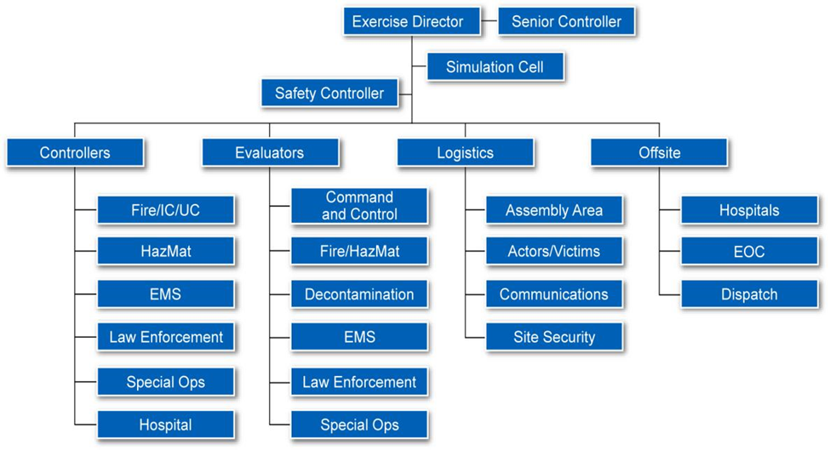

CONTROLLER INSTRUCTIONS

Before the Exercise
- Review appropriate emergency plans, procedures, and protocols.
- Review appropriate FE package materials, including the objectives, scenario, injects, safety and security plans and controller instructions.
- Attend required briefings.
- Report to the FE check-in location at the time designated in the FE schedule, meet with FE staff, and present the Player Briefing if assigned to do so.
- Be at the appropriate location at least 15 minutes before the FE starts.
- Obtain, locate and test necessary communications equipment.

During the Exercise
- Wear controller identification items (e.g., badge).
- Avoid personal conversations with FE players.
- If you have been given injects, deliver them to appropriate players at the time indicated in the MSEL (or as directed by the Exercise Director). Note: If the information depends on some action to be taken by the player, do not deliver the inject until the player has earned the information by successfully accomplishing the required action.
- When your inject is delivered, notify the [Senior Controller or Control Cell] and note both the time that particular inject was delivered and the player actions.
- Receive and record FE information from players that would be directed to nonparticipating organizations.
- Observe and record FE artificialities that interfere with FE realism. If an FE artificiality interferes with FE play, report it to the Exercise Director.
- Begin and end all FE communications with the statement, [“This is an exercise.”]
- Do not prompt players regarding what a specific response should be, unless that inject requires you to do so. Clarify information but do not provide coaching.
- Ensure that all observers and media personnel stay out of the FE activity area. If you need assistance, notify the Exercise Director.
- Do not give information to players about scenario event progress or other participants’ methods of problem resolution. Players are expected to obtain information through existing resources.

After the Exercise
- Distribute copies of Participant Feedback Forms and pertinent documentation.
- All controllers are expected to conduct a Hot Wash at their venue and, in coordination with the venue evaluator, take notes on findings identified by FE players. Do not discuss specific issues or problems with FE players before the Hot Wash.
- At exercise termination, summarize your notes from the exercise and Hot Wash and prepare for the Controller and Evaluator Debriefing. Have your summary ready for the Exercise Director.

CONTROLLER RESPONSIBILITIES
The following table details controller responsibilities. For controller assignment details, see [Appendix F].

Table 3: Controller Responsibilities
EXERCISE DIRECTOR
- Oversees all FE functions.
- Oversees and remains in contact with controllers and evaluators.
- Oversees setup and takedown of FE, and positioning of controllers and evaluators.
SENIOR CONTROLLER
- Monitors FE progress.
- Coordinates decisions regarding deviations or significant changes to the scenario.
- Monitors controller actions and ensures implementation of designed or modified actions at the appropriate time.
- Debriefs controllers and evaluators after the FE.
- Oversees setup and takedown of the FE.

SAFETY CONTROLLER
- Monitors FE safety during FE setup, conduct, and cleanup.
- Receives any reports of safety concerns from other controllers or participants.
PUBLIC INFORMATION OFFICER (PIO)
- Provides escort for observers.
- Provides narration and explanation during FE events, as needed.
- Performs pre-FE and post-FE public affairs duties.
- May act as media briefer and escort at the FE site.
- Serves as safety officer for his or her site.
VENUE CONTROLLER
- Issues FE materials to players.
- Monitors the FE timeline.
- Provides input to players (i.e., injects) as described in the MSEL.
- Serves as safety officer for his or her site.
SIMCELL CONTROLLER
- Role plays as nonparticipating organizations or individuals.
- Monitors the FE timeline.
- Provides input to players (i.e., injects) as described in the MSEL.

EVALUATOR INFORMATION AND GUIDANCE

EXERCISE EVALUATION OVERVIEW
Exercise evaluation assesses an organization’s capabilities to accomplish a mission, function, or objective. Evaluation provides an opportunity to assess performance of critical tasks to capability target levels. Evaluation is accomplished by the following means:
- Observing the event and collecting supporting data;
- Analyzing collected data to identify strengths and areas for improvement; and
- Reporting exercise outcomes in the After Action Report (AAR).

Evaluation Documentation

Evaluator Package
The evaluator package contains this Controller/ Evaluator (C/E) Handbook, Exercise Evaluation Guides (EEG), and other items as necessary. Evaluators should bring the package to the Functional Exercise (FE). They may reorganize the material so information that is critical to their specific assignment is readily accessible. Evaluators may bring additional technical materials specific to their assigned activities.

Exercise Evaluation Guides
EEGs provide a consistent tool to guide FE observation and data collection. EEGs are aligned to FE objectives and capabilities and list the relevant capability targets and critical tasks. Data collected in EEGs by each evaluator will be used to develop the analysis of capabilities in the AAR.

Each evaluator is provided with an EEG for each capability that he/she is assigned to evaluate. Evaluators should complete all assigned EEGs and submit them to the Lead Evaluator at the conclusion of the FE. The Lead Evaluator and Senior Controller compile all evaluator submissions into the first working draft of the AAR.

After Action Report / Improvement Plan
The main focus of the AAR is analysis of capabilities. The AAR includes a rating of how FE participants performed for each capability exercised, as well as strengths and areas for improvement.

Following completion of the draft AAR, elected and appointed officials confirm observations identified in the AAR and determine which areas for improvement require further action. As part of the improvement planning process, elected and appointed officials identify corrective actions to bring areas for improvement to resolution and determine the appropriate organization with responsibility for those actions. Corrective actions are consolidated in the Improvement Plan (IP), which is included as an appendix to the AAR.

EVALUATOR INSTRUCTIONS
General
- Avoid personal conversations with players.
- Do not give information to players about event progress or other participants’ methods of problem resolution. Players are expected to obtain information through their own resources.

Before the Exercise
- Review appropriate plans, procedures, and protocols.
- Attend required evaluator training and other briefings.
- Review appropriate FE materials, including the FE schedule and evaluator instructions.
- Review the EEGs and other supporting materials for your area of responsibility to ensure that you have a thorough understanding of the capabilities, capability targets, and critical tasks you are assigned to evaluate.
- Report to the FE check-in location at the time designated in the FE schedule and meet with FE staff.
- Obtain or locate necessary communications equipment and test it to ensure that you can communicate with other evaluators and the Exercise Director.

During the Exercise
- Wear evaluator identification items (e.g., badge, vest).
- Stay in proximity to players that have the authority to make decisions.
- Use EEGs to document performance relative to FE objectives, capabilities, capability targets, and critical tasks.
- Focus on critical tasks as specified in the EEGs.
- Your primary duty is to document performance of capabilities. After the FE, performance information will be used to determine whether the FE capability targets were effectively met and to identify strengths and areas for improvement.

After the Exercise
- Participate in the Hot Wash and take notes on findings identified by players.
- Do not discuss specific issues or problems with participants before the Hot Wash.
- After the Hot Wash, summarize your notes and prepare for the Controller and Evaluator Debriefing. Have your summary ready for the Lead Evaluator.
- Complete and submit all EEGs and other documentation to the Lead Evaluator at the end of the FE.

Using Exercise Evaluation Guides
Terminology
EEGs are structured to capture information specifically related to evaluation requirements developed by the Exercise Planning Team. The following evaluation requirements are documented in each EEG:
- [Capability. The distinct critical elements necessary to achieve a specific mission area (e.g., prevention). National Core, Public Health Emergency Preparedness (PHEP), or Health Care Preparedness and Response Capabilities should be referenced as appropriate to the requirements of your agency/organization.]
- [Tasks. The distinct elements required to perform a capability; they describe how the capabilities will be met. Tasks generally include activities, resources and responsibilities required to fulfill capabilities. Tasks are based on operational plans, policies and procedures to be reviewed during the exercise.]
- [Rating. A rating should be provided for each objective as well as the overarching capability. Rating definitions are provided on the following page.]
- [Observation Notes and Explanation of Rating. This is narrative of the evaluator’s analysis of an action. This response will help form the analysis section of the AAR.]
- [Recommendations. This provides the evaluator’s recommendation for resolving identified issues. This response will help form the recommendations section of the AAR.]

Documenting Observations
For each EEG, evaluators provide a rating, observation notes, an explanation of the rating, and a final capability rating. In order to efficiently complete these sections of the EEG, evaluators should focus their observations on the capabilities and tasks listed in the EEG.

Observation notes should include if and how quantitative or qualitative goals were met. For example, an objective might state, “Within four hours of the incident….” Notes on that objective should include the actual time required for exercise players to complete the tasks. Additionally, observations should include:
- How the task was or was not met;
- Pertinent decisions made and information gathered to make them;
- Requests made and how they were handled;
- Resources utilized;
- Plans, policies, procedures, or legislative authorities used or implemented; and
- Any other factors which contributed to the results.

Evaluators should also note if an obvious cause or underlying reason resulted in players not meeting
a capability or task.

Assigning Ratings
Based on their observations, evaluators assign a rating for each capability listed on the EEGs. Evaluators then consider all ratings for the capability and assign an overall capability rating. The rating scale includes four ratings:
- [Performed without Challenge (P)]
- [Performed with Some Challenges (S)]
- [Performed with Major Challenges (M)]
- [Unable to be Performed (U)]

Definitions for each of these ratings are included in the EEGs.

Placement and Monitoring
Evaluators should be positioned so they can observe player actions and hear conversations without interfering with those activities. In certain conditions, more than one evaluator may be needed in a particular area. See [Appendix F] for specific evaluator assignments. See [Appendix D] for FE site maps highlighting key locations.

APPENDIX A: EXERCISE SCHEDULE
[Note: Jurisdictions/Organizations/Facilities should fill in and adjust the following timeline, breaks, etc.]

TIME | PERSONNEL | ACTIVITY | LOCATION
[Date of Pre-Exercise Activities]
[Time] | Functional Exercise (FE) Controllers, Evaluators, & Staff | - Controller & Evaluator Orientation Briefing | [Location]
[Time] | FE Controllers & Staff | - Set up Control Cell and walk-through the exercise site(s) | [Location]
[Time] | All FE Players | - Player Briefing | [Location]
[Date of Functional Exercise]
[Time] | Controllers & FE Staff | - Check-in for final instructions and communications check | [Location]
[Time] | Media | - Media Briefing | [Location]
[Time] | Very Important Persons (VIP) & Selected FE Staff | - VIP Briefing | [Location]
[Time] | All Participants | - Safety/Player Briefing | [Location]
[Time] | All | - All participants in starting positions | [Location]
[Time] | All | - Functional Exercise Starts | [Location]
[Time] | All | - Functional Exercise Ends | [Location]
Immediately following the FE | All | - Venue Hot Washes  - Turn in all Participant Feedback Forms | [Location]
[Time] | Controllers & Evaluators | - Controller/Evaluator Debrief | [Location]
[Date of Post-Exercise Activities]
[Time] | Controllers, Evaluators, and Exercise Planning Team members | - After Action Meeting | [Location]

APPENDIX B: EXERCISE PARTICIPANTS
NAME | ORGANIZATION
Federal
State
[Jurisdiction A]
[Jurisdiction B]

APPENDIX C: COMMUNICATIONS PLAN
Jurisdictions, organizations, and facilities should use any pre-existing communications plans. For entities and organizations without an established communications plan, the plan below may be utilized.

All spoken and written communications will start and end with the statement [“THIS IS AN EXERCISE.”]

PLAYER COMMUNICATIONS
Functional Exercise (FE) communications do not interfere with real-world emergency communications. Players use routine organization communications systems. Additional communication assets may be made available as the FE progresses. Each venue or organization coordinates its internal communication networks and channels.

CONTROLLER COMMUNICATIONS
Face-to-face interaction is the principal method of information transfer for controllers during the FE. The controller communications network allows the Exercise Director or Senior Controller to make and announce universal changes in FE documentation, such as changes to the Master Scenario Events List (MSEL).

[Landline telephone] is the primary means of communication between the SimCell, Controllers, and Players. A list of key telephone numbers will be available before the FE starts.

COMMUNICATIONS CHECK
Before the FE, the Controllers will conduct a communications check with all interfacing communications nodes to ensure redundancy and uninterrupted flow of control information.

PLAYER BRIEFING
Controllers may be required to provide scenario details to participants to begin exercise play. Technical handouts or other materials also may be provided to orient players with the exercise.

PUBLIC AFFAIRS
The sponsor organization and participating organizations are responsible for coordinating and disseminating public information before the FE. Each venue should follow internal procedures.

COMMUNICATIONS DIRECTORY
PARTICIPATING AGENCY | NUMBER/CHANNEL
[Fire Department] | [(888) 888-8888]
[EMS Agency] | [(888) 888-8888]
[Police Department] | [(888) 888-8888]
[Public Health Department Operations Center (DOC)] | [(888) 888-8888]
[Hospital Command Center] | [FRS Channel 12]
[Health Officer] | [FRS Channel 2]

APPENDIX D: EXERCISE SITE MAPS
[Map Title]
[Insert map]
[Map Title]
[Insert map]

APPENDIX E: EXERCISE SCENARIO
[Scenario information to be added. If you are using the statewide exercise scenario, you may choose to insert your tailored version of the Scenario Summary document here. Otherwise, insert the scenario narrative chosen by your facility/agency/jurisdiction.]

MAJOR EVENTS

[Venue Name]
- [Insert a list of major exercise events at each venue, including both simulated scenario events and important expected player actions.]
- [Insert event description.]
- [Insert event description.]

[Venue Name]
- [Insert a list of major exercise events at each venue, including both simulated scenario events and important expected player actions.]
- [Insert event description.]
- [Insert event description.]

[Venue Name]
- [Insert a list of major exercise events at each venue, including both simulated scenario events and important expected player actions.]
- [Insert event description.]
- [Insert event description.]

APPENDIX F: CONTROLLER & EVALUATOR ASSIGNMENTS
[Note: This is a sample list of controller and evaluator assignments. The positions should be modified based on the type and scope of the exercise. For example, if the exercise will not include a Simulation Cell (SimCell), then a controller does not need to fulfill that function. Both controllers and evaluators may be assigned to a second area if play has been completed in the first.]
NAME | ROLE | POSITION
 | [Controller] | [Exercise Director]
 | [Controller] | [Senior Controller]
 | [Controller] | [Safety Controller]
 | [Evaluator] | [Lead Evaluator]
[Exercise Venue Name]
 | [Controller] | [Site Safety Officer]
 | [Controller] | [Function/Venue] Controller
 | [Controller] | [Function/Venue] Controller
 | [Evaluator] | [Function/Venue] Evaluator
 | [Evaluator] | [Function/Venue] Evaluator
[Exercise Venue Name]
 | [Controller] | [Site Safety Officer]
 | [Controller] | [Function/Venue] Controller
 | [Controller] | [Function/Venue] Controller
 | [Evaluator] | [Function/Venue] Evaluator
 | [Evaluator] | [Function/Venue] Evaluator
[SimCell]
 | [Controller] | [Lead SimCell Controller, Master Scenario Events List (MSEL) Manager]
 | [Controller] | [Function/Organization] Simulator

APPENDIX G: COMMUNICATION & INFORMATION MANAGEMENT
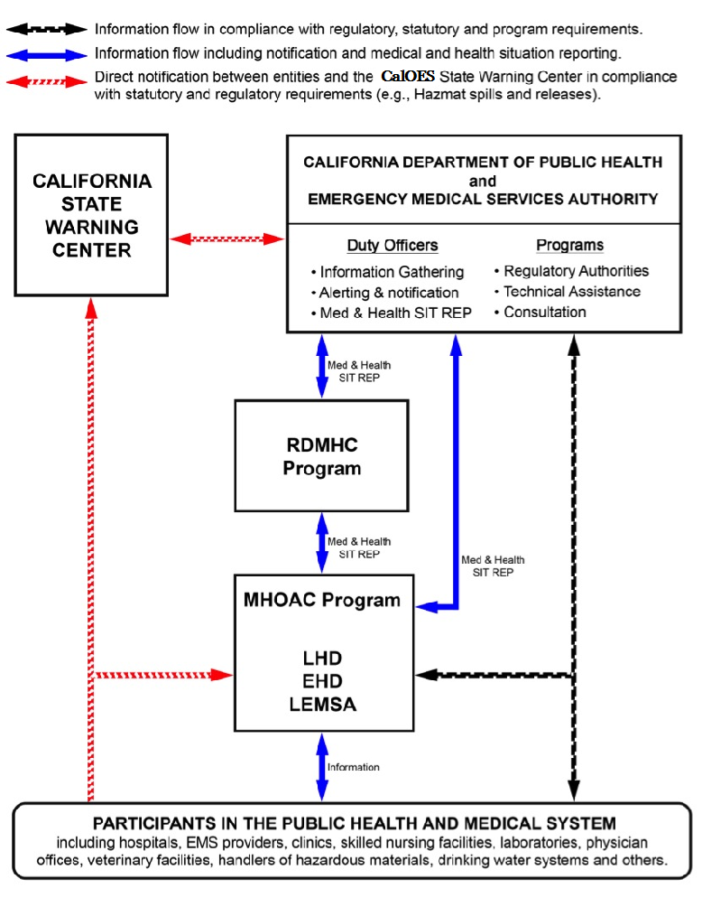
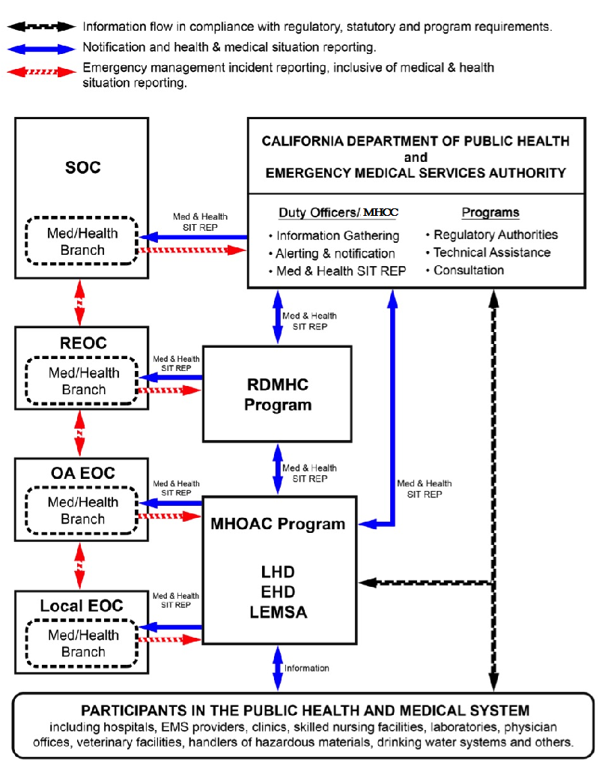

NOTIFICATION PROCESS FOR UNUSUAL EVENTS AND EMERGENCY SYSTEM ACTIVATION – FIELD TO STATE
SEMS Level | Entity | Initial Notification
Field | Field-Level Participants in the Public Health and Medical System:  Hospitals  EMS Providers  Community Clinics  Skilled Nursing Facilities  Public Water Systems  Public Health Laboratories | Notify local and State agencies in accordance with statutory and regulatory requirements and local policies and procedures.
Local Gov't | Public Health and Medical Agencies:  LHD EHD Local Emergency Medical Services Authority Local Emergency Medical Services Authority (LEMSA) | Notify local and State agencies in accordance with statutory and regulatory requirements and local policies and procedures.  Notify the Medical Health Operational Area Coordinator Program (MHOAC) Program.  Local Health Department (LHD) / Environmental Health Departments (EHDs): notify the CDPH Duty Officer Program (either directly or via the MHOAC Program) or Medical and Health Coordination Center (MHCC) if activated.
OA | MHOAC Program | Notify the Regional Disaster Medical Health Coordinator/Specialist (RDMHC/S) Program in affected region.  Notify the local emergency management agency in accordance with local policies and procedures.  Notify the CDPH and/or EMSA Duty Officer Programs (either directly or via the RDMHC/S Program).
Region | RDMHC/S Program | Notify the CDPH and/or EMSA Duty Officer Programs.  Notify the local emergency management agency in accordance with local policies and procedures.  Notify the MHOAC Program(s) in unaffected Operational Areas (OA) within the Mutual Aid Region to inform and provide advance warning if requests for assistance are anticipated.
SEMS LEVEL | ENTITY | INITIAL NOTIFICATION
State | CDPH and EMSA  Duty Officer Programs | Notify State agencies in accordance with policies and procedures.  Notify the RDMHC/S Programs in other Mutual Aid Regions if assistance is required or anticipated.
State | California Governor’s Office of Emergency Services (Cal OES)  State Warning Center | Notify State agencies, including Cal OES, in accordance with policies and procedures.

NOTIFICATION PROCESS FOR UNUSUAL EVENTS AND EMERGENCY SYSTEM ACTIVATION STATE TO FIELD
SEMS Level | Entity | Initial Notification
State | Cal OES  State Warning Center | Notify the CDPH and EMSA Duty Officer Programs.
State | CDPH and EMSA  Duty Officer Programs | Notify State agencies in accordance with policies and procedures.  Notify the RDMHC/S Program in accordance with policies and procedures: request acknowledgement of notification if a Medical and Health Situation Report is expected; escalate to the MHOAC Program if acknowledgement of notification is not received from the RDMHC/S Program within 15 minutes. Notify the RDMHC Program by email if no Medical and Health Situation Report is expected by CDPH and/or EMSA.  Notify LHD/EHDs in accordance with policies and procedures and field-level entities in accordance with statutory and regulatory requirements for specific functions.
Region | RDMHC Program | Notify the MHOAC Program immediately if the State has requested a Medical and Health Situation Report. Otherwise, notify the MHOAC Program in accordance with policies and procedures.  Notify emergency management agencies in accordance with policies and procedures, including the Cal OES Regional Duty Officer (or Regional Emergency Operations Center [REOC] if activated).
OA | MHOAC Program | Notify local agencies (LHD, EHD, LEMSA, emergency management) in accordance with local policies and procedures.
Local Gov't | Public Health and Medical Agencies:  LHD EHD LEMSA | Notify appropriate field-level entities in accordance with local policies and procedures.

MEDICAL AND HEALTH SITUATION REPORT UNUSUAL EVENTS
AND EMERGENCY SYSTEM ACTIVATION
SEMS Level | Entity | Activity
Field | Field-Level Participants in the Public Health and Medical System:  Hospitals  EMS Providers  Community Clinics  Skilled Nursing Facilities Public Water Systems Public Health Laboratories | Provide situational information to the appropriate local agency (e.g., LHD, EHD, LEMSA or MHOAC Program) in accordance with local policies and procedures.
Local Gov't | Public Health and Medical Agencies:  LHD, EHD, LEMSA | Provide situational information to the MHOAC Program in accordance with local policies and procedures.
OA | MHOAC Program | Within two hours of incident recognition, prepare and submit initial Medical and Health Situation Report to: (1) RDMHC/S Program; (2) CDPH and/or EMSA Duty Officer Programs (or MHCC if activated); and (3) emergency management agency for the OA (or OA Emergency Operations Center [EOC] if activated) in accordance with local policies and procedures. Under pressing circumstances, the initial Situation Report may be verbally delivered. Update as agreed or pursuant to change in status but no less than once per operational period.
Region | RDMHC Program | Confirm that the MHOAC Program submitted the Medical and Health Situation Report to CDPH and/or EMSA Duty Officer Programs and the emergency management agency for the OA (or OA EOC if activated) in accordance with policies and procedures.  Confirm that the Cal OES Regional Duty Officer (or REOC if activated) received the information contained in the Medical and Health Situation Report in accordance with policies and procedures.
State | CDPH and EMSA  Duty Officer Programs (or MHCC if activated) | Share information with State agencies in accordance with policies and procedures.  Incorporate relevant information from Medical and Health Situation Reports into the statewide Public Health and Medical Daily Situation Report and share with Cal OES, California Health and Human Services (CHHS) Agency, RDMHC/S Programs, MHOAC Programs and other stakeholders at least once per operational period.

The designation of Public Health and Medical Incident Level 1, 2, or 3 describes the need for resources. It is also important to assess and report the operational status of the Public Health and Medical System within the Operational Area. Public Health and Medical System Status is assessed using a color-coded system that describes conditions along a continuum from normal daily operations to major disaster. This system is modeled after the system developed to assess and report Health Care Surge Level described in CDPH’s Standards and Guidelines for Healthcare Surge During Emergencies.

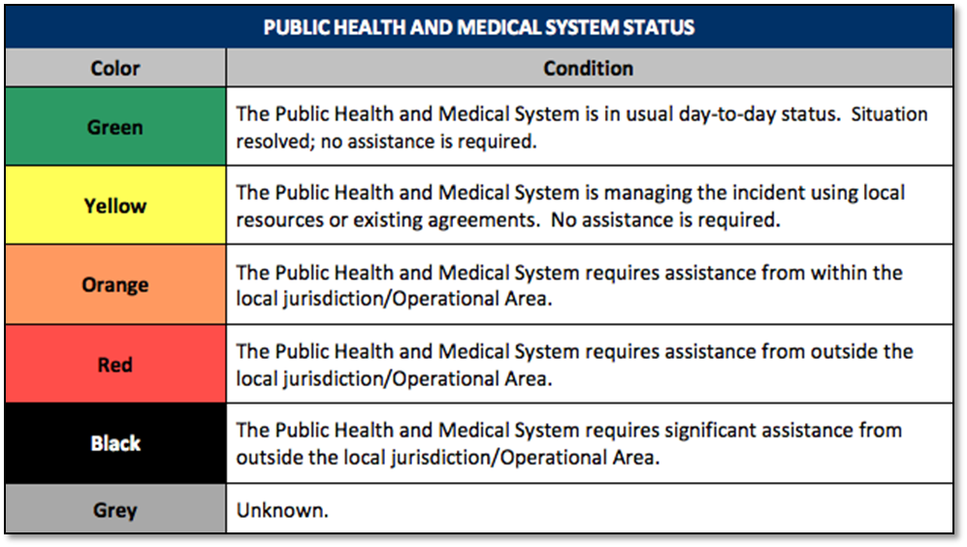

APPENDIX H: FORMS

Situation Report Form:
https://www.cdph.ca.gov/Programs/EPO/CDPH%20Document%20Library/SitRep2-7c%20Fillable.pdf

Resource Request Form:
https://www.cdph.ca.gov/Programs/EPO/CDPH%20Document%20Library/ResourceRequestMedicalandHealthOPAREAtoREGIONSTATE.xls

APPENDIX I: SAFETY CHECKLIST
[Each agency should fill in safety checklist information specific to their FE.]

Site Control/scene safety

- Access to functional exercise (FE) sites and the [Control Cell and/or SimCell] is limited to FE participants.
- All participants check in before the FE.
- Media/Observers are escorted to designated areas and accompanied by an FE controller at all times.
- FE staff are wearing the pre-determined badges, hats, and/or vests to clearly display their FE roles.
- A perimeter fence or other types of barrier controls are in place.
- Site access points to the site or building have been identified and will be monitored during the duration of the FE.
- Vehicle traffic is separated from pedestrian traffic on the site.
- Vehicle barriers at the perimeter and building maintain access for emergency responders, including large fire apparatus.
- Signs provide control of vehicles and people.
- All existing fire hydrants on the site are accessible.
- Floor plans posted show exits, entrances, location of security equipment, etc.

Participant Safety

- All participants are aware that there is a Safety Controller on scene.
- All participants know to use the phrase [“THIS IS NOT A DRILL”] if an emergency arises that requires assistance.
- All participants are aware that they should notify emergency services and the closest controller if they observe another participant who is seriously ill or injured.
- All participants know to advise their venue’s controller or evaluator of any unauthorized persons.
- All participants are aware of exercise identification items and will be able to identify FE staff.
- All participants are aware of the exits, entrances, location of security equipment, etc.
- All participants are aware of and have agreed to the relevant weapons policy.

APPENDIX J: ACRONYMS
AAM | After Action Meeting
AAR | After Action Report
AAR/IP | After Action Report / Improvement Plan
AFN | Access and Functional Needs
C/E | Controller/Evaluator
CAHAN | California Health Alert Network
CAHF | California Association of Health Facilities
Cal OES | California Governor's Office of Emergency Services
Cal OSHA | California Division of Occupational Safety and Health
CBO | Community Based Organization
CCLHO | California Conference of Local Health Officers
CDPH | California Department of Public Health
CERT | Community Emergency Response Team
CHA | California Hospital Association
C/ME | Coroner/Medical Examiner
CPCA | California Primary Care Association
CHHS | California Health and Human Services Agency
DHS | Department of Homeland Security
DOC | Department Operations Center
ED | Emergency Department
EEG | Exercise Evaluation Guide
EHD | Environmental Health Department
EMS | Emergency Medical Services
EMSA | Emergency Medical Services Authority
EMSAAC | Emergency Medical Services Administrators Association of California
EOC | Emergency Operation Center
EOM | California Public Health and Medical Emergency Operations Manual
EOP | Emergency Operations Plan
EPO | California Department of Public Health Emergency Preparedness Office
ETA | Estimated Time of Arrival
ExPlan | Exercise Plan
FAC/FIC | Family Assistance Center / Family Information Center
FBI | Federal Bureau of Investigation
FE | Functional Exercise
FEMA | Federal Emergency Management Agency
FOUO | For Official Use Only
FSE | Full Scale Exercise
HAZMAT | Hazardous Materials
HCC | Hospital Command Center
HICS | Hospital Incident Command System
HIPAA | Health Insurance Portability and Accountability Act
HPP | Hospital Preparedness Program
HSEEP | Homeland Security Exercise and Evaluation Program
IAP | Incident Action Plan
ICS | Incident Command System
IP | Improvement Plan
JIC | Joint Information Center
JIS | Joint Information System
JRIC | Joint Regional Intelligence Center
JTTF | Joint Terrorism Task Force
LEMSA | Local Emergency Medical Services Authority
LHD | Local Health Department
MCI | Mass Casualty Incident
MHCC | Medical and Health Coordination Center
MHOAC | Medical/Health Operational Area Coordinator Program
MOU | Memorandum of Understanding
MRC | Medical Reserve Corps
MSEL | Master Scenario Events List
NGO | Non-governmental organization
NHICS | Nursing Home Incident Command System
NIMS | National Incident Management System
OA | Operational Area
OEM | Office of Emergency Management
OES | California Governor’s Office of Emergency Services
PHEP | Public Health Emergency Preparedness
POC | Point of Contact
PPE | Personal Protective Equipment
RDMHC | Regional Disaster Medical Health Coordinator
RDMHS | Regional Disaster Medical Health Specialist
REOC | Regional Emergency Operation Center
SEMS | Standardized Emergency Management System
SimCell | Simulation Cell
SitMan | Situation Manual
SME | Subject Matter Expert
SOC | State Operations Center
SWAT | Special Weapons and Tactics Team
SWMHE | Statewide Medical and Health Exercise
TLO | Terrorism Liaison Officer
TTX | Tabletop Exercise
UC | Unified Command
VIP | Very Important Person

. After tailoring the document to your jurisdiction/organization/facility, be sure to update the Table of Contents by right clicking on it and selecting “update field”.
. The Health Care Preparedness and Response Capabilities were released by the Assistant Secretary for Preparedness and Response (ASPR) in December of 2016. They replace the 2011 – 2016 Hospital Preparedness Program (HPP) capabilities.
. From FEMA’s Emergency Management Institute Exercise Design Guidelines, in “Unit 4: Exercise Design Steps.”
. From FEMA’s Emergency Management Institute Exercise Design Guidelines, in “Unit 4: Exercise Design Steps.”
. Standardized Emergency Management System
. Source: CDPH Emergency Operations Manual, July 2011.

