Stormwater Control Plan
For
[Name of Project]

[Date]

[Name of Owner]
[Owner’s Representative and Contact Information]

Prepared by:
(STAMP)
[Preparer’s Name]
[Preparer’s Contact Information]

Table of Contents
I. Project Data 4
II. Setting 4
II.A. Project Location and Description 4
II.B. Existing Site Features and Conditions 4
II.C. Opportunities and Constraints for Stormwater Control 5
III. Low Impact Development Design Strategies 5
III.A. Optimization of Site Layout 5
III.A.1. Limitation of development envelope 5
III.A.2. Preservation of natural drainage features 5
III.A.3. Setbacks from creeks, wetlands, and riparian habitats 5
III.A.4. Minimization of imperviousness 5
III.A.5. Use of drainage as a design element 5
III.B. Use of Permeable Pavements (self-treating areas) 5
III.C. Dispersal of Runoff to Pervious Areas (self-retaining areas) 5
III.D. Stormwater Control Measures 5
IV. Documentation of Drainage Design 5
IV.A. Drainage Management Area Characterization 5
IV.B. Sizing Calculations 6
IV.B.1. Areas Draining to Bioretention Facilities (PCR 2 Projects) 7
V. Source Control Measures 8
V.A. Site activities and potential sources of pollutants 8
V.B. Source Control Table 8
V.C. Features, Materials, and Methods of Construction of Source Control BMPs 8
VI. Stormwater Facility Maintenance 8
VI.A. Ownership and Responsibility for Maintenance in Perpetuity 8
VI.B. Summary of Maintenance Requirements for Each Stormwater Facility 9
VII. Construction Checklist 9
VIII. Certifications 9

Tables
Table 1: Project Data 4
Table 2: Table of Drainage Management Areas 6
Table 3: Table of Runoff Reduction and Structural Control Measures 6
Table 4: Table of Areas Draining to Self-Retaining Area 7
Table 5: Table of LID Facility Sizing Calculation 7
Table 6: Source Control Table 8
Table 7 Construction Checklist Table 9

Figures
Vicinity Map x

Attachments
Existing Impervious Area Exhibit (if applicable)
Net Impervious Area Exhibit
Drainage Management Areas (DMAs) Exhibit
Stormwater Control Measures Sizing Calculator (applicable Tier Results)
- Tier 2 Treatment
- Tier 2 Storage (if applicable)
- Tier 3 Retention (if applicable)
Other (if applicable)

Appendices
Non-retention Based Treatment System Documentation
Non-Vegetated Self-Retaining Area Documentation
Other (if applicable)

Project Data
Table 1: Project Data
Project Name/Number | [Tract Number, Parcel Map Number, PMT Number]
Application Submittal Date | [to be verified by municipal staff]
Project Location | [Street Address if available, or intersection and/or APN]
Project Phase No. | [If project is being constructed in phases, indicate the phase number. If not, enter “NA”]
Project Type and Description | [Example entries: “Detached single-family residence,” “5-story office building,” “Residential with 160 single-family homes,” “Five 4-story buildings to contain 200 condominiums,” “100-unit, 2-story shopping mall,” “mixed use retail and residential development (apartments)”, “Industrial warehouse.”]
Hydrologic Soil Group | [Examples of HSG’s, specify Group or Groups and indicate where each group occurs on the site]  Group A (Low runoff potential) are sand, loamy sand or sandy loam types of soils. They have low runoff potential and high infiltration rates even when thoroughly wetted. They consist chiefly of deep, well to excessively drained sands or gravels and have a high rate of water transmission (1 to 8.3 inches per hour).  Group B are silt loam or loam types of soils. They have a moderate infiltration rate when thoroughly wetted and consist chiefly or moderately deep to deep, moderately well to well drained soils with moderately fine to moderately coarse textures. They have a moderate rate of water transmission (0.5 to 1 inch per hour).  Group C are sandy clay loam. They have low infiltration rates when thoroughly wetted and consist chiefly of soils with a layer that impedes downward movement of water and soils with moderately fine to fine structure. They have a slow rate of transmission (0.17 to 0.27 inches per hour).  Group D (High runoff potential) are clay loam, silty clay loam, sandy clay, silty clay or clay type soils. This HSG has the highest runoff potential. They have very low infiltration rates when thoroughly wetted and consist chiefly of clay soils with a high swelling potential, soils with a permanent high water table, soils with a claypan or clay layer at or near the surface and shallow soils over nearly impervious material. They have a very slow rate of water transmission (.02 to 0.1 inches per hour).
Soil Infiltration Rate
Total Project Site Area (acres)
Total New Impervious Surface Area
Total Replaced Impervious Surface Area
Total Pre-Project Impervious Surface Area
Total Post-Project Impervious Surface Area
Net Impervious Area (Exhibit shall be provided to justify net impervious area results) | [New Imp. Area + Reconstructed Imp. Area – (Total Pre-Project Imp. Area – Total Post-Project Imp. Area)]
Watershed Management Zone(s)
Design Storm Frequency and Depth | [85-percentile depth or 95-percentile depth]
Drainage Report Name | [If PCR 4]

Setting

Project Location and Description
[Include site location, division of parcels, existing and intended site use (i.e. parking lot, open space), zoning, setback and open space requirements, project phasing, number of residential units or square footage of office or retail, parking requirements, neighborhood character, other notable project characteristics. A vicinity map may also be useful.]

Existing Site Features and Conditions
[Include site size, shape, and topography. Hydrologic features, including any contiguous natural areas, wetlands, watercourses, seeps or springs. Existing land uses. Soil types and hydrologic soil groups, vegetative cover, and impervious areas, if any. Wells, landslides, slumps, or rock outcrops, if any. Existing drainage for site and nearby areas, including location of municipal storm drains.]

Opportunities and Constraints for Stormwater Control
[Examples of opportunities: Existing natural areas, low areas, oddly configured or otherwise unbuildable areas, easements and required landscape amenities including open space and buffers that might be used for bioretention facilities, and differences in elevation, which can provide needed hydraulic head.]
[Examples of constraints: impermeable soils or near-surface bedrock, high groundwater, groundwater pollution or contaminated soils, steep slopes, geotechnical instability, density/high-intensity land use, heavy pedestrian or vehicular traffic, utility locations, archaeology, safety concerns.]

Low Impact Development Design Strategies

Optimization of Site Layout

Limitation of development envelope

Preservation of natural drainage features

Setbacks from creeks, wetlands, and riparian habitats

Minimization of imperviousness

Use of drainage as a design element

Use of Permeable Pavements (self-treating areas)

Dispersal of Runoff to Pervious Areas (self-retaining areas)

Stormwater Control Measures

Documentation of Drainage Design

Drainage Management Area Characterization
The DMA numbers below correspond with DMA numbers of DMA exhibit. Each DMA has only one surface type. DMAs listed include all impervious surfaces and all vegetated areas except those designated as structural control measures (SCMs).
Pervious areas are further categorized as either self-treating or self-retaining areas.
- Areas designated as self-treating areas are undisturbed areas, or areas planted with native, drought-tolerant, or LID-appropriate vegetation and do not receive runoff from other areas.
- Areas designated as self-retaining are low-lying areas that receive runoff from adjoining areas. Site retaining areas may have natural vegetation, or be landscape, or may be porous pavements (where the soils underlying the porous pavements drain well enough to handle the additional run-on).

Summarize approach to managing different types of drainages.
Table 2: Table of Drainage Management Areas
DMA ID | Surface Type & description | Area (sf) | Drains to  (provide DMA or SCM DMA ID) |  |  | Notable or exception characteristics or conditions
 |  |  | Self-treating | Self-Retaining | SCM

Table 3: Table of Runoff Reduction and Structural Control Measures
DMA ID | scm | scm type | water quality flow rate (cfs)  or volume required (cf) | water quality flow rate (cfs)  or volume provided (cf)

Sizing Calculations
The pervious area listed below only includes the functional bottom width of the SRA in the receiving self-retaining DMA area column.
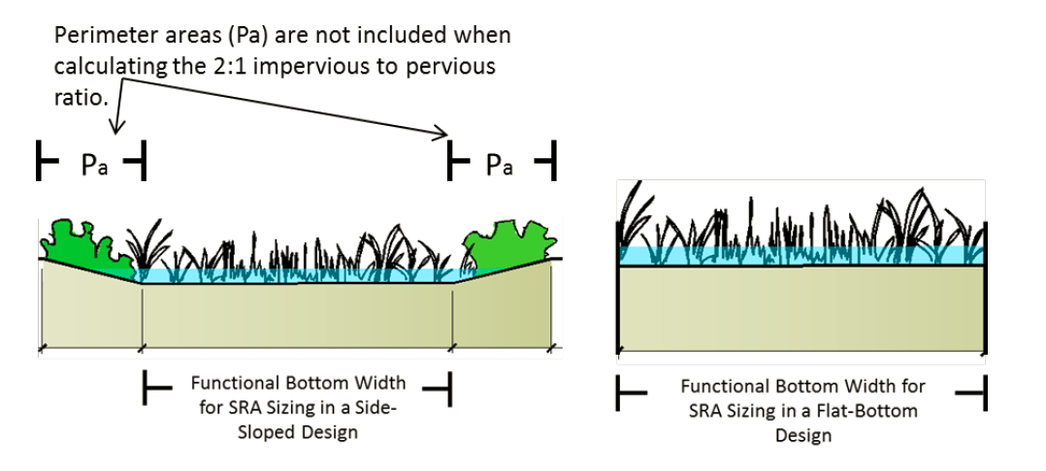
Based on Central Coast Post-Construction Requirements Implementation Guidance Series, Series Issue #1: The use of Self-Retaiing Areas to Support Post Construction Stormwater Control Compliance:
☐ 2:1 SRA Sizing is acceptable ☐ 2:1 SRA Sizing is Un-acceptable
The design storm (inches): _________
Saturated Soil Infiltration Rates (in/hr) _________
(A/B Soils 0.75 in/hr, C/D Soils 0.25 in/hr, or site specific in conformance with soil infiltration methodology per County LID Handbook)

Table 4: Table of Areas Draining to Self-Retaining Area
[May substitute with output from Santa Barbara County Sizing Calculator]
DMA Name | Area  (square feet) | Post-project  surface type | Runoff  factor | [A]  Product  (Area x runoff factor) | Receiving self-  retaining DMA | [B]  Receiving self-  retaining DMA Area (square feet) | Ratio  [A]/[B]
[Describe design of any non-vegetative SRAs here. For example, pervious pavers with storage to retain paver surface area plus assigned DMA run-on]

Areas Draining to Bioretention Facilities (PCR 2 Projects)
Table 5: Table of LID Facility Sizing Calculation
[Copy entire table once for each SCM or may substitute table with Santa Barbara County Stormwater Control Measures Sizing Calculator results]
DMA Name | DMA  Area  (square feet) | Post-project  surface type | DMA  Runoff  factor | DMA  Area ×  runoff factor | SCM Name
 |  |  |  |  | SCM Sizing  factor | Minimum  SCM  Size | Proposed  SCM  Size
Total |  |  |  |  | 0.04

Source Control Measures

Site activities and potential sources of pollutants

Source Control Table
Table 6: Source Control Table
[Sample topics listed below]
 | Pollutants Associated with Activity
Potential Pollutant Source | Sediment/ Litter/ Debris | Nutrients/ Organic Matter | Bacteria | Hydro-carbons | Toxics/ Chemicals/ Paint | Other | Source Control BMP Proposed
Pets |  | X | X |  |  |  | Good housekeeping/ Illicit Discharge Control/Pet Waste Station
Parked Vehicles | X |  |  | X |  |  | Vehicle Maintenance, Fueling and Storage
Roads, Fertilizers, Pesticides, Storm Drains, Etc.

Features, Materials, and Methods of Construction of Source Control BMPs

Stormwater Facility Maintenance

Ownership and Responsibility for Maintenance in Perpetuity
[Review the County of San Luis Obispo Requirements for Post-Construction Operation and Maintenance Agreements: https://www.slocounty.ca.gov/Departments/Planning-Building/Stormwater/Services/Post-Construction-Stormwater-Management.aspx
Projects that trigger Performance Requirements 2, 3, or 4, are required to record an Agreement with the County on incorporate language into CC&Rs accepting responsibility for inspection, operation and maintenance of facilities. The Agreement /CC&Rs is established in conjunction with a Condition Compliance Monitoring (CCM) permit case.
Within the Stormwater Control Plan, please indicate whether the project will utilize an Agreement or CC&Rs to meet this requirement, and who the responsible party will be.
Public Works will request a CCM Case number from the Department of Planning & Building during review of the stormwater control plan.]

Summary of Maintenance Requirements for Each Stormwater Facility
Complete this section using form SWP-1008, available at: https://www.slocounty.ca.gov/Departments/Planning-Building/Stormwater/Services/Post-Construction-Stormwater-Management.aspx

Construction Checklist
[Complete the first two columns in the checklist, listing each stormwater source control measure and SCM included in the project.]
Table 7 Construction Checklist Table
SWCP Page No. | Structural Control Measure SCMs | Plan Sheet No. | SCM Detail No.

Certifications
The design of stormwater treatment facilities and other stormwater pollution control measures in this plan are in accordance with the Post-Construction Stormwater Management Resolution R3-2013-0032 and the current edition of the County’s LID Handbook.

