This Appendix contains instructions and hyperlinks to commonly used platforms and tools for developing a SWCP. The summary table below indicates the location of information in this appendix.
Table Number | Table Title | Notes
A-1 | Identifying MS4 Area Boundaries and Watershed Management Zone | Step by step instructions for digital mapping tools to identify MS4 boundaries and WMZs in San Luis Obispo County.
A-2 | Web resources and reference hyperlinks | Descriptions and hyperlinks to web resources commonly used in formulating Stormwater Control Plans.

Please email stormwater@co.slo.ca.us if any links are discovered to be non-functional. This resource was most recently updated in January 2023.

Table A-1: Identifying MS4 Area Boundaries and Watershed Management Zones
Instructions for utilizing Land Use View online mapping tools
Step 1: Navigate to the County of San Luis Obispo Planning & Building Department web page. https://www.slocounty.ca.gov/Departments/Planning-Building.aspx
Step 2: Select the icon for “Interactive Map” shown on the main page to load the Land Use View application. | 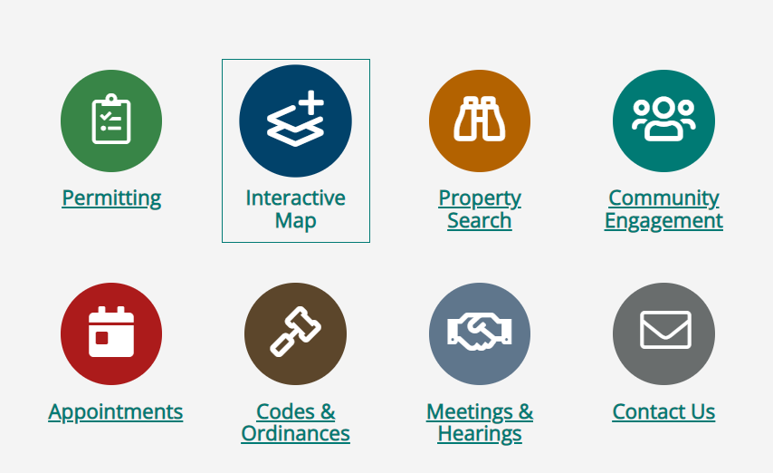
Step 3: Select ‘Layers’ in the lower left menu bar. | 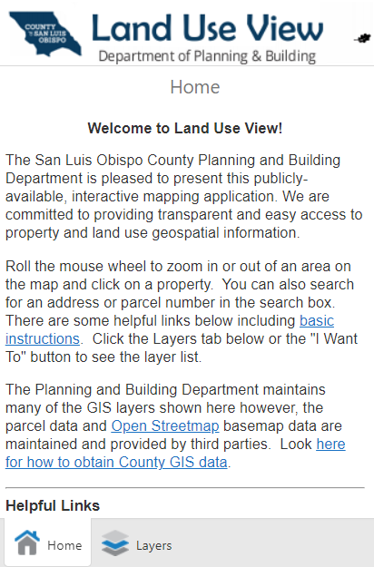
Step 4: Expand the Layers group named “Planning” | 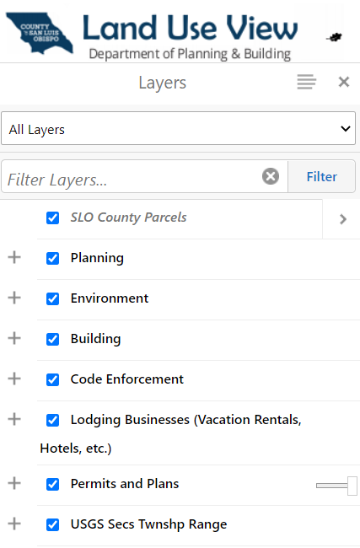
Step 5: Expand the Layer named “Stormwater Management Areas” Turn on the Layer named “MS4 Coverage Areas” | 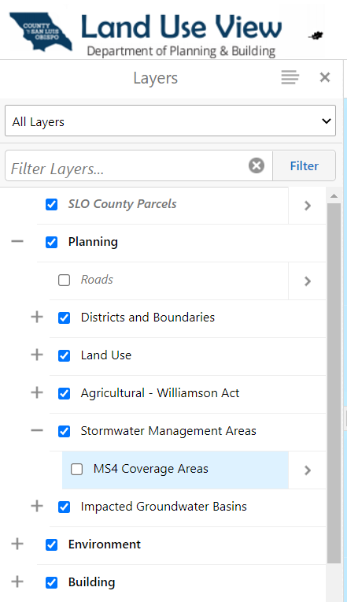
Step 6: Expand the Layer named “Environment” and expand the group named “Water” | 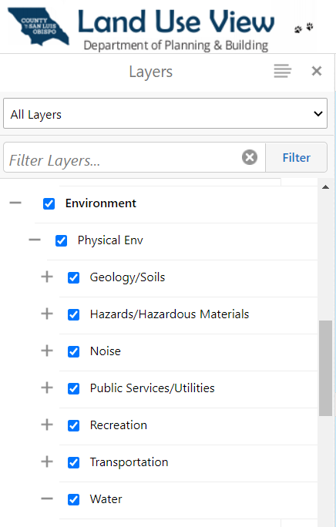
Step 7: Turn on the Layer named “PW-Watershed Management Zones” | 4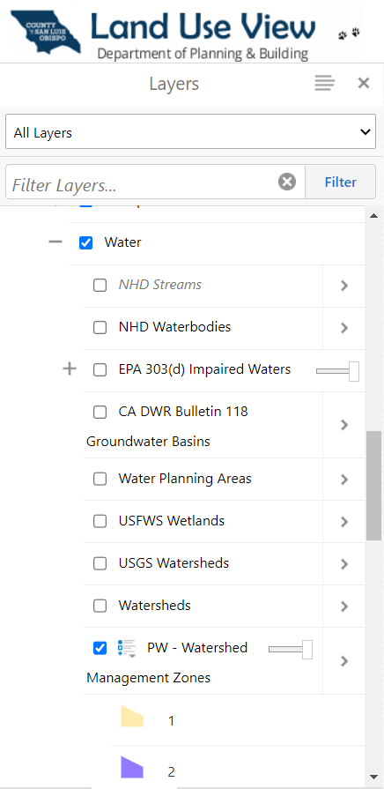
Step 7: Use the map to navigate to your project location or enter the APN in the ‘Search’ box to determine whether it is in a MS4 Coverage Area and the applicable Watershed Management Zone.
Table A-2: Web resources and reference hyperlinks
Page Hosting Agency | Site Title | Description | Link:
Central Coast Regional Water Quality Control Board. | Central Coast Region Post-Construction Stormwater Requirements | Resources and documents related to Resolution R3-2013-0032. | https://www.waterboards.ca.gov/centralcoast/water_issues/programs/stormwater
County of San Luis Obispo, Public Works Department | Stormwater Requirements for New Construction | Resources page with instructions and forms for construction permit applications.  Includes County PCR Waiver Request form, SWCP App, SWCP Template. | https://www.slocounty.ca.gov/Departments/Public-Works/Services/Programs-Outreach/Stormwater-Requirements-for-New-Construction.aspx
County of San Luis Obispo, Planning & Building Department | Post-Construction Stormwater Management | Resources page with forms and instructions for County long-term operations and maintenance agreements.  Includes O&M Agreement forms and templates. | https://www.slocounty.ca.gov/Departments/Planning-Building/Department-Services/Agriculture,-Water,-and-Energy/Stormwater/Post-Construction-Stormwater-Management.aspx
County of Santa Barbara,  Public Works Department | New and Redevelopment | Stormwater control plan manual and design resources.  Includes Stormwater Control Measures Sizing Calculator and instructions. | https://www.countyofsb.org/2324/New-Redevelopment
Environmental Protection Agency, Southwest Region 9 | Underground Injection Well Registration | Resources page with instructions and links for registering dry wells and underground stormwater chamber systems. | https://www.epa.gov/uic/forms/underground-injection-well-registration-epas-pacific-southwest-region-9
State of Washington,  Department of Ecology | Emerging Stormwater Treatment Technologies (TAPE) | Stormwater treatment technologies reviewed and certified by the Washington state Technology Assessment Protocol – Ecology (the TAPE program). | https://ecology.wa.gov/Regulations-Permits/Guidance-technical-assistance/Stormwater-permittee-guidance-resources/Emerging-stormwater-treatment-technologies
Central Coast Low Impact Development Initiative (LIDI) | LID Design and Construction | Resources to guide LID design and construction for the central coast region. | https://www.centralcoastlidi.org/projects.php
State Water Resources Control Board | GeoTracker | Water Board’s data management system for sites that impact or have the potential to impact ground water quality in California. | https://geotracker.waterboards.ca.gov/
County of San Luis Obispo, Planning & Building Department | Buildings and Construction Code, Title 19 | Current County code Title 19 detailing requirements for buildings and construction. Chapter 19.11 details stormwater management requirements. | https://library.municode.com/ca/san_luis_obispo_county/codes/county_code?nodeId=TIT19BUCO
County of San Luis Obispo, Public Works Department | Public Improvement Standards | Current County Public Improvement Standards, most recent version adopted in 2022. | https://www.slocounty.ca.gov/Departments/Public-Works/Forms-Documents/Development-Services/Public-Improvements/Public-Improvement-Standards.aspx
County of San Luis Obispo, Public Works Department | Encroachment Permits | Resources, forms and documents for applying for a County of San Luis Obispo Encroachment Permit. | https://www.slocounty.ca.gov/Departments/Public-Works/Services/Applications,-Permits-Fees/Encroachment-Permits.aspx
Central Coast Regional Water Quality Control Board. | Central Coast Region Post-Construction Stormwater Requirements | Resources and documents related to Resolution R3-2013-0032. | https://www.waterboards.ca.gov/centralcoast/water_issues/programs/stormwater
County of San Luis Obispo, Public Works Department | Stormwater Requirements for New Construction | Resources page with instructions and forms for construction permit applications.  Includes County PCR Waiver Request, SWCP App, SWCP Template. | https://www.slocounty.ca.gov/Departments/Public-Works/Services/Programs-Outreach/Stormwater-Requirements-for-New-Construction.aspx

