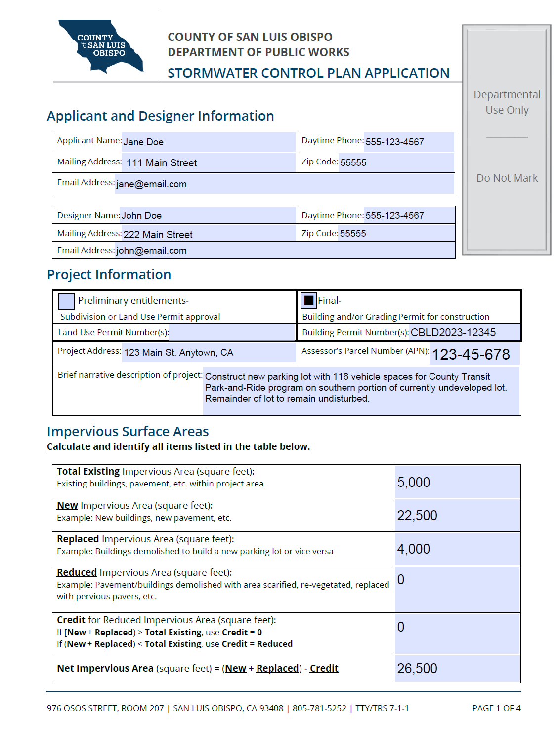
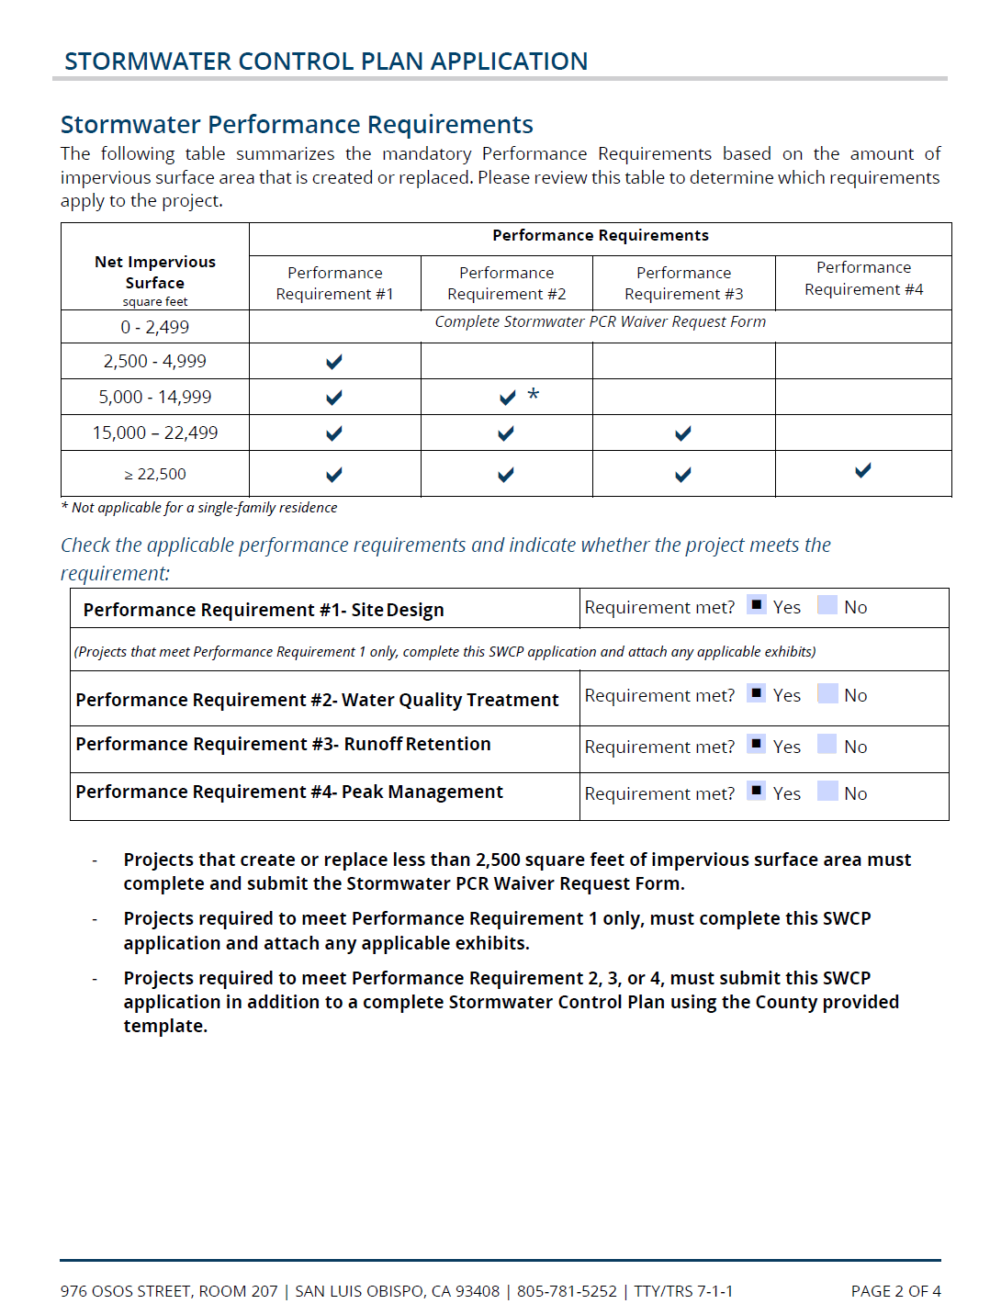
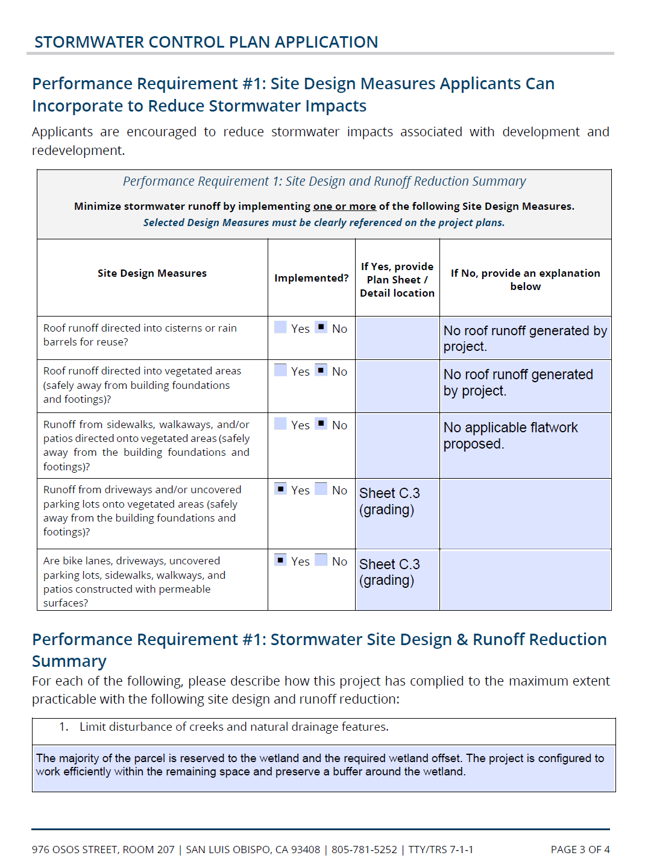

Date: | January 1, 2024
Name of owner: | General Land Development Company, LLC.
Owner’s representative and contact information: | Jane Doe  (555)123-4567 Jane@email.com
Plan prepared by: | General Civil Engineering Consultants, Inc.
Preparer’s name and contact information: | John Doe  (555)123-4567 John@email.com
Submitted to: | County of San Luis Obispo

Post-Construction Stormwater Control Plan for:
Main Street Park and Ride Lot, Anytown

Preparer’s signed stamp:

Stormwater Control Plan Submittal Completion Checklist

Exhibits:
Element | Included? | Notes
Exhibit depicting SCMs, Drainage Management Areas (DMAs). | Yes | Attachment 1
Exhibit depicting pre and post project pervious and impervious areas. | Yes | Attachment 1
Opportunities and constraints map. | Yes | Attachment 4

Required Submittals for PR#2
Element | Included? | Notes
Source control checklist. | Yes | Section 4
Plan sheet detail indicating location of PR#1 implementation. | Yes | Section 3.b  Sheet C3.0 (grading)  Sheet C4.0 (details)
Draft long-term operations and maintenance plan. | Yes | Attachment 5

Required Submittals for PR#3
Element | Included? | Notes
LID opportunities and constraints analysis with map. | Yes | Attachment 4
Underground infiltration system pretreatment device certification. | N/A | Pretreatment provided by bioretention and biofiltration features
Soils testing report and design infiltration rate supporting documentation. | Yes | Grading permit package

Requirements for PR#4
Element | Included? | Notes
Calculations for peak management. | Yes | Attachment 2

Table of Contents
1. Summary Project Data 1
2. Project setting 2
a. Project Location and Description 2
b. Existing Site Features and Conditions 3
c. Opportunities and Constraints for Stormwater Control 3
3. Low Impact Development Design Strategies 4
a. Site Design Strategies 4
b. Runoff Reduction Strategies 4
c. Self-treating and self-retaining areas 6
4. Documentation of Drainage Design 6
a. Drainage Management Areas Summary 6
b. Stormwater Structural Control Measures 6
c. Areas Draining to Self-retaining Areas 9
d. SCM Construction Checklist 10
5. Pollutant Source Control Measures 11
6. Stormwater Infrastructure Maintenance 14
a. Operations and Maintenance Agreements 14
b. Summary of Maintenance Requirements for each Structural Control Measure 14
7. Conclusions and Certification of Compliance 15

List of Tables
Table 1: Summary Project Data 1
Table 2: Site Soils summary data 2
Table 3: Performance Requirement #1 Runoff Reduction Strategies 4
Table 4: Performance Requirement #3 Additional LID Design Strategies 5
Table 5: Drainage Management Areas and Characteristics 6
Table 6: Structural Control Measure Summary Table (PR2 – Treatment Only) 7
Table 7: Structural Control Measure Summary Table (PR3 – Runoff Retention) 8
Table 8: Structural Control Measure Summary Table (PR4 – Peak Management) 8
Table 9: Subgrade Stormwater Structural Control Measures 8
Table 10: Self-retaining area summary 9
Table 11: SCM Construction Details Summary Table 10
Table 12: Plant Palette Selected for Vegetated SCMs 11
Table 13: Permanent Pollutant Source Control Measures 11

List of Figures
Figure 1:Project Vicinity Map 2

List of Attachments
Attachment 1: Site Maps and Exhibits 16
Attachment 2: SCM Sizing Calculator Outputs 20
Attachment 3: Non-retention Based Treatment System Documentation 29
Attachment 4: LID Opportunities and Constraints Checklist 30
Attachment 5: Draft SCM Operations & Maintenance Forms 34

Summary Project Data
Table 1 provides a summary of project data related to demonstrating compliance with the Post-Construction Stormwater Management Requirements (the PCRs) for Development Projects in the Central Coast [Resolution R3-2013-0032]. The proposed project is designed to comply with applicable requirements outlined in the PCRs.
Table 1: Summary Project Data
Project name: | Main Street Park-and-Ride Lot
Project or permit number: | Building Permit CBLD2023-12345
Preliminary or Final SWCP: | ☐ Preliminary entitlements  Subdivision or Land Use Permit approval. |  |  |  | ☒ Final  Building and/or Grading Permit for construction.
Project location: | Northwest corner of Main Street and Broadway  123 Main St. Anytown, CA  APN: 123-45-678
Project Description: | Construct new parking lot with 116 vehicle spaces for County Transit Park-and-Ride program on southern portion of currently undeveloped lot. Remainder of lot to remain undisturbed.
Total project site area: | 0.72 acres = 31,500 SF
Total Existing Impervious Area: | 5,000 SF
New Impervious Area: | 22,500 SF
Replaced impervious Area: | 4,000 SF (existing asphalt driveway)
Reduced Impervious Area: | 0 SF  Credit = 0  Unless (Pre-Project Impervious – Post-Project Impervious) > 0
Credit for Reduced Impervious Area:  If post-project > pre-project, Credit = 0  If post-project < pre-project, Credit = Reduced | [22,500 +4,000] = 26,500  Total existing: 5,000  Credit = 0
Net impervious area: | (New + Replaced) – Credit  = (22,500 + 4,000) – (0)  = 26,500 SF
Watershed management zone: | WMZ 1
Design storm frequency and depth: | ☒ 85th percentile |  | ☒ 95th percentile |  |  | 85th i = 1.1”  95th i = 1.9”
Applicable performance requirements: | ☒ PR #1 | ☒ PR #2 |  | ☒ PR #3 |  |  | ☒ PR #4

Table 2 summarizes the predominant soil characteristics of the development site and data generated from web generated soils reports and site soils explorations and testing.
Table 2: Site Soils summary data
Predominant soil type(s) of site: | Silty well-graded sand.
Predominant hydrologic soils group classification of site: | ☒ Group A | ☐ Group B | ☐ Group C | ☐ Group D
Soils testing conducted at site: | ☒ Borings |  | ☐ Percolation testing
 | ☒ Infiltration testing |  | ☐ Other
Brief summary of soil testing conducted: | Three (3) soil borings were performed to collect soil samples and establish the soil profile and water table depth.  Two (2) percolation tests were performed, and the percolation data was converted using the Porchet method to establish design infiltration rates for the underground infiltration chambers.  The soils report for the project site was included with the building permit application.
Design soil infiltration rate: | 1.0 inches/hour
Factor of Safety applied: | FS=2

Project setting

Project Location and Description
This project site is located at the northwest corner of the intersection of Main Street and Broadway in Anytown, California. The site is currently zoned for Public Facilities and is undeveloped except for an existing storage shed and driveway. The proposed project will construct a new parking lot containing 116 parking stalls to be used by transit passengers from the adjacent communities in conjunction with the County Transit Park-and Ride program.
Figure 1:Project Vicinity Map
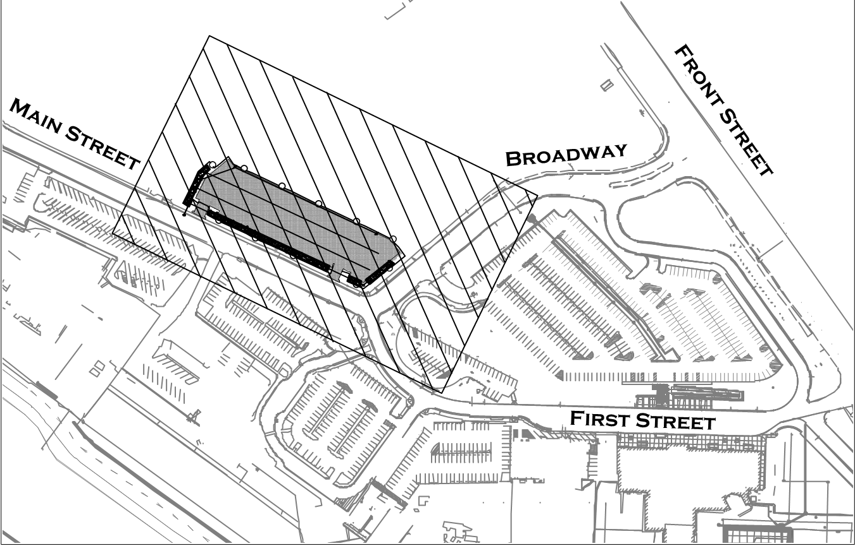

Existing Site Features and Conditions
The property is a 2.52 acre irregularly shaped parcel. Apart from the existing driveway and storage shed, the parcel is undeveloped and evenly covered with grasses and sage brush. The property can be roughly separated into two distinct flat areas to the north and south separated by a 15-foot sloped decline toward the middle.

The north portion of the property is a large triangular low-lying area containing a sensitive wetland. This area is mostly flat with gentle slopes to an internal naturally occurring sump area.
The south portion of the property is a roughly 30,000 SF rectangular area bounded on the south and east by existing curb, gutter, and sidewalk improvements along Main Street and Broadway. This area is flat and roughly level with the adjacent streets but is bounded on the north by a sloped decline descending roughly 15 feet to the wetland below.

The proposed project will be constructed in the southern portion of the parcel leaving the wetland undisturbed and maintaining a 50’ minimum offset from the wetland boundary as established by the project biological report. In the current condition, the project area is gently sloped to sheet flow toward the northern wetland and does not receive any significant run-on from the adjacent streets or properties. The proposed design will divert runoff from new impervious areas away from the northern wetland to new stormwater features on site for treatment and retention with attenuated overflows to the existing storm drain in Main Street.

The design was evaluated in coordination with the project biologist for the possibility of detrimental impact to the wetland caused by a net reduction of historical runoff received by the wetland. It was determined that the soil and vegetation immediately around the project area provide for quick infiltration and surface retention of runoff. As a result, historical runoff received by the wetland from the project area is negligible. Rather, the project biology report indicated that the wetland is primarily fed by surface flows descending from the larger, steeper areas to the north and west, and the report recommended that diverting new flows away from the wetland is the preferred strategy to avoid potential pollutant load on the wetland.

Opportunities and Constraints for Stormwater Control
Projects triggering PR#3 and above are required to submit a LID opportunities and constraints analysis.
This project is PR#3 or above: | ☒ Yes | ☐ No
The LID opportunities and constraints checklist is included as an Attachment to this SWCP. | ☒ Yes | ☐ No | ☐ Not Applicable
The LID opportunities and constraints site map is included as an Attachment to this SWCP. | ☒ Yes | ☐ No | ☐ Not Applicable
The LID Opportunities and Constraints checklist and site map are included in Attachment 4.

Low Impact Development Design Strategies

Site Design Strategies
Performance Requirement #1 is applicable to all regulated projects that create and/or replace ≥2,500 sf of impervious surface area. This project has incorporated Low Impact Development site design strategies as detailed below.

Limit disturbance to creeks and natural drainage features
The project will maintain a minimum 50’ offset from the wetland on the north side of the property and keep this area undisturbed. Runoff from the project will be directed away from the wetland since the site will be graded to collect runoff into the on-site SCMs which will overflow to the public storm drains in the street. As discussed above, this strategy will protect the wetland from potential pollution.

Minimize compaction of highly permeable soils
The proposed project will occur on the south, rectangular portion of the site which was graded and flattened by previous owners and well compacted by vehicle parking. Therefore, the project will not increase compaction of soils beyond the historically well compacted areas.

Limit clearing and grading of native vegetation to minimum area necessary
The project will maintain a minimum 50’ offset from the wetland on the north side of the property and keep this area undisturbed. The project area is clear of vegetation except for some grasses, so disturbance to vegetation will be minimal if any.

Minimize impervious surfaces and concentrate improvements on the least-sensitive portions of the site.
The available project area is restricted to the south area of the parcel by the wetland on the north and the required 50’ setback. The project area was already graded by previous owners and somewhat well compacted by vehicles parking.

Runoff Reduction Strategies
Performance Requirement #1 mandates that one or more runoff reduction measures be integrated into the site design. Table 3 indicates where runoff reduction measures have been incorporated into the proposed project.
Table 3: Performance Requirement #1 Runoff Reduction Strategies
Runoff Reduction Strategy | Guidelines | Location implemented | Plan sheet and detail
Direct roof runoff into cisterns or rain barrels for reuse. | Minimum 100-gallon volume for collection. | N/A  No roof area proposed | N/A  No roof area proposed
Direct roof runoff to vegetated areas away from foundations and footings. | Minimum 10% of roof area directed to vegetated areas. | N/A  No roof area proposed | N/A  No roof area proposed
Direct runoff from sidewalks, walkways and/or patios onto vegetated areas. | Minimum 10% of flatwork* area drainage directed to vegetated areas. | N/A  No applicable flatwork proposed. | N/A  No applicable flatwork proposed.
Direct runoff from driveways and/or parking lots onto vegetated areas. | Minimum 10% of flatwork area drainage directed to vegetated areas. | 25,000 SF impervious to vegetated SCMs / 26,500 total impervious area = 94% > 10% OK | Sheet C3.0 (grading) Sheet C4.0 (details)
Construct bike lanes, driveways, uncovered parking lots, sidewalks, walkways,  and patios with permeable surfaces. | Minimum 10% of flatwork area constructed with permeable surfaces. | 1,080 SF permeable pavers / 26,500 SF pavement = 4% < 10% Does not meet PR1 minimum | Sheet C3.0 (grading) Sheet C4.0 (details)
*Flatwork refers to smooth paved surfaces such as sidewalks, driveways, pathways, or parking lots.
Additional site design and runoff reduction strategies are required for projects that must comply with Performance Requirement #3. Table 4 indicates the design strategies that were incorporated into the project design to optimize the use of LID.
Table 4: Performance Requirement #3 Additional LID Design Strategies
Augmented PR#3 LID Design Strategies | Implemented? | Explanation
Define the development envelope and protected areas. Identify areas suitable for development and areas to remain undisturbed. | ☒ Yes ☐ No | The majority of the parcel is reserved to the wetland and the required wetland offset. The project is configured to work efficiently within the remaining space.
Conserve natural areas, including existing trees, vegetation, and soils. | ☒ Yes ☐ No | The site design leaves vegetated margins on all sides of the property which are conserved to the extent feasible. The majority of the site, including the north wetland will be left undisturbed.
Limit the overall impervious footprint of the project. | ☒ Yes ☐ No | The project footprint has been reduced to the extent feasible. The anticipated parking demands were reviewed with County Transit to limit unnecessary redundancy.
Construct streets, sidewalks, parking lot aisles to minimum widths required. | ☒ Yes ☐ No | The parking stalls and drive aisles were designed to the minimum dimensions allowed by County Land Use Ordinance and CalFire.
Set back development from creeks, wetlands, and riparian habitats. | ☒ Yes ☐ No | The entire area of disturbance is set back 50’ minimum from the wetland boundary established by the project biological report.
Conform the site layout along natural landforms. | ☒ Yes ☐ No | The project was designed to fit within an existing flat, graded area bounded in the north by an existing grade break to the rest of the site. This will minimize grading and take advantage of the existing terrain.
Avoid excessive grading and disturbance of vegetation and soils. | ☒ Yes ☐ No | The project was designed to fit within an existing flat, graded area bounded in the north by an existing grade break to the rest of the site. This will minimize grading and take advantage of the existing terrain.
Table 4 is not applicable to this project. | ☐ The requirements of this table are not applicable to the project. This project is not required to comply with Performance Requirement #3.

Self-treating and self-retaining areas
This project reduces the amount of runoff for which Stormwater Structural Control Measures (SCMs are required by utilizing self-treating and self-retaining areas.
This project reduces the amount of runoff for which Stormwater Structural Control Measures (SCMs) are required by utilizing self-treating and self-retaining areas. The rear corners of the project area furthest from the street were reserved as self-treating or self-retaining areas.

The NW corner of the site slopes back toward the property edge and the wetland in the current condition. To avoid re-grading this corner, it will be graded to match the current terrain and isolate runoff from six parking stalls and a portion of the drive aisle. These six stalls will be built with pervious pavers to self-retain 1,420 SF of asphalt pavement.

The NE edge requires minor grading to confirm to existing grade, but it will be vegetated and reserved as a self-treating area (DMA 6).

Documentation of Drainage Design

Drainage Management Areas Summary
The project site has been delineated into distinct Drainage Management Areas (DMAs), sized per the guidelines in the County of San Luis Obispo Post-Construction Stormwater Guidebook. Descriptions of each DMA are included in Table 5.
Table 5: Drainage Management Areas and Characteristics
DMA Number/ID | Surface Type & description |  | Area (sf) |  | Drains to:
DMA 1 |  | HMA Pavement |  | 2,500 | ☐ Self-treating | ☐ Self-retaining | ☒ SCM
DMA 2 |  | HMA Pavement |  | 10,000 | ☐ Self-treating | ☐ Self-retaining | ☒ SCM
DMA 3 |  | HMA Pavement |  | 5,000 | ☐ Self-treating | ☐ Self-retaining | ☒ SCM
DMA 4 |  | HMA Pavement |  | 5,000 | ☐ Self-treating | ☐ Self-retaining | ☒ SCM
DMA 5 |  | HMA Pavement |  | 2,500 | ☐ Self-treating | ☐ Self-retaining | ☒ SCM
DMA 6 |  | Landscaping |  | 500 | ☒ Self-treating | ☐ Self-retaining | ☐ SCM
DMA 7 |  | HMA Pavement Draining to Pavers |  | 1,500 | ☐ Self-treating | ☒ Self-retaining | ☐ SCM

Stormwater Structural Control Measures

Structural Control Measures for PR#2 Treatment
This project requires construction of Stormwater Structural Control Measures (SCMs) to treat runoff in compliance with Performance Requirement #2, Water Quality Treatment. Treatment for each DMA is provided by one of the following types of features:
- Bioretention Basins
Required SCM Capacity = Volume (CF) of 85th percentile storm runoff from DMAs flowing to SCM
Provided SCM Capacity = Design volume (CF) of bioretention basin
- Biofiltration Features (i.e., bioretention w/ underdrain)
Required SCM Capacity = Area (SF) of DMAs flowing to SCM x 0.04
Provided SCM Capacity = Surface area of SCM

- Vegetated Flow-Based Treatment (i.e. vegetated swales, vegetated buffer strips)
Required SCM Capacity = Minimum swale length (FT) or minimum strip width (FT)
Provided SCM Capacity = Actual swale length (FT) or strip width (FT)

- Mechanical Flow-Based Treatment Devices (i.e., filters, mechanical separators)
Required SCM Capacity = Peak flow rate (CFS) to SCM
Provided SCM Capacity = Maximum recommended flow rate (CFS) to the SCM for effective treatment per manufacturer’s specifications or design

No treatment is to be provided by direct infiltration facilities. All direct infiltration facilities must receive flows treated by flow-based treatment devices or by above-ground biofiltration or bioretention facilities. Direct infiltration should be reserved for retention and peak management.

Key attributes of these SCMs for Water Quality Treatment are summarized in Table 6.

Table 6: Structural Control Measure Summary Table (PR2 – Treatment Only)
SCM Number/ID | DMA Number/ID | SCM Type | Required SCM Capacity  (CFS, SF, FT, CF) | Provided SCM Capacity  (CFS, SF, FT, CF)
SCM 1 | DMA 1 | Vegetated Swale | 22 FT | 54 FT
SCM 2 | DMA 2 | Bioretention | 953 CF | 1650 CF
SCM 3 | DMA 3 | Bioretention | 500 CF | 900 CF
SCM 4 | DMA 4 | Bioretention | 500 CF | 900 CF
SCM 5 | DMA 5 | Vegetated Swale | 22 FT | 72 FT

Additionally, the vegetated swales have been designed for hydraulic capacity per the County Public Improvement Standards. This is documented within the project’s Drainage Report.

Structural Control Measures for PR#3 Retention
This project requires construction of Stormwater Structural Control Measures to achieve compliance with Performance Requirement #3, Retention. Key attributes of the SCMs are summarized in Table 7.

Table 7: Structural Control Measure Summary Table (PR3 – Runoff Retention)
SCM Number/ID | DMA Number/ID | SCM Type | Required SCM volume (CF)  (Area x runoff coefficient x 85th percentile rainfall depth) | Provided SCM volume (CF)
SCM 2 | DMA 2 | Bioretention Basin | 1,647 CF | 1650 CF
SCM 3 | DMA 3 | Bioretention Basin | 863 CF | 900 CF
SCM 4 | DMA 4 | Bioretention Basin | 863 CF | 900 CF
SCM 6 | DMAs 1,5,6 | Underground infiltration chambers | 714 CF | 14,000 CF
Table 7 is not applicable to this project. | ☐ The requirements of this table are not applicable to the project. This project is not required to comply with Performance Requirement #3.

Summary of Structural Control Measures (PR4 – Peak Management)
This project requires construction of Stormwater Structural Control Measures to achieve compliance with Performance Requirement #4, Peak Management. Key attributes of the SCMs are summarized in Table 8.
Table 8: Structural Control Measure Summary Table (PR4 – Peak Management)
SCM Number/ID | DMA Number/ID | SCM Type | 2-Year Storm Runoff (CFS) |  | 5-Year Storm Runoff (CFS) |  | 10-Year Storm Runoff (CFS)
 |  |  | Pre | Post | Pre | Post | Pre | Post
6 | 1,2,3,4,5,6 | Underground chambers | 1.37 | 0 | 1.83 | 0 | 2.35 | 0
Table 8 is not applicable to this project. |  |  | ☐ The requirements of this table are not applicable to the project. This project is not required to comply with Performance Requirement #4.

Underground Structural Control Measures
Projects that intend to utilize underground stormwater structural control measures for retention, infiltration, or peak management must complete Table 9.
Table 9: Subgrade Stormwater Structural Control Measures
This project includes subgrade SCMs: (i.e. dry wells, chambers, vaults.) | ☒ Yes | ☐ No
The project design distributes at least 30% of the post-construction runoff volume to at-grade SCMs or LID features. | ☒ Yes | ☐ No  (If no, provide explanation below)
Explanation (as needed): Per Table 7 above, PR3 requires 4,087CF of total runoff retention. Surface bioretention basins (SCMs 2,3,4) provide 3,450 CF or 84% of the required volume.
The project design includes a TAPE certified* pre-treatment device upstream of subgrade features.  (Include documentation in Attachment) | ☐ Yes | ☒ No
The project design achieves PR#2 water quality treatment using at-grade features upstream of subgrade features. | ☒ Yes | ☐ No
Table 9 is not applicable to this project. | ☐ The project does not include underground structural control measures.
*Information about TAPE certified pre-treatment devices is included in the San Luis Obispo County Post-Construction Stormwater Guidebook.

Areas Draining to Self-retaining Areas
A portion of the project has been designed to drain to self-retaining areas (SRAs), summarized in Table 5. The pervious self-retaining areas included in Table 10 account for only the functional bottom width of the SRA in the receiving self-retaining DMA area column. Perimeter areas are not included when calculating the impervious to pervious ratio.
A portion of the project has been designed to drain to self-retaining areas (SRAs), summarized in Table 5. The pervious self-retaining areas included in Table 6 account for only the functional bottom width of the SRA in the receiving self-retaining DMA area column. Perimeter areas are not included when calculating the impervious to pervious ratio.

The design will incorporate permeable pavers so DMA 7 will function as an SRA. DMA 7 contains six parking stalls and a portion of parking drive aisle for a total of 2,500 SF of area. All six stalls will be constructed with pavers.

Table 10: Self-retaining area summary
SRA Number/ID | Description | [A]  SRA Area (SF) | DMAs Draining to SRA Number/ID | [B]  Total Areas Draining to SRA (SF) | Ratio  [B]/[A]
DMA 7 | Pervious pavers w/ gravel storage below | 1,080 | DMA 7 | 1,420 | 1.3 : 1
Table 10 is not applicable to this project. |  | ☐ The project does not include any self-retaining areas.

Minimum Stall Size = 10’ x 18’ = 180 SF
Paver Area for Six Parking Stalls = (6)*(180 SF) = 1,080 SF
Tributary Area to Pavers = 2,500 SF – 1,080 SF = 1,420 SF

Check:
(1,420 SF) / (1,080 SF) = 1.3
1.3:1 (< 2:1 ok)

The proposed design meets the criteria for the use of self-retaining areas as written in the County of San Luis Obispo Post-Construction Stormwater Guidebook:
Self-retaining area sizing: | ☒ 2:1 Sizing Ratio (acceptable) | ☐ >2:1 Sizing Ratio (un-acceptable)

SCM Construction Checklist
Construction details are provided for each SCM planned for the site. These details include specifications for materials, elevations, plants, and protection of features during construction Table 11 indicates where SCM construction details can be reviewed.
Table 11: SCM Construction Details Summary Table
DMA Name/ID | SCM ID and Type | Plan Sheet No. | Plan set | SCM Detail No.
DMA 1 | SCM 1 (Vegetated Swale) | C2.0 | ☒ Grading Permit  ☐ Structure Permit | C3.0, Detail #1
DMA 2 | SCM 2 (Bioretention) | C2.0 | ☒ Grading Permit  ☐ Structure Permit | C3.0, Detail #2
DMA 3 | SCM 3 (Bioretention) | C2.0 | ☒ Grading Permit  ☐ Structure Permit | C3.0, Detail #2
DMA 4 | SCM 4 (Bioretention) | C2.0 | ☒ Grading Permit  ☐ Structure Permit | C3.0, Detail #2
DMA 5 | SCM 5 (Vegetated Swale) | C2.0 | ☒ Grading Permit  ☐ Structure Permit | C3.0, Detail #1
DMA 1-7 | SCM 6 (Chambers) | C2.0 | ☒ Grading Permit  ☐ Structure Permit | C3.0, Detail #3
DMA 7 | SRA (Pavers) | C2.0 | ☒ Grading Permit  ☐ Structure Permit | C3.0, Detail #4

Vegetated SCMs such as bioswales and bioretention require plantings to achieve optimal pollutant load reduction. Project plans must include a detail indicating the plant palette selected for vegetated SCMs. The source of the selected planting palette is summarized in Table 12.

Table 12: Plant Palette Selected for Vegetated SCMs
Name of Plant Palette | Source | Plan Sheet & Detail
Basic Commercial, Inland | ☒ SLO County Post-Construction Guidebook Appendix D  ☐ Central Coast LIDI: Plant Palette Guidebook, or Bioretention Plant Guide  ☐ Other [describe] | Sheet L.1, Detail 5

Pollutant Source Control Measures
The project design includes pollutant source control measures to limit the exposure of potential pollutants once construction is complete. Source controls may be operational, structural or procedural. Permanent source control measures that are applicable to the project site and that will be implemented are indicated in Table 13.
Table 13: Permanent Pollutant Source Control Measures
Pollutant Generating Activities and Sources | Source Control BMP | Method selected
Vehicle or equipment cleaning.  Un-authorized non-stormwater discharges. | Educational stormwater signage.  (Operational.) | ☒‘No Dumping’ storm drain inlet markers.  ☐‘Rainwater only’ storm drain inlet markers.  ☐ Educational or informational stormwater signage for LID features.
Fuel dispensing areas.  Chemical or material storage areas.  Refuse areas. | Secondary containment devices.  (Structural) | ☐ Raised permanent containment around liquid storage tanks.  ☐ Rolling berm containment around liquid handling or loading areas.
Loading docks.  Parking/storage areas. | Permanent protective shelters/covers.  (Structural.)  Waste collection and disposal equipment. (Operational.) | ☐ Permanent storage sheds/canopies to shield equipment or materials.  ☐ Canopy downspouts routed away from shelters covering equipment and materials.  ☒ Trash and recycling receptacles provided in parking and storage areas.
Refuse/ trash disposal areas.  Building and grounds maintenance. | Permanent protective shelters/covers.  (Structural)  Informational signage.  (Operational)  Periodic inspection.  (Operational.) | ☐ Drainage from adjoining areas diverted away from trash storage area.  ☐ Trash storage area walled and covered.  ☒ Storm drains located away from trash storage areas.  ☐ Trash storage area paved to mitigate spills.  ☒ Informational signage posted.  ☒ Scheduled periodic inspection of waste receptacles.
Loading & unloading areas. | Permanent protective shelters.  (Structural.)  Drainage routing or containment.  (Structural.)  Spill cleanup and control materials.  (Operational) | ☐ Permanent overhead canopy covering loading docks.  ☐ Below-grade loading docks drain to water quality pre-treatment device.  ☐ Trash receptacles provided near loading docks.  ☐ Spill cleanup kit provided near loading docks.  ☐ Loading docks located away from storm drain inlets.
Restaurants, grocery stores, and other food service operations. | Equipment cleaning and maintenance procedures.  (Operational)  Drains clearly marked and verified.  (Operational) | ☐ Indoor sinks and cleaning facilities sized for largest possible items for cleaning.  ☐ Sinks and cleaning areas connected to grease interceptors.  ☐ Indoor floor drains connected to sanitary sewer.  ☐ Outdoor floor drains connected to sanitary sewer in permanently covered areas.  ☐ Cleaning and degreasing agents used on site are low-hazard or biodegradable.
High traffic pedestrian areas.  Pet-friendly areas. | Waste collection and disposal equipment. (Operational)  Educational signage.  (Operational) | ☐ Permanent pet waste bag dispenser stations provided.  ☒ Trash and recycling receptacles provided in areas of heavy pedestrian traffic.  ☐ Informational pet waste signage installed.
Outdoor Pools, Spas, Fountains | Drainage design to manage overflows, backwashing, and maintenance. (Structural)  Technician training and disposal plans. (Operational) | ☐ Design prevents overflow discharge to streets, storm drains or creeks/waterways.  ☐ Design incorporates filter backwash treatment plan.  ☐ Service technicians trained in appropriate chemical application and disposal.  ☐ Disposal plan for periodic water feature draining/refilling is established.
Landscaping maintenance.  Landscaping irrigation systems. | Storage areas for landscaping chemicals. (Structural.)  Water efficient irrigation system.  (Operational.)  Training for maintenance staff and chemical applicators. (Operational.)  Less hazardous chemicals selected for maintenance. (Procedural.) | ☐ Covered and contained storage area provided for all pesticide, herbicides, and landscaping chemicals.  ☐ Temporary landscape material stockpiling area provided away from water courses and drain inlets.  ☒ Water efficient irrigation systems installed.  ☒ Scheduled semi-annual irrigation maintenance and system verification.  ☒ Employees and maintenance contractors appropriately licensed and trained.  ☒ Chemical use (fertilizers, herbicides, pesticides) is minimized.  ☒ Chemical applicators licensed or trained in proper application and disposal requirements.  ☒ Less toxic chemicals substituted for hazardous toxic chemicals.
Fire Sprinkler Test Water | Fire system flushing water disposal plan. (Operational.) | ☐ Fire system flushing area sited near landscaping for test water infiltration.  ☐ Fire sprinkler line flush testing area designed for flow direction to sanitary sewer.
Vehicle or Equipment Parking areas. | Parking area regular maintenance. (Operational.)  Vehicle and equipment regular maintenance. (Operational.) | ☒ Trash receptacles provided in areas of heavy pedestrian traffic.  ☒ Sweeping and litter removal scheduled as part of ongoing maintenance.  ☐ Vehicles and equipment regularly serviced at off-site location.  ☐ Vehicles and equipment fueled in designated location with spill control kits.
Un-authorized non-stormwater discharges | Employee/contractor training.  (Operational.) | ☐ Mobile cleaning vendors appropriately trained, capable of collecting and removing wash waters for offsite disposal.  ☐ Service contractors equipped with appropriate washout and containment supplies.

Stormwater Infrastructure Maintenance

Operations and Maintenance Agreements

The Regional Transit Authority will be responsible for operations and maintenance of the stormwater system in perpetuity. These responsibilities are transferred to future owners upon completion of sale of the project site or portion thereof. This project intends to delegate responsibility for long-term operations and maintenance as follows:
Recorded maintenance agreement type: | ☒ Agreement | ☐ Codes, Covenants & Restrictions language.
The party responsible for operations and maintenance of the system will be: | ☒ Single owner | ☐ Multiple owners
 | ☐ Owner’s association | ☐ Corporation
The party responsible for operations and maintenance of the system: | ☒ Is located locally in San Luis Obispo County. | ☐ Has a designated local representative in San Luis Obispo County.
 | ☐ Is located outside the County, within California. | ☐ Is located outside California.
The party responsible for operations and Maintenance intends to complete annual inspections and maintenance by the following methods: | ☒ Self-inspect and maintain. Contract out for additional maintenance support as necessary. | ☐ Contract out all system inspection and maintenance services.

Summary of Maintenance Requirements for each Structural Control Measure
The maintenance requirements and anticipated annual costs for maintaining each SCM associated with the project are documented in County form SWP-1008. Copies of these forms are included as Attachment 5. An operations and maintenance agreement will be recorded with the County Clerk Recorder prior to final of project construction.

Conclusions and Certification of Compliance
This project meets each of the applicable Performance Requirements stipulated by the PCRs.
Performance Requirement #1 | Compliance achieved onsite?  ☒ Yes ☐ No | Measure(s) implemented:  Runoff from hardscape is directed to vegetated areas. Design incorporates permeable pavers.
Performance Requirement #2 | Volume of treatment required for project:  DMA 2,3,4  1,953 CF required (bioretention)  DMA 1,5  22 FT required each (vegetated swale)  DMA 7  None (self-retained) | Volume of treatment provided by project:  DMA 2,3,4  3,450 CF provided (bioretention)  DMA 1,5  54 FT and 72 FT  DMA 7  None (self-retained) | Compliance achieved:  ☒ Onsite ☐ Offsite
Performance Requirement #3 | Volume of retention required for total project:  4,087 CF | Volume of retention provided by total project:  17,450 CF | Compliance achieved:  ☒ Onsite ☐ Offsite
Performance Requirement #4 | Peak management required:  6,578 CF (2-year volume)  9,867 CF (5-year volume)  11,276 CF (10-year volume) | Peak management achieved:  17,450 CF provided.  Peak flow reduced to 0 CFS for 2,5,10-year

The registered professional engineer, geologist, architect or landscape architect authoring this report certifies that all applicable post-construction stormwater performance requirements have been applied to this project and that this plan conforms to the requirements of the Central Coast Post-Construction Stormwater Management Resolution R3-2013-0032 and the current edition of the County’s Post-Construction Stormwater Guidebook.
Preparer Name: John Doe
Date: 01/01/2024
License Number: 12345 | License Type: Civil Engineer

Attachment 1: Site Maps and Exhibits

Pre-Project Impervious Area Exhibit
Post-Project Impervious Area Exhibit
Drainage Management Areas (DMAs) & Structural Control Measures (SCMs) Exhibit

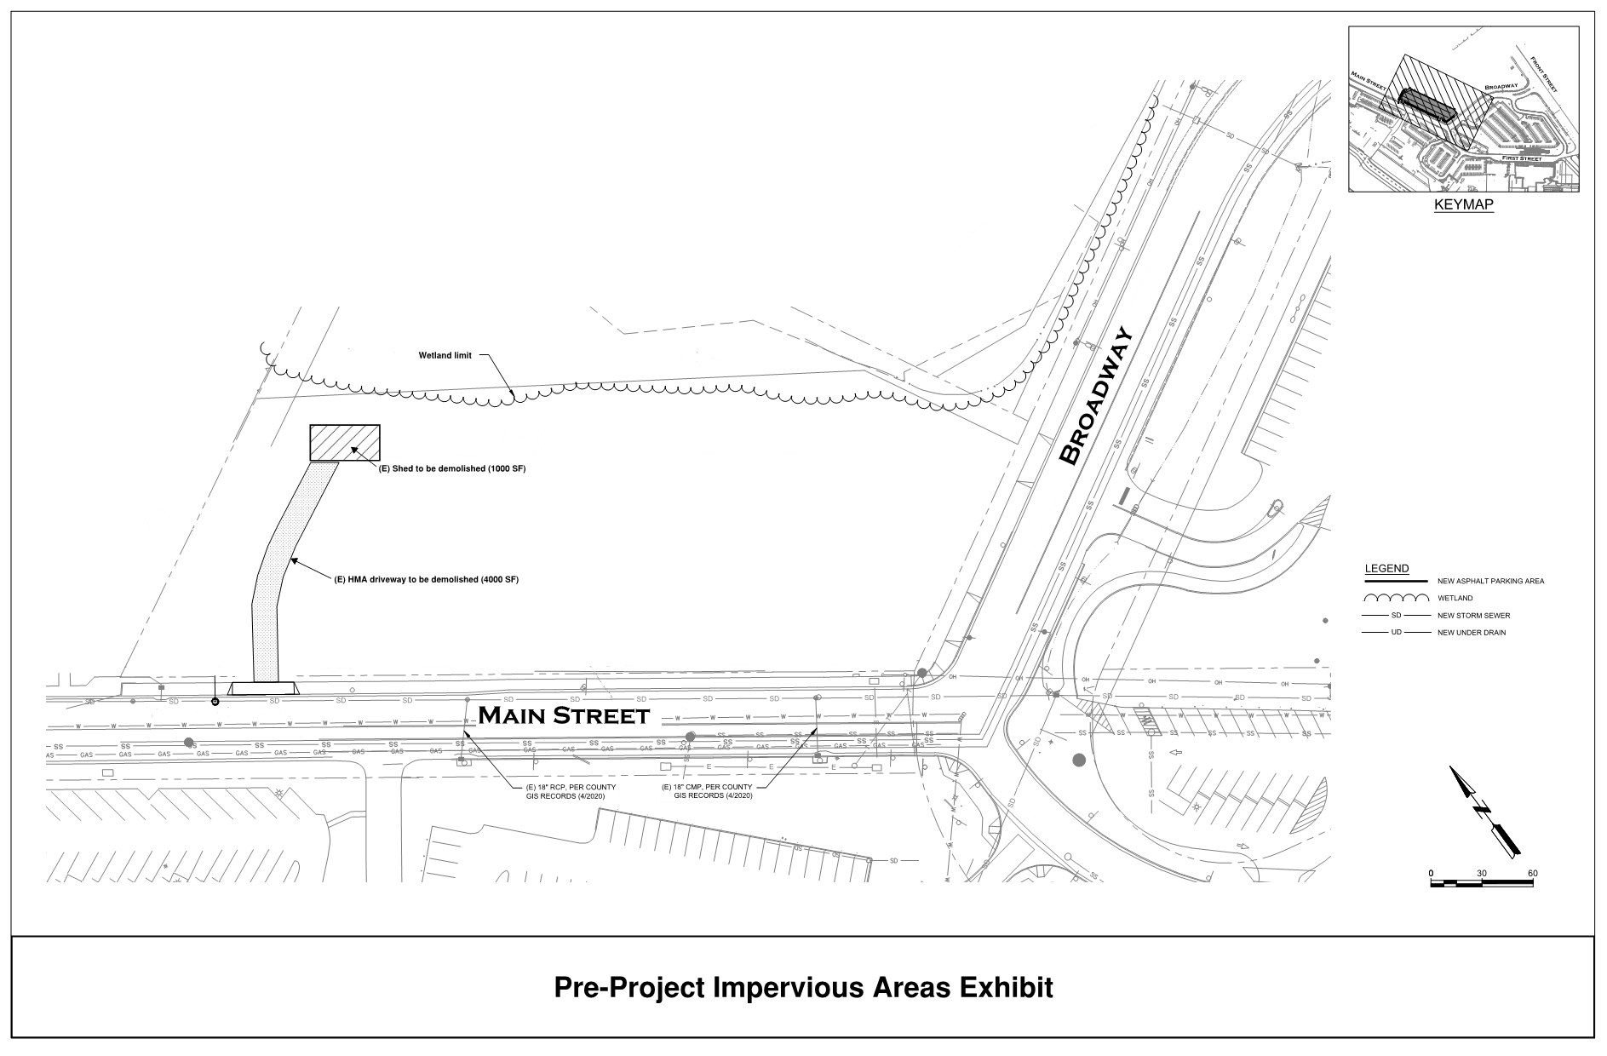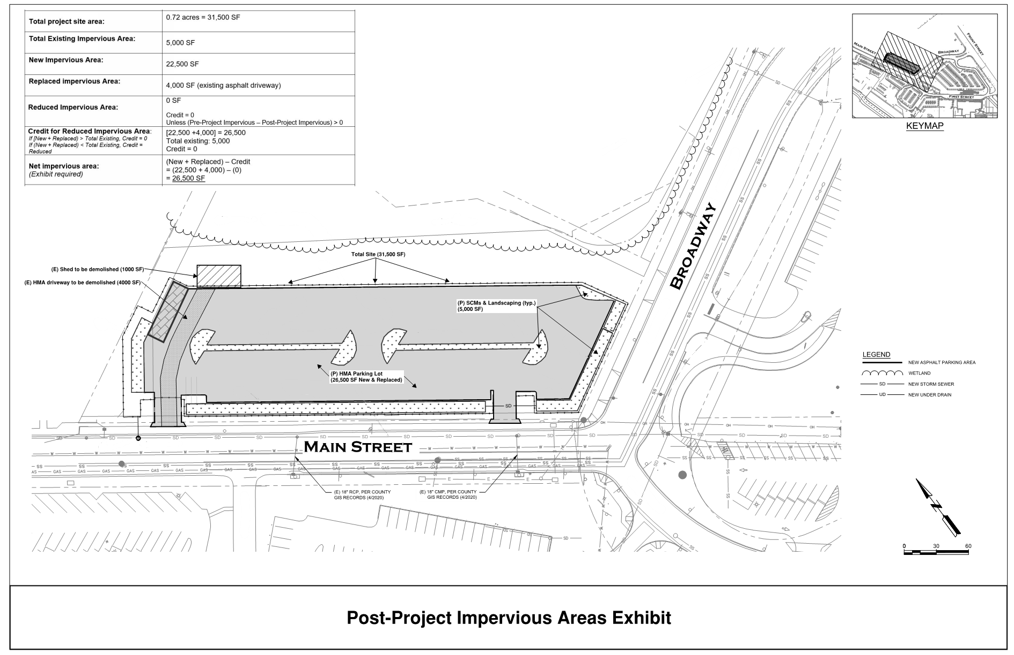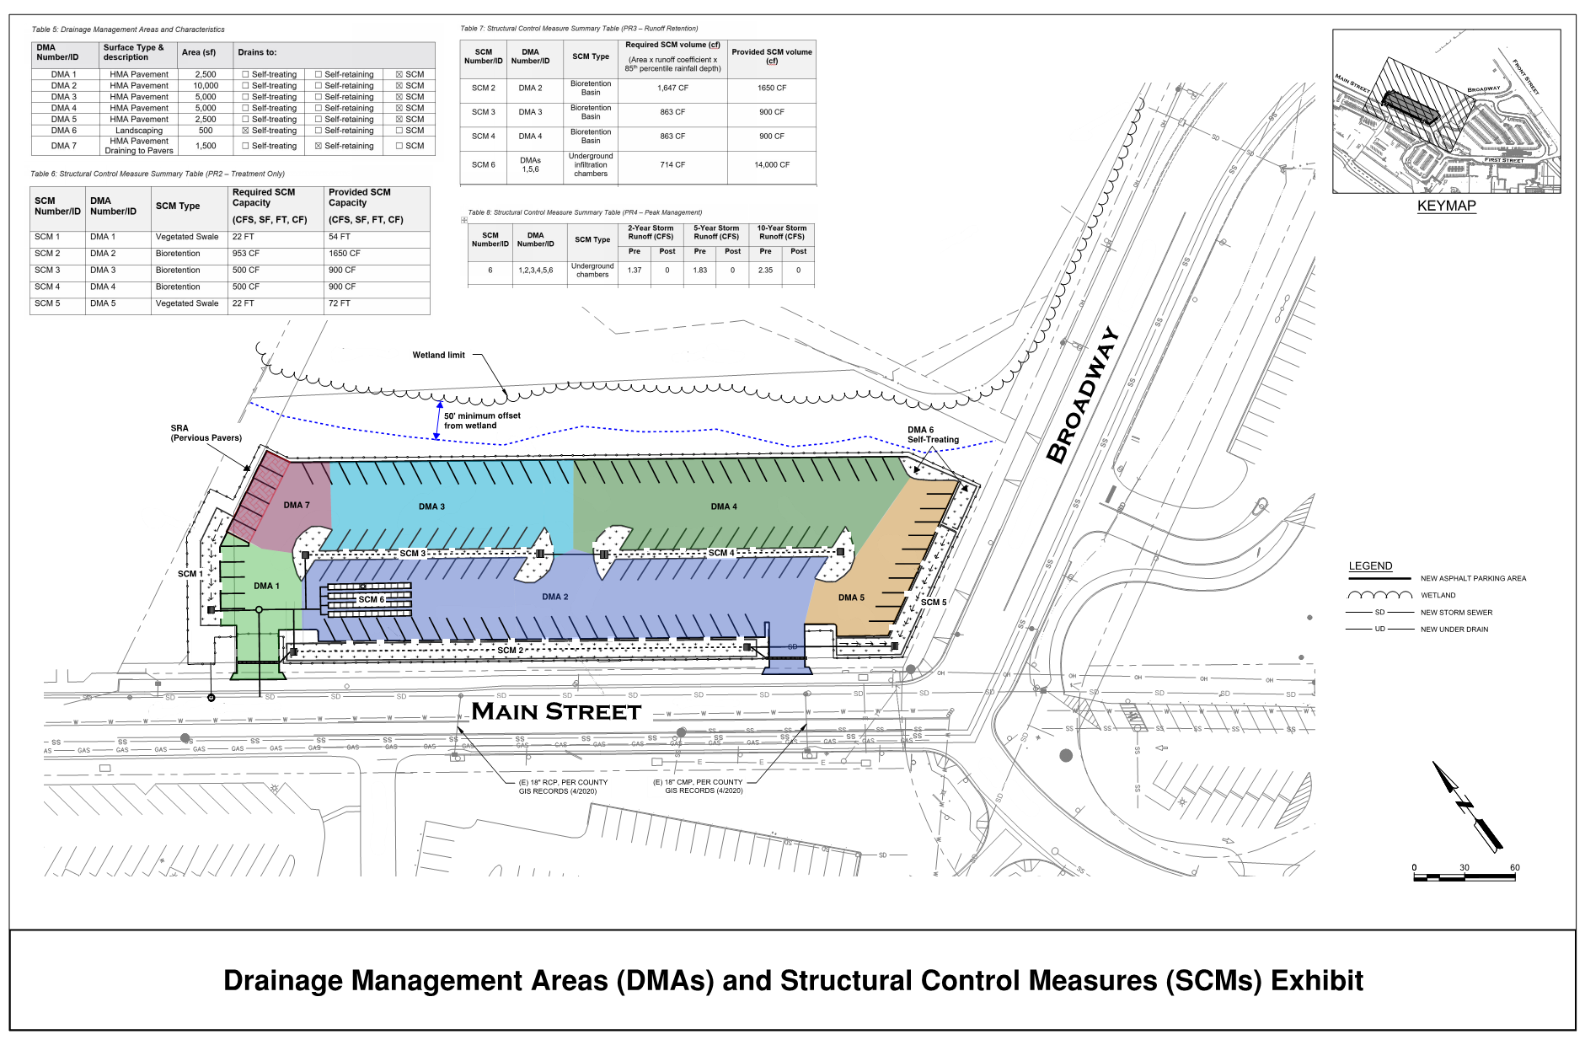

Attachment 2: SCM Sizing Calculator Outputs

Supporting Calculations for Structural Control Measures (PR2 – Treatment)

SCM 1, 5 – Vegetated Swale

Size for water quality treatment – Minimum flow capacity is equal to water quality peak runoff.
Minimum flow length to provide minimum 5-minute hydraulic residence time.

Water Quality Peak Flow: Rational Method, Q = CiA
- Q = Water Quality Peak flow (cfs)
- C = PCRs Runoff Coefficient
  - C = 0.858i³ – 0.78i² + 0.744i + 0.04 = 0.862
    - i = Percent impervious
- i = WQF Rainfall Intensity (0.2 in/hr)
- A = Tributary Area (acres)

Swale Sizing: Manning’s Equation, Q = (1.49/n) * A * R^{2/3} * S^{1/2}
- Q = Flow (cfs)
- n = Manning’s coefficient
- A = Cross-sectional area of the flow in the channel (ft²)
- R = Hydraulic Radius, A/P (ft)
  - P = Wetted perimeter of flow area (ft)
- S = Channel longitudinal slope (ft/ft)
Used Manning’s equation to iteratively solve channel design variables.

See attached spreadsheet printout for vegetated swale calculations and sizing. The site grading directs runoff from each DMA to the upstream end of the swale. The swales were also sized for hydraulic capacity per the County Public Improvement Standards, this is documented within the project’s drainage report.

SCM 2, 3, 4

Size for treatment by retention of 85th percentile storm volume (simple method)
Min Req’d Retention Volume = C x Rainfall Depth x A,
- C = PCRs Runoff Coefficient (unitless)
  - C = 0.858i³ – 0.78i² + 0.744i + 0.04 = 0.862
i = Percent impervious
- C = 0.89 for 100% impervious surface
- 85th percentile rainfall depth = 1.1 inches for this location
- A = retention tributary surface area (SF)

SCMs must also have sufficient volume to capture the rain that falls directly on them (C = 1.0)

SCM | Tributary DMA | Surface Type | C | A (SF) | Required  Volume (CF)
SCM 2 | DMA 2 | HMA | 0.89 | 10,000 | 816
 | SCM 2 | Bioretention | 1.00 | 1,500 | 138
 |  |  |  | SCM 2 Total | 953
SCM 3 | DMA 3 | HMA | 0.89 | 5,000 | 408
 | SCM 3 | Bioretention | 1.00 | 1,000 | 92
 |  |  |  | SCM 3 Total | 500
SCM 4 | DMA 4 | HMA | 0.89 | 5,000 | 408
 | SCM 4 | Bioretention | 1.00 | 1,000 | 92
 |  |  |  | SCM 4 Total | 500

Supporting Calculations for Structural Control Measures (PR3 – Retention)

Size for retention of 95th percentile storm volume (simple method)
Min Req’d Volume = C x Rainfall Depth x A,
- C = PCRs Runoff Coefficient (unitless)
  - C = 0.858i³ – 0.78i² + 0.744i + 0.04 = 0.862
i = Percent impervious
- C = 0.89 for 100% impervious surface
- C = 0.04 for 0% impervious
- 95th percentile rainfall depth = 1.9 inches for this location
- A = retention tributary surface area (SF)

SCM | Tributary DMA | Surface Type | C | A (SF) | Required  Volume (CF)
SCM 2 | DMA 2 | HMA | 0.89 | 10,000 | 1,409
 | SCM 2 | Bioretention | 1.00 | 1,500 | 238
 |  |  |  | SCM 2 Total | 1,647
SCM 3 | DMA 3 | HMA | 0.89 | 5,000 | 705
 | SCM 3 | Bioretention | 1.00 | 1,000 | 158
 |  |  |  | SCM 3 Total | 863
SCM 4 | DMA 4 | HMA | 0.89 | 5,000 | 705
 | SCM 4 | Bioretention | 1.00 | 1,000 | 158
 |  |  |  | SCM 4 Total | 863
SCM 6 | DMA 1 | HMA | 0.89 | 2500 | 352
 | DMA 5 | HMA | 0.89 | 2500 | 352
 | DMA 6 | Landscape | 0.04 | 500 | 3
 | SCM 1 | Landscape (swale) | 0.04 | 500 | 3
 | SCM 5 | Landscape (swale) | 0.04 | 500 | 3
 |  |  |  | SCM 6 Total | 714

Check PR3 Drawdown Requirements

Site infiltration rate = 1.0 inches/hour = 0.0833 ft/hour

SCM | 95th Percentile Runoff Volume (CF) | SCM Floor Area (SF) | 95th Percentile Storm Depth (FT) | SCM Type | Safety  Factor | Drawdown Time (HOURS)
 |  |  | (Volume / Area) |  |  | (Depth / Infiltration Rate x Safety Factor)
2 | 1,647 | 1,500 | 1.10 | Bioretention | 1 | 13.2
3 | 863 | 1,000 | 0.86 | Bioretention | 1 | 10.4
4 | 863 | 1,000 | 0.86 | Bioretention | 1 | 10.4
6 | 714 | 800 | 0.89 | Underground Chambers | 2 | 21.4

All SCMs fully infiltrate in less than 48 hours per Central Coast Water Board requirements.

Supporting Calculations for Structural Control Measures (PR4 – Peak Management)

Look-up Inputs from County Standard H-4 (PIS) and calculate required retention volume using County modified rational method. For County retention standard, use storm duration t = 10 hours = 36,000 seconds. For peak flow calculations, assign minimum Tc of 10 minutes to all DMAs.

- Peak Runoff, Q = CiA (CFS)
  - C = Rational method runoff coefficient
  - i = storm intensity (inches/hour)
  - A = tributary area (acres)
- Volume = V = Q x t (CF)
  - t = storm duration (seconds)

Annual Rainfall at Project Site = 25 inches
Storm Recurrence | Storm Intensity "i"  (in/hr)
(years) | 10 min (Q) | 10 hour (V)
2 | 2.1 | 0.28
5 | 2.8 | 0.42
10 | 3.6 | 0.48

Area ID | Surface Type | Area (SF) | Area (ACRES) | Runoff  Coefficient, C | Peak Runoff, Q (CFS)
 |  |  |  |  | 2-year | 5-year | 10-year
DMA 1 | HMA Pavement | 2,500 | 0.06 | 0.95 | 0.11 | 0.15 | 0.20
DMA 2 | HMA Pavement | 10,000 | 0.23 | 0.95 | 0.46 | 0.61 | 0.79
DMA 3 | HMA Pavement | 5,000 | 0.11 | 0.95 | 0.23 | 0.31 | 0.39
DMA 4 | HMA Pavement | 5,000 | 0.11 | 0.95 | 0.23 | 0.31 | 0.39
DMA 5 | HMA Pavement | 2,500 | 0.06 | 0.95 | 0.11 | 0.15 | 0.20
DMA 6 | Landscaping | 500 | 0.01 | 0.65 | 0.02 | 0.02 | 0.03
DMA 7 | HMA Pavement | 1,500 | 0.03 | 0.95 | 0.07 | 0.09 | 0.12
SCM 1 | Vegetated Swale | 500 | 0.01 | 0.65 | 0.02 | 0.02 | 0.03
SCM 2 | Bioretention Basin | 1,500 | 0.03 | 0.65 | 0.05 | 0.06 | 0.08
SCM 3 | Bioretention Basin | 1,000 | 0.02 | 0.65 | 0.03 | 0.04 | 0.05
SCM 4 | Bioretention Basin | 1,000 | 0.02 | 0.65 | 0.03 | 0.04 | 0.05
SCM 5 | Vegetated Swale | 500 | 0.01 | 0.65 | 0.02 | 0.02 | 0.03
 |  |  |  | Site Total | 1.37 | 1.83 | 2.35
 |  |  |  | DMA/SCM 2 Sub-Total | 0.50 | 0.67 | 0.87
 |  |  |  | DMA/SCM 3 Sub-Total | 0.26 | 0.35 | 0.45
 |  |  |  | DMA/SCM 4 Sub-Total | 0.26 | 0.35 | 0.45
Area ID | Surface Type | Area (SF) | Area (ACRES) | Runoff  Coefficient, C | Runoff Volume, V (CF)
 |  |  |  |  | 2-year | 5-year | 10-year
DMA 1 | HMA Pavement | 2,500 | 0.06 | 0.95 | 550 | 824 | 942
DMA 2 | HMA Pavement | 10,000 | 0.23 | 0.95 | 2,198 | 3,298 | 3,769
DMA 3 | HMA Pavement | 5,000 | 0.11 | 0.95 | 1,099 | 1,649 | 1,884
DMA 4 | HMA Pavement | 5,000 | 0.11 | 0.95 | 1,099 | 1,649 | 1,884
DMA 5 | HMA Pavement | 2,500 | 0.06 | 0.95 | 550 | 824 | 942
DMA 6 | Landscaping | 500 | 0.01 | 0.65 | 75 | 113 | 129
DMA 7 | HMA Pavement | 1,500 | 0.03 | 0.95 | 330 | 495 | 565
SCM 1 | Vegetated Swale | 500 | 0.01 | 0.65 | 75 | 113 | 129
SCM 2 | Bioretention Basin | 1,500 | 0.03 | 0.65 | 226 | 338 | 387
SCM 3 | Bioretention Basin | 1,000 | 0.02 | 0.65 | 150 | 226 | 258
SCM 4 | Bioretention Basin | 1,000 | 0.02 | 0.65 | 150 | 226 | 258
SCM 5 | Vegetated Swale | 500 | 0.01 | 0.65 | 75 | 113 | 129
 |  |  |  | Site Total | 6,578 | 9,867 | 11,276
DMA/SCM 2 Sub-Total |  |  |  |  | 2,424 | 3,636 | 4,155
DMA/SCM 3 Sub-Total |  |  |  |  | 1,250 | 1,874 | 2,142
DMA/SCM 4 Sub-Total |  |  |  |  | 1,250 | 1,874 | 2,142

10-year Volume Retained by Bioretention SCMs
= 1,650 CF (SCM 2) + 900 CF (SCM 3) + 900 CF (SCM 4)
= 3,450 CF

Confirm Bioretention SCM storage will be fully utilized, e.g. 10-year Runoff Volume is >= Volume Retained
SCM 2: 4,155 > 1,650 CF
SCM 3: 2,142 > 900 CF
SCM 4: 2,142 > 900 CF

Retain remainder runoff volume in SCM 6, Underground Chambers

Minimum Required 10-year Volume for Underground Chambers
= Total Site Runoff Volume– Volume Retained by Bioretention SCMs
= 11,276 CF – 3,450 CF
= 7,826 CF

Capacity Provided by Proposed Underground Chambers
= 14,000 CF (> 8,026 CF, ok)

Total Capacity Provided by all SCMs
= 14,000 CF + 3,450 CF
= 17,450 CF
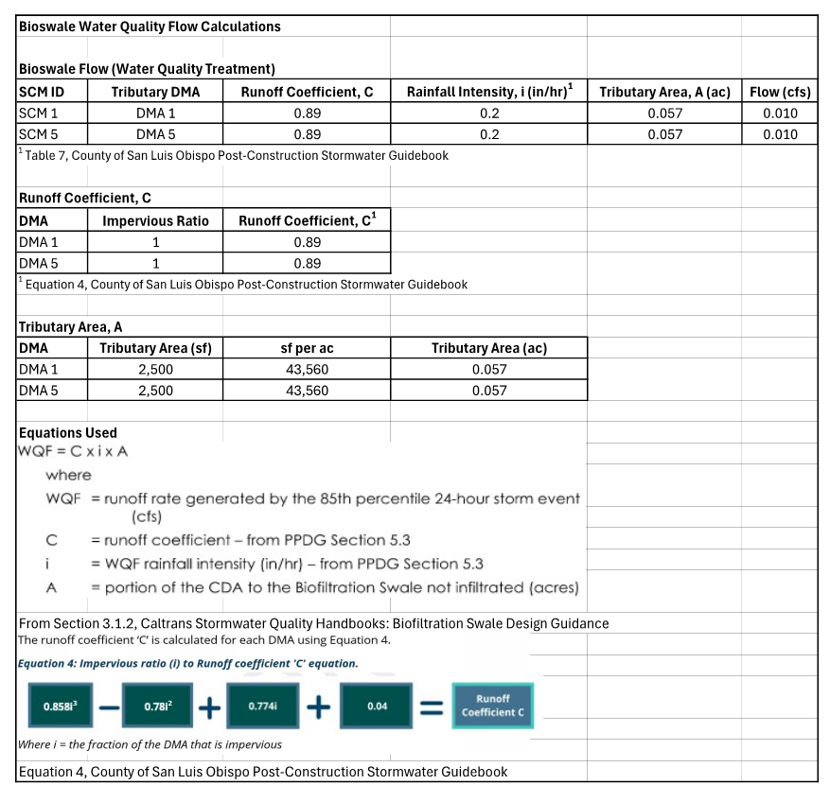

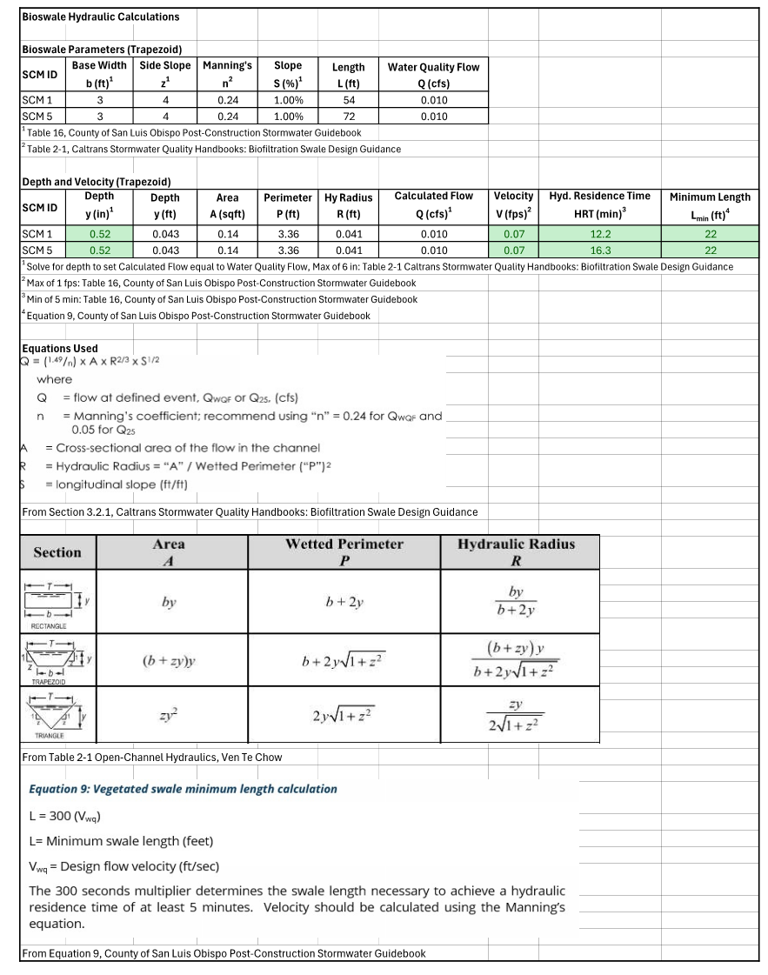
Attachment 3: Non-retention Based Treatment System Documentation
Not Applicable.
Attachment 4: LID Opportunities and Constraints Checklist

Existing Vegetation
Preserve or minimize disturbance to existing natural vegetated features. Designs that integrate natural features of the project site are better at mimicking pre-development runoff characteristics. Effective management of both existing and proposed site vegetation can reduce a development’s impact on stormwater runoff quality and quantity.
☐ Yes ☐ No ☒ N/A | Existing, high-quality vegetation has been identified and noted on the Opportunity and Constraints Map. Access to these areas will be restricted during construction.
☐ Yes ☐ No ☒ N/A | Existing trees have been identified and noted on the Opportunity and Constraints Map. The location of tree protection fencing is identified to restrict site disturbance and protect these locations during construction.
☐ Yes ☐ No ☒ N/A | Notes have been included on the corresponding site plans in areas where highly visible temporary fencing shall be placed around vegetation and tree areas that are to be preserved during construction.

Survey and Site Topography
Identify opportunities and constraints within site topography and natural drainage patterns that can be incorporated into the design. Integrating existing drainage patterns into the site plan can maintain a site’s predevelopment hydrologic function and will result in lower construction costs over sites that modify site topography and develop new drainage patterns.
☒ Yes ☐ No ☐ N/A | The site has been surveyed and a topographic base file has been created to identify topography and natural drainage patterns.
☒ Yes ☐ No ☐ N/A | Existing low-spots and sumps within the topography have been identified on the Opportunity and Constraints Map. These areas will be preserved and utilized as BMP locations where technically feasible.
☒ Yes ☐ No ☐ N/A | Existing high-spots within the topography have been identified on the Opportunity and Constraints Map. These areas be preserved for placement of structures or hardscapes where feasible, allowing runoff to drain to low lying areas for treatment.
☐ Yes ☐ No ☒ N/A | Areas within 50 feet from the top of slopes that are greater than 20% and over 10 feet of vertical relief have been identified on the Opportunity and Constraints Map. Notes on the map indicate that SCMs are not authorized within these areas.

Soil Analysis
Native undisturbed soils have a complex matrix created by the growth and decay of plant roots, earthworms, and insect activity. Topsoil stripping and stockpiling destroys soil structure and diminishes natural biological activity. Avoid and limit unnecessary site disturbances during construction. Plan LID and SCM placement where soils support infiltration (Soil Groups A and B). To the extent feasible, plan buildings and structures and hardscapes placement where soils discourage infiltration (Soil Group C and D).
☒ Yes ☐ No ☐ N/A | Locations where soils encourage infiltration (Soil Group A and B) have been identified on the Opportunity and Constraints Map. Where feasible, these areas have been preserved or dedicated to SCM locations.
☒ Yes ☐ No ☐ N/A | Locations where soils discourage infiltration (Soil Group C and D) have been identified on the Opportunity and Constraints Map. Where feasible, these locations have been dedicated to the proposed project improvements such as structures and hardscapes, or contractor staging and equipment storage areas, etc.
☒ Yes ☐ No ☐ N/A | Locations where existing structures and hardscapes will be removed during construction (exposing highly compacted soils) have been identified on the Opportunity and Constraints Map. Placement of SCMs has been avoided in these areas.

Geotechnical Analysis
Data from the preliminary geotechnical analysis or soil borings should be evaluated to support identification of opportunities and constraints. These areas should be specifically identified with limits noted on the Opportunities and Constraints Map.
☐ Yes ☒ No | The site contains areas designated as an erosion hazard, or landslide hazard.
☐ Yes ☒ No | The site contains groundwater that drains into an erosion hazard, or landslide hazard area.
☐ Yes ☒ No | The geotechnical report identified contaminated soils:  ☐ These soils will be removed during construction.  ☐ These soils will remain in place during construction.
☒ Yes ☐ No ☐ N/A | The groundwater table elevation (including seasonally high and historically high) has been determined.
☒ Yes ☐ No | The seasonally high groundwater table elevation is at least 10-feet below the proposed invert elevations of the proposed SCMs.
☐ Yes ☐ No ☒ N/A | Fractured bedrock identified through geotechnical testing is below the proposed invert elevations of the proposed SCMs.
☒ Yes ☐ No | Infiltration testing has been performed onsite at the proposed SCM locations and the geotechnical report has identified that the site is suitable for infiltration.

Setbacks
Establish setbacks and buffer zones surrounding restricted and/or sensitive areas. Identify all areas where SCMs cannot be constructed due to setback requirements. Examples include existing and proposed building foundations, municipal water wells, private water wells, septic systems, easements, etc.
☐ Yes ☐ No ☒ N/A | Private potable water wells in the vicinity have been identified (onsite and offsite) and a minimum offset radius has been established indicating where infiltration SCMs are not authorized.
☐ Yes ☐ No ☒ N/A | Municipal potable water wells in the vicinity have been identified (onsite and offsite) and a minimum 100 foot offset radius has been established indicating where infiltration based SCMs are not authorized.
☐ Yes ☐ No ☒ N/A | Within the Coastal Zone, a setback of 100 feet has been established from the upland extent of riparian vegetation. The limits of these setbacks are indicated on the Opportunity and Constraints map.
☒ Yes ☐ No ☐ N/A | Within the Urban Reserve Lines, a setback of 50 feet has been established from the upland extent of riparian vegetation. The limits of these setbacks are indicated on the Opportunity and Constraints map.
☒ Yes ☐ No ☐ N/A | A setback of either 5 or10 feet has been established from all property lines to SCMs and the limits of these setbacks have been indicated on the Opportunity and Constraints Map.
☐ Yes ☐ No ☒ N/A | A setback of either 5 or 10 feet has been established from all existing and proposed building foundations with notes indicating infiltration SCMs are not authorized within these limits.

Hydrology Features
Identify onsite and offsite downstream waterways, including creeks, wetlands, watercourse, seeps, riparian zones areas of 100-year flood inundation, potential stormwater run-on locations and depths to groundwater. All areas of hydrologic importance should be delineated at the earliest stage in the development planning process.
☒ Yes ☐ No ☐ N/A | Hydrological features such as creeks, wetlands, riparian zones, etc. have been identified and incorporated into the Opportunity and Constraints Map.  Notes have been added to the Opportunity and Constraint Map indicating that these areas will be protected by exclusionary fencing during construction to prevent resource damage.
☒ Yes ☐ No ☐ N/A | The pre-developed site drainage pathways have been identified and the limits of these features have been placed onto the Opportunities and Constraints Map.
☒ Yes ☐ No ☐ N/A | Existing storm drain infrastructure, including potential points of connection have been identified and placed onto the Opportunities and Constraints Map.
☐ Yes ☐ No ☒ N/A | Stormwater run-on locations have been identified and placed onto the Opportunities and Constraints Map.

Hazardous Areas & Pollutants of Concern (POCs)
Identify locations where existing or future pollutants may occur onsite and identify features that may prevent these pollutants from being exposed to stormwater runoff. Examples include chemical storage locations, fueling stations, and industrial operation areas.
☐ Yes ☐ No ☒ N/A | Existing hazardous storage areas and POC sources have been identified and placed onto the Opportunities and Constraints Map.
☐ Yes ☐ No ☒ N/A | Proposed hazardous storage areas and POC sources have been identified and placed onto the Opportunities and Constraints Map.

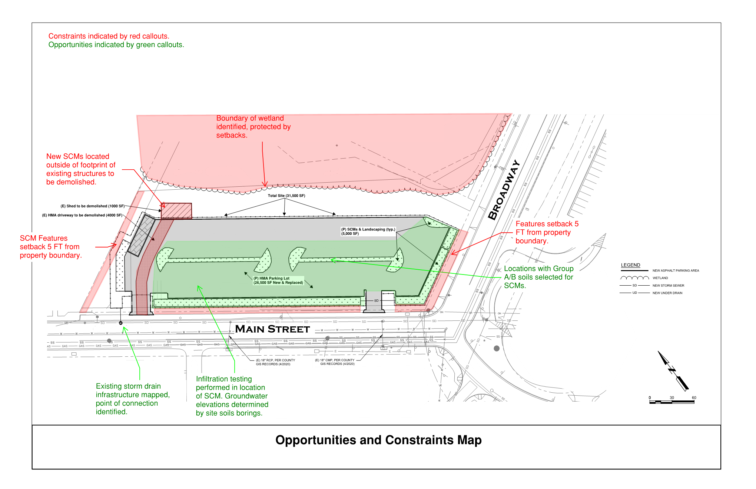
Attachment 5: Draft SCM Operations & Maintenance Forms
