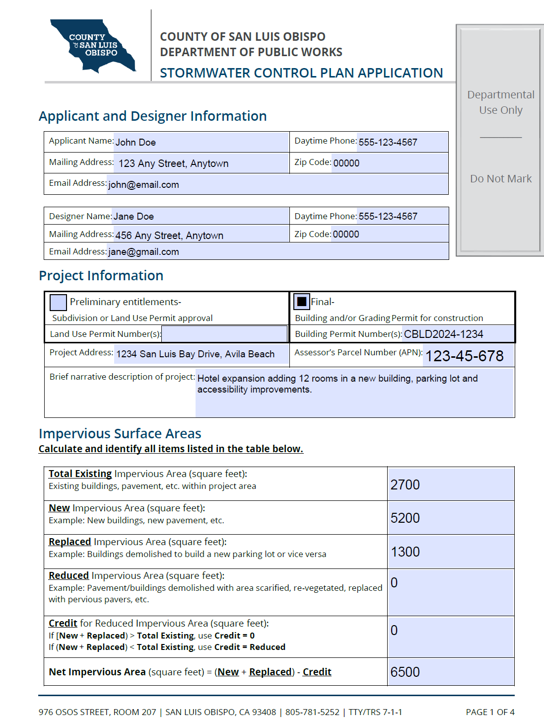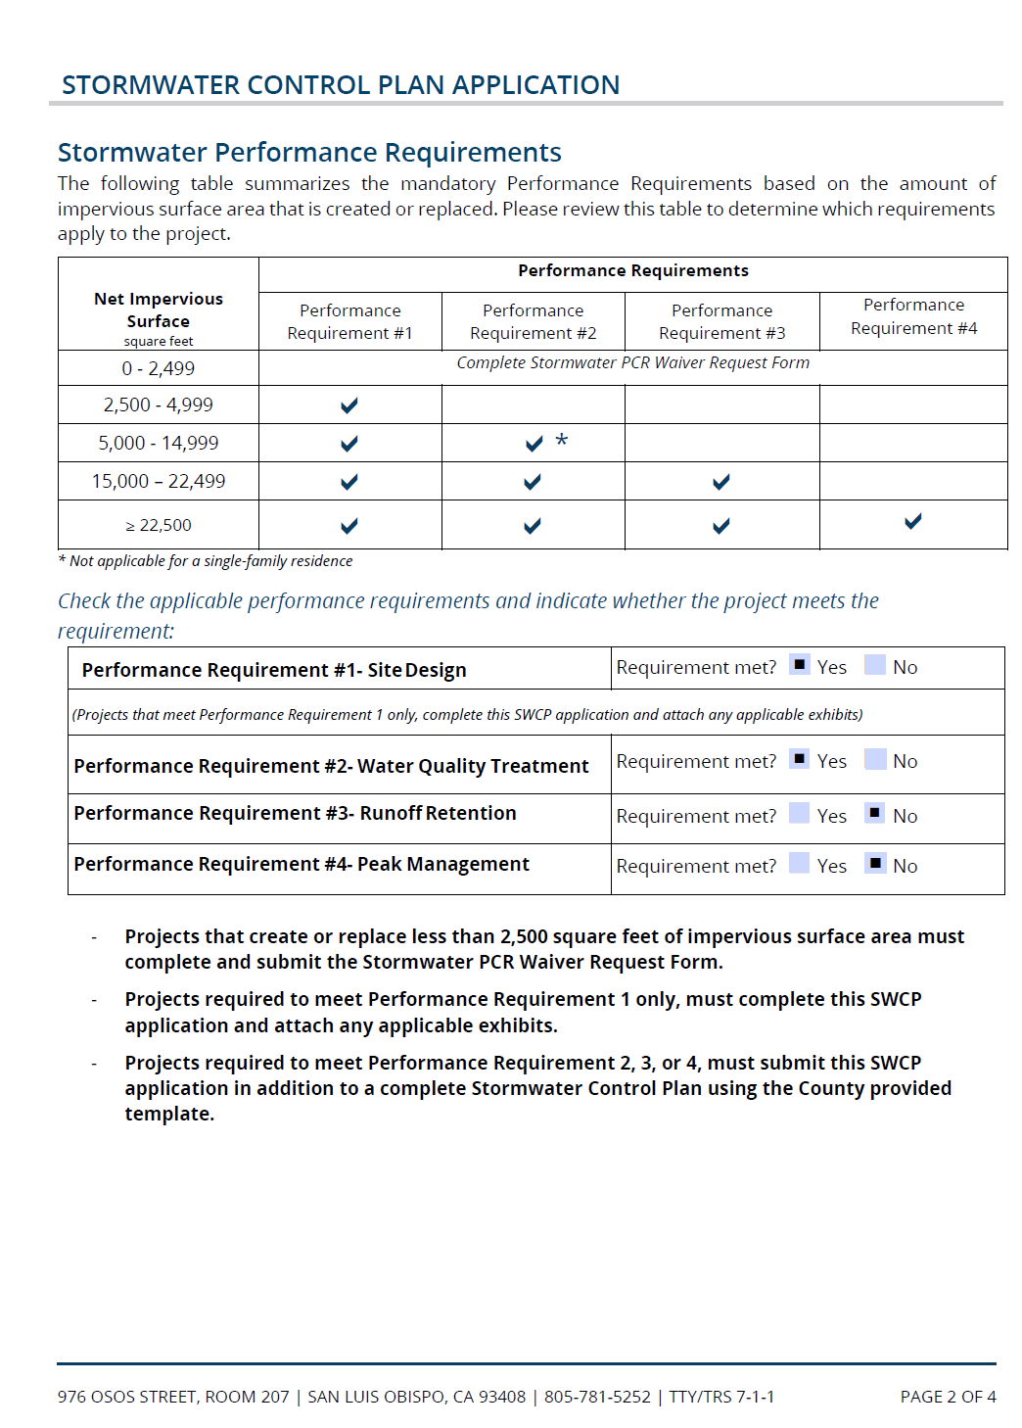
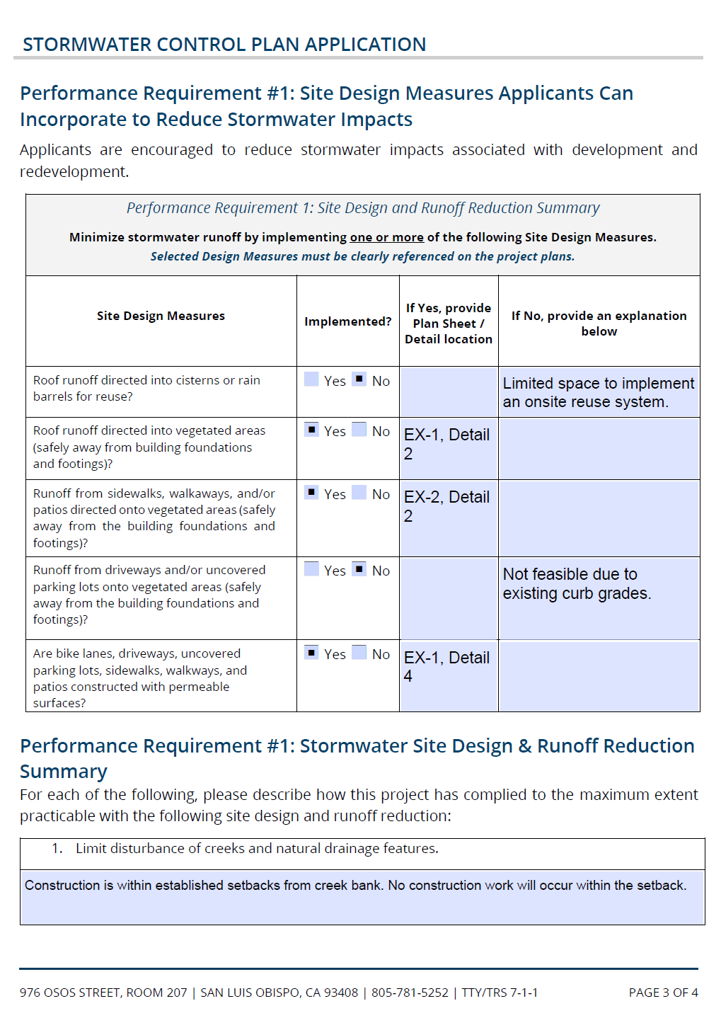
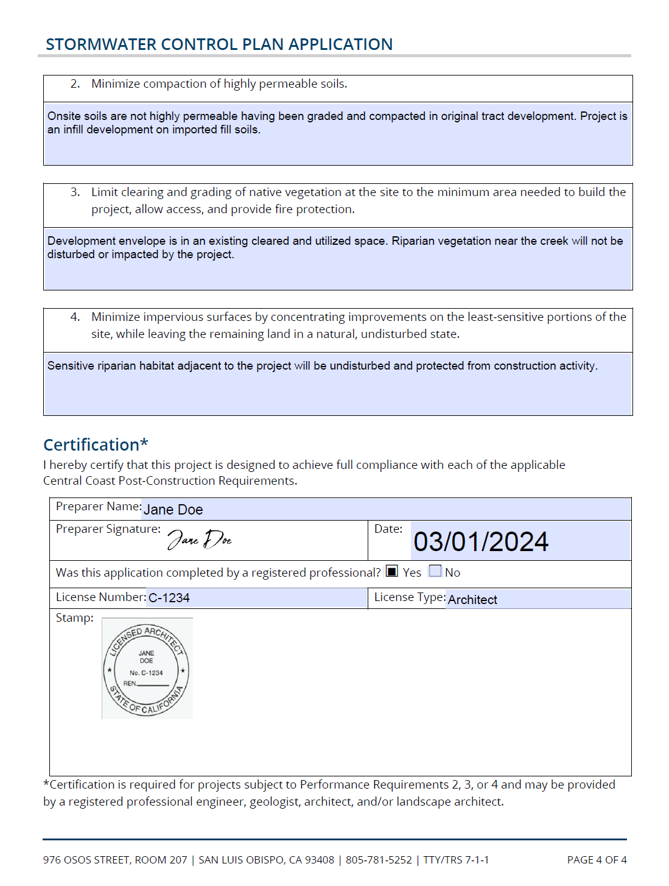

Post-Construction Stormwater Control Plan for:
San Luis Bay Hotel Expansion Project, Avila Beach

Date: | 03/01/2024
Name of owner: | John Doe
Owner’s representative and contact information: | General Land Development Company  (555) 123-4567
Plan prepared by: | General Civil Engineering & Architecture Consultants Inc.
Preparer’s name and contact information: | Jane Doe  (555)123-4567 jane@email.com
Submitted to: | County of San Luis Obispo

Preparer’s signed stamp:

Stormwater Control Plan Submittal Completion Checklist

Exhibits:
Element | Included? | Notes
Exhibit depicting SCMs, Drainage Management Areas (DMAs). | Yes | Attachment 1
Exhibit depicting pre and post project pervious and impervious areas. | Yes | Attachment 1
Opportunities and constraints map. | N/A | N/A

Required Submittals for PR#2
Element | Included? | Notes
Source control checklist. | Yes
Plan sheet detail indicating location of PR#1 implementation. | Yes
Draft long-term operations and maintenance plan. | Yes

Required Submittals for PR#3
Element | Included? | Notes
LID opportunities and constraints analysis with map. | N/A | Project does not meet threshold for PR#3.
Underground infiltration system pretreatment device certification. | N/A
Soils testing report and design infiltration rate supporting documentation. | N/A

Requirements for PR#4
Element | Included? | Notes
Calculations for peak management. | N/A | Project does not meet threshold for PR#4.

Table of Contents
1. Summary Project Data 1
2. Project setting 2
a. Project Location and Description 2
b. Existing Site Features and Conditions 3
c. Opportunities and Constraints for Stormwater Control 4
3. Low Impact Development Design Strategies 4
a. Site Design Strategies 4
b. Runoff Reduction Strategies 4
c. Self-treating and self-retaining areas 5
4. Documentation of Drainage Design 6
a. Drainage Management Areas Summary 6
b. Stormwater Structural Control Measures 6
c. Areas Draining to Self-retaining Areas 8
d. SCM Construction Checklist 9
5. Pollutant Source Control Measures 10
6. Stormwater Infrastructure Maintenance 12
a. Operations and Maintenance Agreements 12
b. Summary of Maintenance Requirements for each Structural Control Measure 13
7. Conclusions and Certification of Compliance 13

List of Tables
Table 1: Summary Project Data 1
Table 2: Site Soils summary data 2
Table 3: Performance Requirement #1 Runoff Reduction Strategies 4
Table 4: Performance Requirement #3 Additional LID Design Strategies 5
Table 5: Drainage Management Areas and Characteristics 6
Table 6: Structural Control Measure Summary Table (PR2 – Treatment Only) 7
Table 7: Structural Control Measure Summary Table (PR3 – Runoff Retention) 7
Table 8: Structural Control Measure Summary Table (PR4 – Peak Management) 8
Table 9: Subgrade Stormwater Structural Control Measures 8
Table 10: Self-retaining area summary 9
Table 11: SCM Construction Details Summary Table 9
Table 12: Plant Palette Selected for Vegetated SCMs 9
Table 13: Permanent Pollutant Source Control Measures 10

List of Figures
Figure 1:Project Vicinity Map 2
Figure 2: Project Site Soils Map (optional) 3

List of Attachments
Attachment 1: Site Maps and Exhibits 14
Attachment 2: SCM Sizing Calculator Outputs 17
Attachment 3: Non-retention Based Treatment System Documentation 19
Attachment 4: LID Opportunities and Constraints Checklist 20
Attachment 5: Draft SCM Operations and Maintenance Information 23

Summary Project Data
Table 1 provides a summary of project data related to demonstrating compliance with the Post-Construction Stormwater Management Requirements (the PCRs) for Development Projects in the Central Coast [Resolution R3-2013-0032]. The proposed project is designed to comply with applicable requirements outlined in the PCRs.
Table 1: Summary Project Data
Project name: | San Luis Bay Hotel Expansion
Project or permit number: | CBLD2024-1234
Preliminary or Final SWCP: | ☐ Preliminary entitlements  Subdivision or Land Use Permit approval. |  |  |  | ☒ Final  Building and/or Grading Permit for construction.
Project location: | 1234 San Luis Bay Drive, Avila Beach  APN 123-45-6789
Project Description: | New building for hotel expansion, parking lot and accessibility improvements.
Total project site area: | 0.29 acres  12,680 SF
Total Existing Impervious Area: | 2,700 SF
New Impervious Area: | 5,200 SF
Replaced impervious Area: | 1,300 SF
Reduced Impervious Area: | N/A
Credit for Reduced Impervious Area:  If [New + Replaced) > Total Existing, Credit = 0  If (New + Replaced) < Total Existing, Credit = Reduced | 0 SF
Net impervious area: | 6,500 SF
Watershed management zone: | WMZ 1
Design storm frequency and depth: | ☒ 85th percentile |  | ☐ 95th percentile |  |  | 1.1”
Applicable performance requirements: | ☒ PR #1 | ☒ PR #2 |  | ☐ PR #3 |  |  | ☐ PR #4

Table 2 summarizes the predominant soil characteristics of the development site and data generated from web generated soils reports and site soils explorations and testing.
Table 2: Site Soils summary data
Predominant soil type(s) of site: | Alluvial soft clays and sands.
Predominant hydrologic soils group classification of site: | ☐ Group A | ☐ Group B | ☒ Group C | ☐ Group D
Soils testing conducted at site: | ☐ Borings |  | ☐ Percolation testing
 | ☐ Infiltration testing |  | ☒ Other
Brief summary of soil testing conducted: | Cone penetration test (descriptive only – no percolation/infiltration tests)
Design soil infiltration rate: | 0.25 in/hr
Factor of Safety applied: | N/A

Project setting

Project Location and Description
The project consists of construction of a standalone expansion to an existing hotel. Maintaining the existing commercial zoning, the project proposes a 3-story hotel with 12 rooms. The building will contain approximately 10,150 square feet of usable area within a 4,210 square foot impervious footprint. Beyond the structure, the project will reconfigure sidewalk and four existing parking spots to meet current accessibility requirements.

Figure 1:Project Vicinity Map
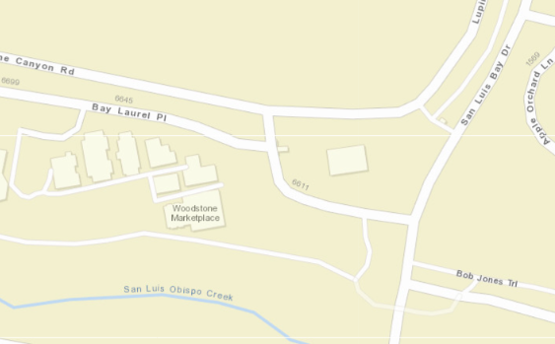

Existing Site Features and Conditions
The project site is a 0.23-acre lot that was previously graded with fill during construction of Tract 1234 in the 1990s. The lot has been used as amenity open space since construction of the tract in the early 2000s.
The current site condition is landscaping (primarily turf) over fill soils. The existing limited impervious areas consist of access flatwork, a concrete picnic area, and a decorative accessory structure. Runoff is generally directed to an existing storm drain system constructed with the Tract. The Bob Jones Trail is located beyond the southern site boundary and San Luis Obispo Creek. The site is in the San Luis Obispo Creek floodplain but only vulnerable to inundation in extreme flood events.
The site soils as mapped by NRCS are shown below. The underlying site soils are defined by the NRCS as HSG C. During soils testing, groundwater was noted approximately 20 feet below ground.
Figure 2: Project Site Soils Map (optional)
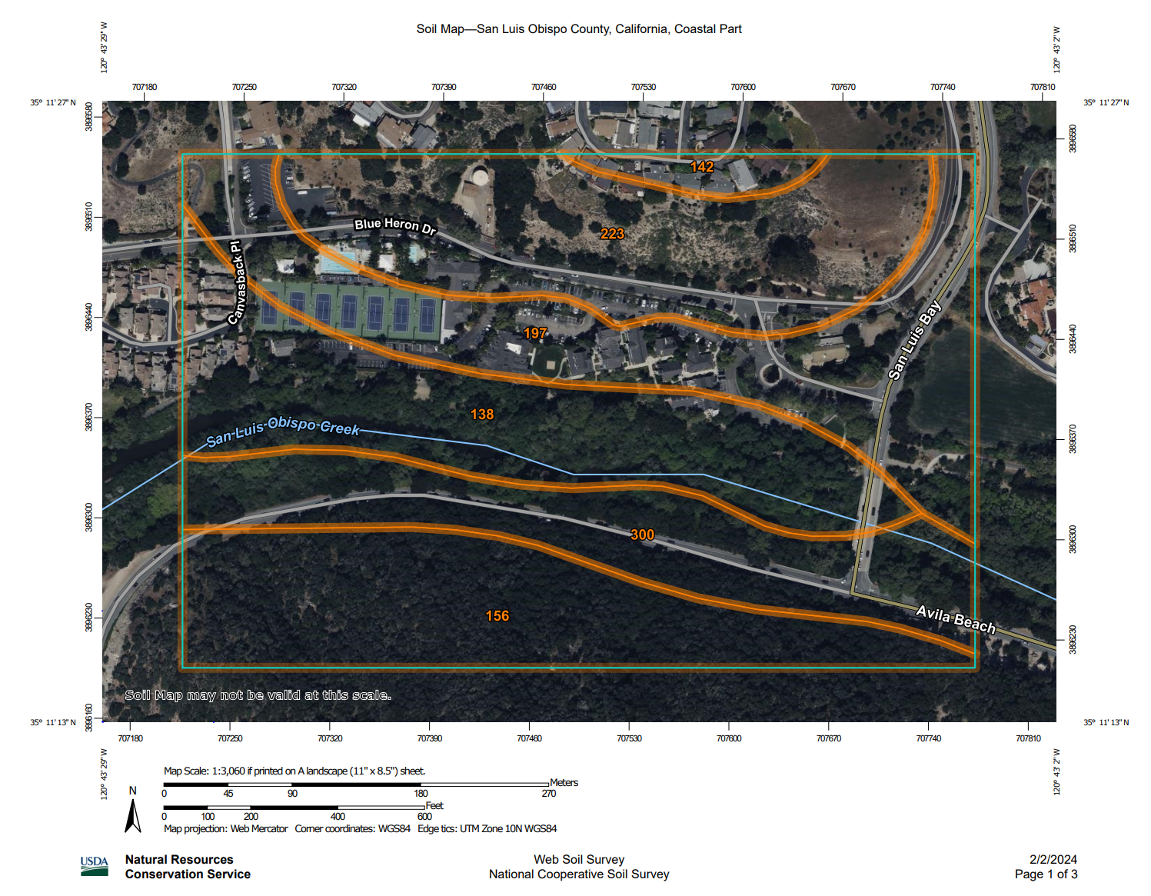

Opportunities and Constraints for Stormwater Control
Projects triggering PR#3 and above are required to submit a LID opportunities and constraints analysis.
This project is PR#3 or above: | ☐ Yes | ☒ No
The LID opportunities and constraints checklist is included as an Attachment to this SWCP. | ☐ Yes | ☐ No | ☒ Not Applicable
The LID opportunities and constraints site map is included as an Attachment to this SWCP. | ☐ Yes | ☐ No | ☒ Not Applicable

Low Impact Development Design Strategies

Site Design Strategies
Performance Requirement #1 is applicable to all regulated projects that create and/or replace ≥2,500 sf of impervious surface area. This project has incorporated Low Impact Development site design strategies as detailed below.

Limit disturbance to creeks and natural drainage features
Construction is sited beyond creek banks and natural drainage features.

Minimize compaction of highly permeable soils
Onsite soil is not highly permeable having been graded and compacted in original Tract development.

Limit clearing and grading of native vegetation to minimum area necessary
Development envelope is preexisting cleared and utilized space. Creekside vegetation will not be disturbed for the project.

Minimize impervious surfaces and concentrate improvements on the least-sensitive portions of the site.
The most sensitive areas near the creek will be left undisturbed.

Runoff Reduction Strategies

Performance Requirement #1 mandates that one or more runoff reduction measures be integrated into the site design. Table 3 indicates where runoff reduction measures have been incorporated into the proposed project.
Table 3: Performance Requirement #1 Runoff Reduction Strategies
Runoff Reduction Strategy | Guidelines | Location implemented | Plan sheet and detail
Direct roof runoff into cisterns or rain barrels for reuse. | Minimum 100-gallon volume for collection. | N/A | N/A
Direct roof runoff to vegetated areas away from foundations and footings. | Minimum 10% of roof area directed to vegetated areas. | 100% of 4,210 SF roof to biofiltration basin, OK | C-1.1, C1.2
Direct runoff from sidewalks, walkways and/or patios onto vegetated areas. | Minimum 10% of flatwork* area drainage directed to vegetated areas. | 1,330 SF flatwork to vegetated areas / 2,770 SF total flatwork area 48% > 10% OK | C-1.1
Direct runoff from driveways and/or parking lots onto vegetated areas. | Minimum 10% of flatwork area drainage directed to vegetated areas. | N/A | N/A
Construct bike lanes, driveways, uncovered parking lots, sidewalks, walkways,  and patios with permeable surfaces. | Minimum 10% of flatwork area constructed with permeable surfaces. | 480 SF Pervious Pavers / 2,770 SF total flatwork area 17% > 10% OK | C-1.1  Detail C-4.1
*Flatwork refers to smooth paved surfaces such as sidewalks, driveways, pathways, or parking lots.
Additional site design and runoff reduction strategies are required for projects that must comply with Performance Requirement #3. Table 4 indicates the design strategies that were incorporated into the project design to optimize the use of LID.
Table 4: Performance Requirement #3 Additional LID Design Strategies
Augmented PR#3 LID Design Strategies | Implemented? | Explanation
Define the development envelope and protected areas. Identify areas suitable for development and areas to remain undisturbed. | ☐ Yes ☐ No
Conserve natural areas, including existing trees, vegetation, and soils. | ☐ Yes ☐ No
Limit the overall impervious footprint of the project. | ☐ Yes ☐ No
Construct streets, sidewalks, parking lot aisles to minimum widths required. | ☐ Yes ☐ No
Set back development from creeks, wetlands, and riparian habitats. | ☐ Yes ☐ No
Conform the site layout along natural landforms. | ☐ Yes ☐ No
Avoid excessive grading and disturbance of vegetation and soils. | ☐ Yes ☐ No
Table 4 is not applicable to this project. | ☒ The requirements of this table are not applicable to the project. This project is not required to comply with Performance Requirement #3.

Self-treating and self-retaining areas
This project reduces the amount of runoff for which Stormwater Structural Control Measures (SCM) are required by utilizing self-treating and self-retaining areas.
The parking lot improvements include conversion of some stalls to permeable pavers. The pavers have been designed with adequate gravel storage to treat runoff from the tributary impervious area. However the total tributary area to the pavers including adjacent pervious areas exceed the maximum 2:1 run on ratio. Therefore the pavers are considered an SCM rather than a Self Retaining Area (SRA).

Documentation of Drainage Design

Drainage Management Areas Summary
The project site has been delineated into distinct Drainage Management Areas (DMAs), sized per the guidelines in the County of San Luis Obispo Post-Construction Stormwater Guidebook. Descriptions of each DMA are included in Table 5.
Table 5: Drainage Management Areas and Characteristics
DMA Number/ID | Surface Type & description | Area (sf) | Drains to:
DMA 1 | Parking lot improvements, access flatwork, and landscape | 4,240 | ☐ Self-treating | ☐ Self-retaining | ☒ SCM
DMA 2 | Hotel structure, flatwork, and landscape | 8,430 | ☐ Self-treating | ☐ Self-retaining | ☒ SCM

Stormwater Structural Control Measures

Structural Control Measures for PR#2 Treatment
This project requires construction of Stormwater Structural Control Measures (SCMs) to treat runoff in compliance with Performance Requirement #2, Water Quality Treatment. Treatment for each DMA is provided by one of the following types of features:
- Bioretention Basins
Required SCM Capacity = Volume (CF) of 85th percentile storm runoff from DMAs flowing to SCM
Provided SCM Capacity = Design volume (CF) of bioretention basin
- Biofiltration Features (i.e., bioretention w/ underdrain)
Required SCM Capacity = Impervious area (SF) of DMA(s) flowing to SCM x 0.04
Provided SCM Capacity = Surface area of SCM

- Vegetated Flow-Based Treatment (i.e. vegetated swales, vegetated buffer strips)
Required SCM Capacity = Minimum swale length (ft) or minimum strip width (ft)
Provided SCM Capacity = Actual swale length (ft) or strip width (ft)

- Mechanical Flow-Based Treatment Devices (i.e., filters, mechanical separators)
Required SCM Capacity = Peak flow rate (CFS) to SCM
Provided SCM Capacity = Maximum recommended flow rate (CFS) to the SCM for effective treatment per manufacturer’s specifications or design

No treatment is to be provided by direct infiltration facilities. All direct infiltration facilities must receive flows treated by flow-based treatment devices or by above-ground biofiltration or bioretention facilities. Direct infiltration should be reserved for retention and peak management.

Key attributes of these SCMs for Water Quality Treatment are summarized in Table 6. Calculations are included in Attachment 2.

Table 6: Structural Control Measure Summary Table (PR2 – Treatment Only)
SCM Number/ID | DMA Number/ID | SCM Type | Required SCM Capacity  (CFS, SF, FT, CF) | Provided SCM Capacity  (CFS, SF, FT, CF)
SCM 1 | DMA 1 | Pervious Pavers | 133 CF | 240 CF
SCM 2 | DMA 2 | Biofiltration | 95 SF | 320 SF

Structural Control Measures for PR#3 Retention
This project requires construction of Stormwater Structural Control Measures to achieve compliance with Performance Requirement #3, Retention. Key attributes of the SCMs are summarized in Table 7.
Table 7: Structural Control Measure Summary Table (PR3 – Runoff Retention)
SCM Number/ID | DMA Number/ID | SCM Type | Required SCM volume (CF)  (Area x runoff coefficient x 85th percentile rainfall depth) | Provided SCM volume (CF)
Table 7 is not applicable to this project. | ☒ The requirements of this table are not applicable to the project. This project is not required to comply with Performance Requirement #3.

Summary of Structural Control Measures (PR4 – Peak Management)
This project requires construction of Stormwater Structural Control Measures to achieve compliance with Performance Requirement #4, Peak Management. Key attributes of the SCMs are summarized in Table 8.
Table 8: Structural Control Measure Summary Table (PR4 – Peak Management)
SCM Number/ID | DMA Number/ID | SCM Type | 2-Year Storm Runoff (CFS) |  | 5-Year Storm Runoff (CFS) |  | 10-Year Storm Runoff (CFS)
 |  |  | Pre | Post | Pre | Post | Pre | Post
Table 8 is not applicable to this project. |  |  | ☒ The requirements of this table are not applicable to the project. This project is not required to comply with Performance Requirement #4.

Underground Structural Control Measures
Projects that intend to utilize underground stormwater structural control measures for retention, infiltration, or peak management must complete Table 9.
Table 9: Subgrade Stormwater Structural Control Measures
This project includes subgrade SCMs: (i.e. dry wells, chambers, vaults.) | ☐ Yes | ☐ No
The project design distributes at least 30% of the post-construction runoff volume to at-grade SCMs or LID features. | ☐ Yes | ☐ No  (If no, provide explanation below)
Explanation (as needed):
The project design includes a TAPE certified* pre-treatment device upstream of subgrade features.  (Include documentation in Attachment) | ☐ Yes | ☐ No
The project design achieves PR#2 water quality treatment using at-grade features upstream of subgrade features. | ☐ Yes | ☐ No
Table 9 is not applicable to this project. | ☒ The project does not include underground structural control measures.
*Information about TAPE certified pre-treatment devices is included in the San Luis Obispo County Post-Construction Stormwater Guidebook.

Areas Draining to Self-retaining Areas
DMA 1, which includes impervious flatwork to access the new construction, will drain to the pervious pavers to be installed in a portion of the existing parking lot. These pavers will serve as an SCM, not an SRA. Only considering the impervious area tributary to the SRA meets the default 2:1 run-on ratio. However, considering the landscaped areas in DMA 1 causes the SRA ratio to exceed the default 2:1 ratio, so the paver’s underlying gravel section has been sized as an SCM, as shown in Table 6.
Table 10: Self-retaining area summary
SRA Number/ID | Description | [A]  SRA Area (SF) | DMAs Draining to SRA Number/ID | [B]  Total Areas Draining to SRA (SF) | Ratio  [B]/[A]
Table 10 is not applicable to this project. |  | ☒ The project does not include any self-retaining areas.

The proposed design meets the criteria for the use of self-retaining areas as written in the County of San Luis Obispo Post-Construction Stormwater Guidebook:
Self-retaining area sizing: | ☐ 2:1 Sizing Ratio (acceptable) | ☒ >2:1 Sizing Ratio (un-acceptable)

SCM Construction Checklist
Construction details are provided for each SCM planned for the site. These details include specifications for materials, elevations, plants, and protection of features during construction. Table 11 indicates where SCM construction details can be reviewed.
Table 11: SCM Construction Details Summary Table
DMA Name/ID | SCM ID and Type | Plan Sheet No. | Plan set | SCM Detail No.
DMA 1 | SCM 1  Pervious Pavers | Sheet C-4.1 | ☒ Grading Permit  ☒ Structure Permit | PERVIOUS PAVERS SECTION
DMA 2 | SCM 2  Biofiltration | Sheet C-4.1 | ☒ Grading Permit  ☐ Structure Permit | BIO-TREATMENT BASIN DETAIL

Vegetated SCMs such as bioswales and bioretention require plantings to achieve optimal pollutant load reduction. Project plans must include a detail indicating the plant palette selected for vegetated SCMs. The source of the selected planting palette is summarized in Table 12.

Table 12: Plant Palette Selected for Vegetated SCMs
Name of Plant Palette | Source | Plan Sheet & Detail
Flowering Commercial Palette- Coastal | ☒ SLO County Post-Construction Guidebook Appendix D  ☐ Central Coast LIDI: Plant Palette Guidebook, or Bioretention Plant Guide  ☐ Other [describe] | Sheet L.1, Detail 5

Pollutant Source Control Measures
The project design includes pollutant source control measures to limit the exposure of potential pollutants once construction is complete. Source controls may be operational, structural or procedural. Permanent source control measures that are applicable to the project site and that will be implemented are indicated in Table 13.
Table 13: Permanent Pollutant Source Control Measures
Pollutant Generating Activities and Sources | Source Control BMP | Method selected
Vehicle or equipment cleaning.  Un-authorized non-stormwater discharges. | Educational stormwater signage.  (Operational.) | ☒‘No Dumping’ storm drain inlet markers.  ☐‘Rainwater only’ storm drain inlet markers.  ☐ Educational or informational stormwater signage for LID features.
Fuel dispensing areas.  Chemical or material storage areas.  Refuse areas. | Secondary containment devices.  (Structural) | ☐ Raised permanent containment around liquid storage tanks.  ☐ Rolling berm containment around liquid handling or loading areas.
Loading docks.  Parking/storage areas. | Permanent protective shelters/covers.  (Structural.)  Waste collection and disposal equipment. (Operational.) | ☐ Permanent storage sheds/canopies to shield equipment or materials.  ☐ Canopy downspouts routed away from shelters covering equipment and materials.  ☒ Trash and recycling receptacles provided in parking and storage areas.
Refuse/ trash disposal areas.  Building and grounds maintenance. | Permanent protective shelters/covers.  (Structural)  Informational signage.  (Operational)  Periodic inspection.  (Operational.) | ☒ Drainage from adjoining areas diverted away from trash storage area.  ☒ Trash storage area walled and covered.  ☒ Storm drains located away from trash storage areas.  ☐ Trash storage area paved to mitigate spills.  ☐ Informational signage posted.  ☐ Scheduled periodic inspection of waste receptacles.
Loading & unloading areas. | Permanent protective shelters.  (Structural.)  Drainage routing or containment.  (Structural.)  Spill cleanup and control materials.  (Operational) | ☐ Permanent overhead canopy covering loading docks.  ☐ Below-grade loading docks drain to water quality pre-treatment device.  ☐ Trash receptacles provided near loading docks.  ☐ Spill cleanup kit provided near loading docks.  ☐ Loading docks located away from storm drain inlets.
Restaurants, grocery stores, and other food service operations. | Equipment cleaning and maintenance procedures.  (Operational)  Drains clearly marked and verified.  (Operational) | ☐ Indoor sinks and cleaning facilities sized for largest possible items for cleaning.  ☐ Sinks and cleaning areas connected to grease interceptors.  ☐ Indoor floor drains connected to sanitary sewer.  ☐ Outdoor floor drains connected to sanitary sewer in permanently covered areas.  ☐ Cleaning and degreasing agents used on site are low-hazard or biodegradable.
High traffic pedestrian areas.  Pet-friendly areas. | Waste collection and disposal equipment. (Operational)  Educational signage.  (Operational) | ☒ Permanent pet waste bag dispenser stations provided.  ☒ Trash and recycling receptacles provided in areas of heavy pedestrian traffic.  ☒ Informational pet waste signage installed.
Outdoor Pools, Spas, Fountains | Drainage design to manage overflows, backwashing, and maintenance. (Structural)  Technician training and disposal plans. (Operational) | ☐ Design prevents overflow discharge to streets, storm drains or creeks/waterways.  ☐ Design incorporates filter backwash treatment plan.  ☐ Service technicians trained in appropriate chemical application and disposal.  ☐ Disposal plan for periodic water feature draining/refilling is established.
Landscaping maintenance.  Landscaping irrigation systems. | Storage areas for landscaping chemicals. (Structural.)  Water efficient irrigation system.  (Operational.)  Training for maintenance staff and chemical applicators. (Operational.)  Less hazardous chemicals selected for maintenance. (Procedural.) | ☐ Covered and contained storage area provided for all pesticide, herbicides, and landscaping chemicals.  ☐ Temporary landscape material stockpiling area provided away from water courses and drain inlets.  ☒ Water efficient irrigation systems installed.  ☒ Scheduled semi-annual irrigation maintenance and system verification.  ☐ Employees and maintenance contractors appropriately licensed and trained.  ☒ Chemical use (fertilizers, herbicides, pesticides) is minimized.  ☐ Chemical applicators licensed or trained in proper application and disposal requirements.  ☐ Less toxic chemicals substituted for hazardous toxic chemicals.
Fire Sprinkler Test Water | Fire system flushing water disposal plan. (Operational.) | ☒ Fire system flushing area sited near landscaping for test water infiltration.  ☐ Fire sprinkler line flush testing area designed for flow direction to sanitary sewer.
Vehicle or Equipment Parking areas. | Parking area regular maintenance. (Operational.)  Vehicle and equipment regular maintenance. (Operational.) | ☒ Trash receptacles provided in areas of heavy pedestrian traffic.  ☒ Sweeping and litter removal scheduled as part of ongoing maintenance.  ☐ Vehicles and equipment regularly serviced at off-site location.  ☐ Vehicles and equipment fueled in designated location with spill control kits.
Un-authorized non-stormwater discharges | Employee/contractor training.  (Operational.) | ☐ Mobile cleaning vendors appropriately trained, capable of collecting and removing wash waters for offsite disposal.  ☐ Service contractors equipped with appropriate washout and containment supplies.

Stormwater Infrastructure Maintenance

Operations and Maintenance Agreements
The project owner, John Doe, will be responsible for operations and maintenance of the stormwater system in perpetuity. These responsibilities are transferred to future owners upon completion of sale of the project site or portion thereof. This project intends to delegate responsibility for long-term operations and maintenance as follows:
Recorded maintenance agreement type: | ☒ Agreement | ☐ Codes, Covenants & Restrictions language.
The party responsible for operations and maintenance of the system will be: | ☒ Single owner | ☐ Multiple owners
 | ☐ Owner’s association | ☐ Corporation
The party responsible for operations and maintenance of the system: | ☒ Is located locally in San Luis Obispo County. | ☐ Has a designated local representative in San Luis Obispo County.
 | ☐ Is located outside the County, within California. | ☐ Is located outside California.
The party responsible for operations and Maintenance intends to complete annual inspections and maintenance by the following methods: | ☐ Self-inspect and maintain. Contract out for additional maintenance support as necessary. | ☒ Contract out all system inspection and maintenance services.

Summary of Maintenance Requirements for each Structural Control Measure
The maintenance requirements and anticipated annual costs for maintaining each SCM associated with the project are documented in County form SWP-1008. Copies of these forms are included as Attachment 5. An operations and maintenance agreement will be recorded with the County Clerk Recorder prior to final of project construction.

Conclusions and Certification of Compliance
This project meets each of the applicable Performance Requirements stipulated by the PCRs.
Performance Requirement #1 | Compliance achieved onsite?  ☒ Yes ☐ No | Measure(s) implemented:  Direct roof runoff to vegetated areas away from foundations and footings.  Direct runoff from sidewalks, walkways and/or patios onto vegetated areas.  Construct flatwork with permeable surfaces.
Performance Requirement #2 | Volume of treatment required for project:  713 SF | Volume of treatment provided by project:  800 SF | Compliance achieved:  ☒ Onsite ☐ Offsite
Performance Requirement #3 | Volume of retention required for total project:  N/A | Volume of retention provided by total project:  N/A | Compliance achieved:  ☒ Onsite ☐ Offsite
Performance Requirement #4 | Peak management reduction required:  N/A | Peak management reduction achieved:  N/A

The registered professional engineer, geologist, architect or landscape architect authoring this report certifies that all applicable post-construction stormwater performance requirements have been applied to this project and that this plan conforms to the requirements of the Central Coast Post-Construction Stormwater Management Resolution R3-2013-0032 and the current edition of the County’s Post-Construction Stormwater Guidebook.
Preparer Name: Jane Doe
Date: 03/01/2024
License Number: C-1234 | License Type: Architect

Attachment 1: Site Maps and Exhibits

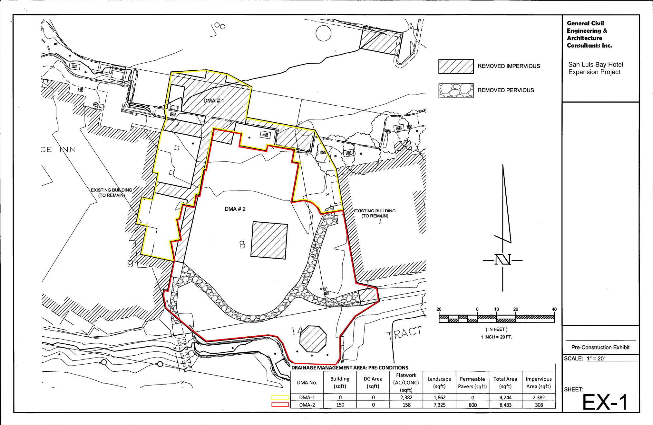
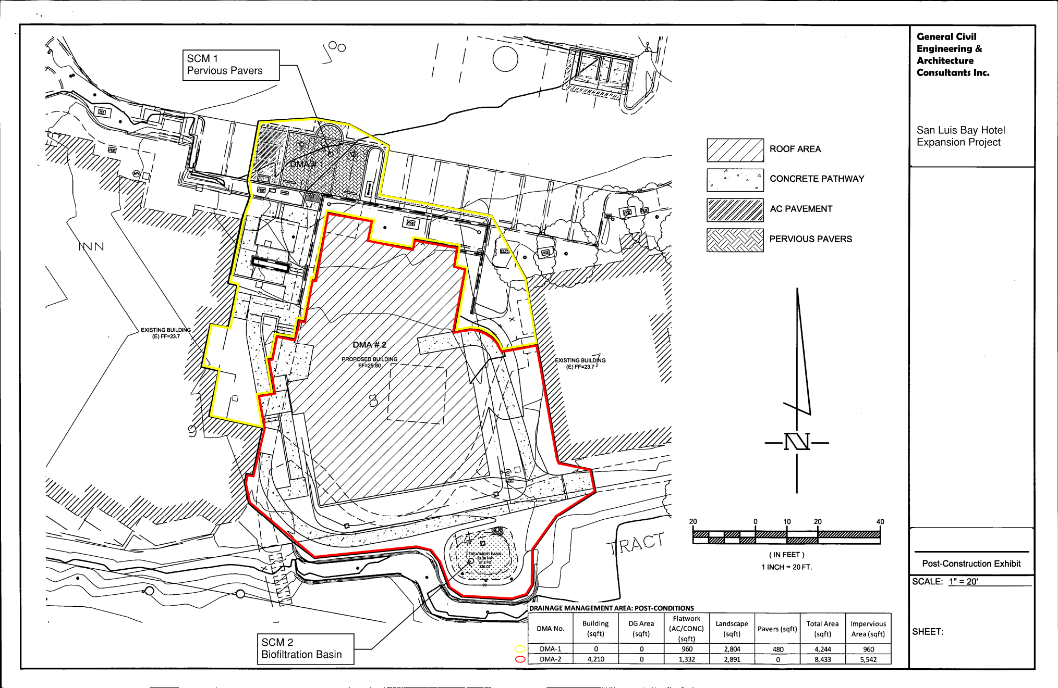

Attachment 2: SCM Sizing Calculator Outputs

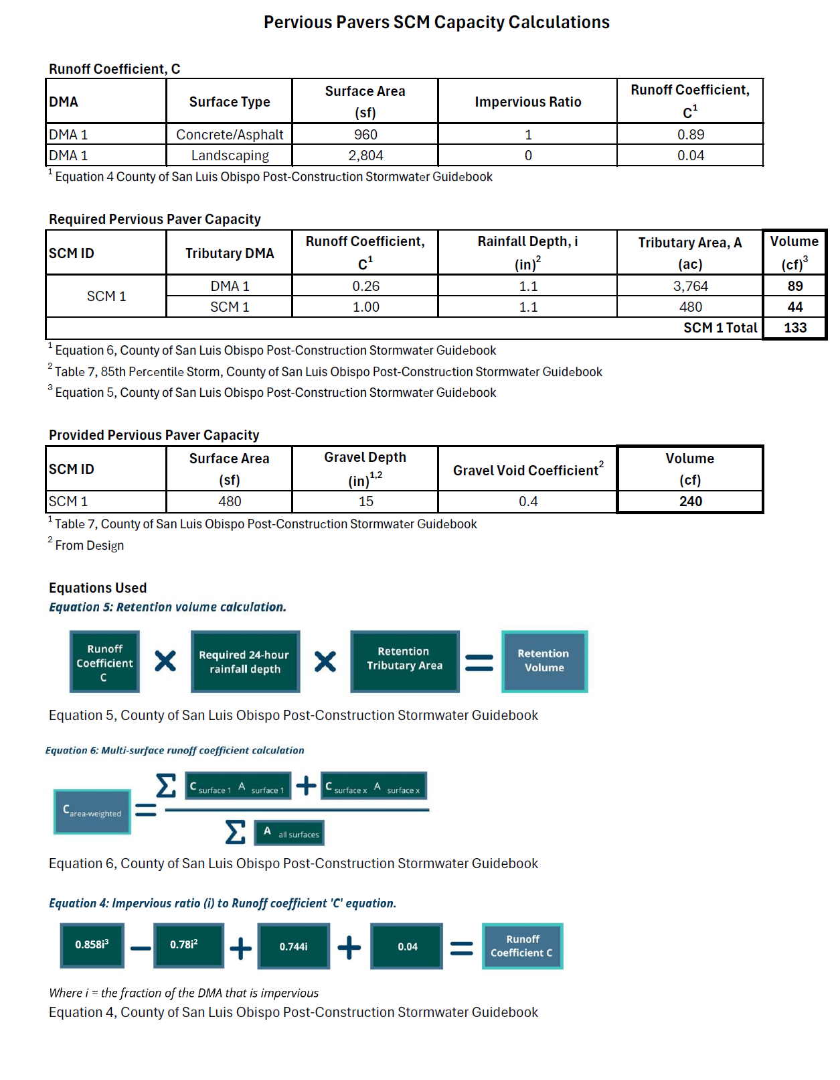
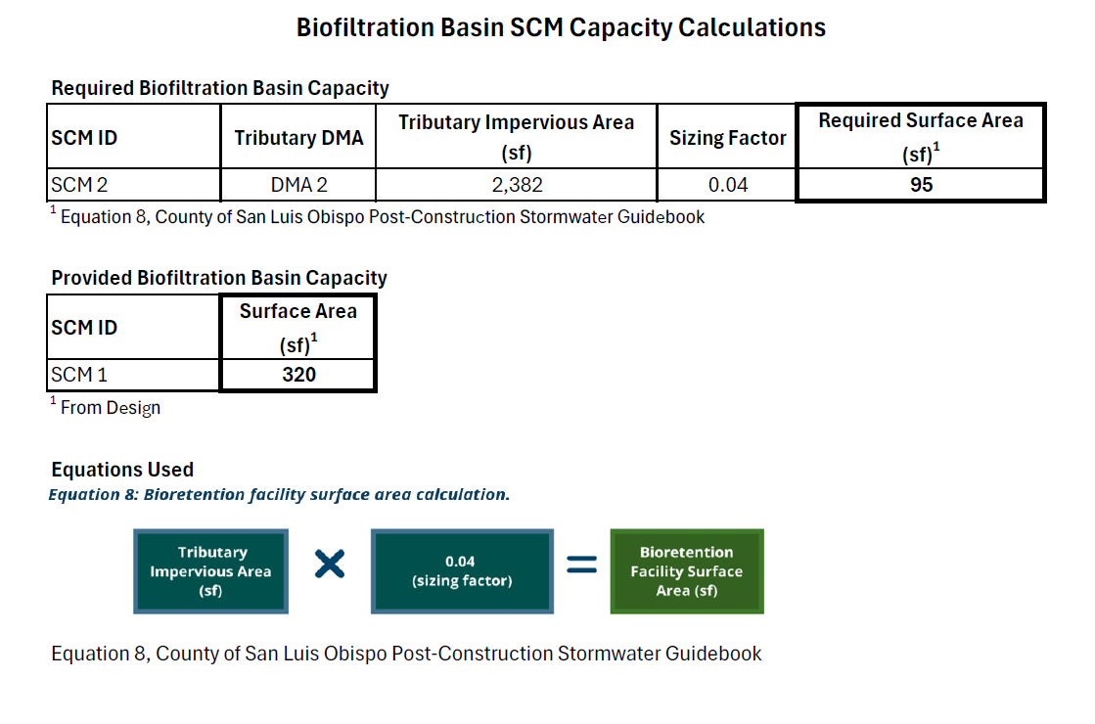

Attachment 3: Non-retention Based Treatment System Documentation
Not Applicable
Attachment 4: LID Opportunities and Constraints Checklist
Not Applicable. Project is not subject to PR#3.

Existing Vegetation
Preserve or minimize disturbance to existing natural vegetated features. Designs that integrate natural features of the project site are better at mimicking pre-development runoff characteristics. Effective management of both existing and proposed site vegetation can reduce a development’s impact on stormwater runoff quality and quantity.
☐ Yes ☐ No ☐ N/A | Existing, high-quality vegetation has been identified and noted on the Opportunity and Constraints Map. Access to these areas will be restricted during construction.
☒ Yes ☐ No ☐ N/A | Existing trees have been identified and noted on the Opportunity and Constraints Map. The location of tree protection fencing is identified to restrict site disturbance and protect these locations during construction.
☐ Yes ☐ No ☐ N/A | Notes have been included on the corresponding site plans in areas where highly visible temporary fencing shall be placed around vegetation and tree areas that are to be preserved during construction.

Survey and Site Topography
Identify opportunities and constraints within site topography and natural drainage patterns that can be incorporated into the design. Integrating existing drainage patterns into the site plan can maintain a site’s predevelopment hydrologic function and will result in lower construction costs over sites that modify site topography and develop new drainage patterns.
☐ Yes ☐ No ☐ N/A | The site has been surveyed and a topographic base file has been created to identify topography and natural drainage patterns.
☐ Yes ☐ No ☐ N/A | Existing low-spots and sumps within the topography have been identified on the Opportunity and Constraints Map. These areas will be preserved and utilized as BMP locations where technically feasible.
☐ Yes ☐ No ☐ N/A | Existing high-spots within the topography have been identified on the Opportunity and Constraints Map. These areas be preserved for placement of structures or hardscapes where feasible, allowing runoff to drain to low lying areas for treatment.
☐ Yes ☐ No ☐ N/A | Areas within 50 feet from the top of slopes that are greater than 20% and over 10 feet of vertical relief have been identified on the Opportunity and Constraints Map. Notes on the map indicate that SCMs are not authorized within these areas.

Soil Analysis
Native undisturbed soils have a complex matrix created by the growth and decay of plant roots, earthworms, and insect activity. Topsoil stripping and stockpiling destroys soil structure and diminishes natural biological activity. Avoid and limit unnecessary site disturbances during construction. Plan LID and SCM placement where soils support infiltration (Soil Groups A and B). To the extent feasible, plan buildings and structures and hardscapes placement where soils discourage infiltration (Soil Group C and D).
☐ Yes ☐ No ☐ N/A | Locations where soils encourage infiltration (Soil Group A and B) have been identified on the Opportunity and Constraints Map. Where feasible, these areas have been preserved or dedicated to SCM locations.
☐ Yes ☐ No ☐ N/A | Locations where soils discourage infiltration (Soil Group C and D) have been identified on the Opportunity and Constraints Map. Where feasible, these locations have been dedicated to the proposed project improvements such as structures and hardscapes, or contractor staging and equipment storage areas, etc.
☐ Yes ☐ No ☐ N/A | Locations where existing structures and hardscapes will be removed during construction (exposing highly compacted soils) have been identified on the Opportunity and Constraints Map. Placement of SCMs has been avoided in these areas.

Geotechnical Analysis
Data from the preliminary geotechnical analysis or soil borings should be evaluated to support identification of opportunities and constraints. These areas should be specifically identified with limits noted on the Opportunities and Constraints Map.
☐ Yes ☐ No | The site contains areas designated as an erosion hazard, or landslide hazard.
☐ Yes ☐ No | The site contains groundwater that drains into an erosion hazard, or landslide hazard area.
☐ Yes ☐ No | The geotechnical report identified contaminated soils:  ☐ These soils will be removed during construction.  ☐ These soils will remain in place during construction.
☐ Yes ☐ No ☐ N/A | The groundwater table elevation (including seasonally high and historically high) has been determined.
☐ Yes ☐ No | The seasonally high groundwater table elevation is at least 10-feet below the proposed invert elevations of the proposed SCMs.
☐ Yes ☐ No ☐ N/A | Fractured bedrock identified through geotechnical testing is below the proposed invert elevations of the proposed SCMs.
☐ Yes ☐ No | Infiltration testing has been performed onsite at the proposed SCM locations and the geotechnical report has identified that the site is suitable for infiltration.

Setbacks
Establish setbacks and buffer zones surrounding restricted and/or sensitive areas. Identify all areas where SCMs cannot be constructed due to setback requirements. Examples include existing and proposed building foundations, municipal water wells, private water wells, septic systems, easements, etc.
☐ Yes ☐ No ☐ N/A | Private potable water wells in the vicinity have been identified (onsite and offsite) and a minimum offset radius has been established indicating where infiltration SCMs are not authorized.
☐ Yes ☐ No ☐ N/A | Municipal potable water wells in the vicinity have been identified (onsite and offsite) and a minimum 100 foot offset radius has been established indicating where infiltration based SCMs are not authorized.
☐ Yes ☐ No ☐ N/A | Within the Coastal Zone, a setback of 100 feet has been established from the upland extent of riparian vegetation. The limits of these setbacks are indicated on the Opportunity and Constraints map.
☐ Yes ☐ No ☐ N/A | Within the Urban Reserve Lines, a setback of 50 feet has been established from the upland extent of riparian vegetation. The limits of these setbacks are indicated on the Opportunity and Constraints map.
☐ Yes ☐ No ☐ N/A | A setback of either 5 or10 feet has been established from all property lines to SCMs and the limits of these setbacks have been indicated on the Opportunity and Constraints Map.
☐ Yes ☐ No ☐ N/A | A setback of either 5 or 10 feet has been established from all existing and proposed building foundations with notes indicating infiltration SCMs are not authorized within these limits.

Hydrology Features
Identify onsite and offsite downstream waterways, including creeks, wetlands, watercourse, seeps, riparian zones areas of 100-year flood inundation, potential stormwater run-on locations and depths to groundwater. All areas of hydrologic importance should be delineated at the earliest stage in the development planning process.
☐ Yes ☐ No ☐ N/A | Hydrological features such as creeks, wetlands, riparian zones, etc. have been identified and incorporated into the Opportunity and Constraints Map.  ☐ Notes have been added to the Opportunity and Constraint Map indicating that these areas will be protected by exclusionary fencing during construction to prevent resource damage.
☐ Yes ☐ No ☐ N/A | The pre-developed site drainage pathways have been identified and the limits of these features have been placed onto the Opportunities and Constraints Map.
☐ Yes ☐ No ☐ N/A | Existing storm drain infrastructure, including potential points of connection have been identified and placed onto the Opportunities and Constraints Map.
☐ Yes ☐ No ☐ N/A | Stormwater run-on locations have been identified and placed onto the Opportunities and Constraints Map.

Hazardous Areas & Pollutants of Concern (POCs)
Identify locations where existing or future pollutants may occur onsite and identify features that may prevent these pollutants from being exposed to stormwater runoff. Examples include chemical storage locations, fueling stations, and industrial operation areas.
☐ Yes ☐ No ☐ N/A | Existing hazardous storage areas and POC sources have been identified and placed onto the Opportunities and Constraints Map.
☐ Yes ☐ No ☐ N/A | Proposed hazardous storage areas and POC sources have been identified and placed onto the Opportunities and Constraints Map.

Attachment 5: Draft SCM Operations and Maintenance Information
