Overview

Please provide the following information.

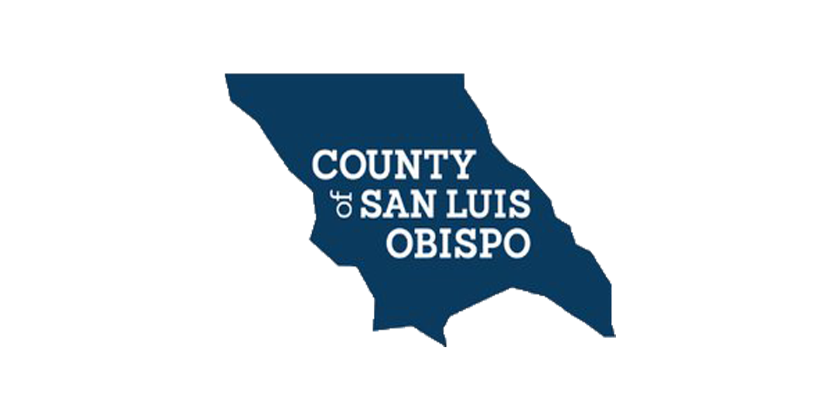 | Neighborly  Administration and Capacity Building Application  Urban County of San Luis Obispo | Department of Social Services  Adult and Homeless Services Branch  PO Box 8119  San Luis Obispo, CA 93403-8119  SS_HSDinfo@co.slo.ca.us

Applications are accepted electronically via Neighborly Software only.

Please review the Notice of Funding Availability (NOFA) and Application Guidelines before submitting your application. All applications must meet the eligibility criteria and requirements set forth in the NOFA. The Urban County of San Luis Obispo receives funding from local, state, and federal sources including Community Development Block Grant (CDBG), HOME Investment Partnership (HOME), and Emergency Solutions Grant (ESG). Please be aware that the CDBG, HOME, and ESG fund sources are not permitted to support activities or projects located in the City of Grover Beach.
Cities participating in the Urban County of San Luis Obispo are eligible to apply for funding from the CDBG grant for Administration and/or Capacity Building projects.

Please note, the online application in Neighborly has branching questions depending on how you answer certain questions. Depending on your project, not all questions that appear on this printed version may be applicable or required.

A. Applicant Information
No data saved

A. Applicant Information

Please provide the following information.

PRIMARY APPLICANT INFORMATION-LEAD AGENCY
A.1. Organization Name

A.2. Type of Organization

A.2.a. Define Other:

A.3. UEI Number: For more information, visit SAM.GOV

A.3.a. Please upload the following documentation:
o Attachment A - Proof of Active SAM.gov Registration *Required
**No files uploaded

A.4. Address

CONTACT INFORMATION
A.5. Contact Person Name

A.6. Contact Person Title

A.7. Phone Number

A.8. Email

B. Proposed Project & Project Details
No data saved

B. Proposed Project & Project Details

Please provide the following information.

B.1. Name of Proposed Project

B.2. Project/Program Address

B.3. Areas Served-Select all that apply

o City of Arroyo Grande
o City of Atascadero
o City of Morro Bay
o City of Paso Robles
o City of Pismo Beach
o City of San Luis Obispo
B.4. Proposed Project Type-A separate application must be submitted for each project type.

B.5. Provide a brief narrative of the proposed project and how funds will be used for administration or planning and capacity building.

B.6. Required Acknowledgement for Federal Grants or Contracts. Does your organization certify that, if awarded funds, it will comply with the requirements as shown as “Example Exhibit D-General Conditions ” and “Example Exhibit E-Special Conditions ”?

C. Funding & Eligible Activities
No data saved

C. Funding & Eligible Activities

Please provide the following information.

C.1. Amount of CDBG funds requested:
$0.00

C.2. Please indicate the amount you are requesting for each jurisdiction:
Jurisdiction | Amount
Total | $0.00

C.2.a. Please upload the following documentation:
o Attachment B - Most Recent Audit *Required
**No files uploaded

D. Required Documents
No data saved

D. Required Documents

Please provide the following information.

Documentation

o Attachment C - Supplemental Documentation
**No files uploaded

Submit
No data saved

Submit

Please provide the following information.

o The applicant certifies that all information contained in this application, and supporting documentation, given for the purpose of obtaining assistance, is true and complete to the best of the applicant’s knowledge.

o I hereby certify that our organization has complied with all applicable laws and regulations pertaining to the application and is an eligible applicant for the requested funding.The organization proposes to provide the program services or complete the project identified in this application. If this application is approved and this organization receives the requested funding this organization agrees to adhere to all relevant Federal, State, and local regulations and other assurances as required by the Commission.

o I hereby certify that the organization is fully capable of fulfilling its obligation under this application, as stated herein.

o I further certify that the information provided in this Funding Application is correct, accurate, and complete.

Authorized Representative Signature
**Not signed

Authorized Representative Title

